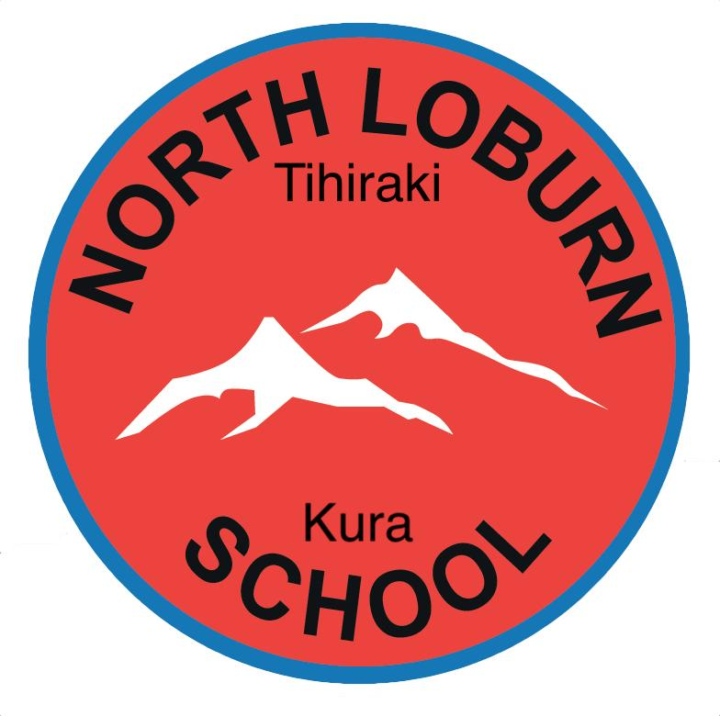
Tihiraki North Loburn
ENROLMENT FORM

Welcome to the first stage of enrolling at Tihiraki North School. If you prefer, this form can be completed online via the link on our website.

This is a provisional enrolment form based on the following information being provided to the school:
- A copy of the eligibility document for your child (proving your child is eligible to be enrolled in a state funded school in NZ). This can be either:
  - NZ birth certificate or NZ passport (if NZ citizen)
  - Australian passport (if Australian citizen) or
  - NZ residency permit or NZ student visa/permit and Parental work permit (if the child is not a NZ citizen).
- Proof of your address (if in zone e.g., utilities bill, rental/sales agreement).
- Immunisation certificate
- A copy of any Court Order Documents (if applicable)

Please be aware that the responsibility lies with the applicant to prove permanent residence in the school zone. It is an offence under the Education Act 1989 section 110 to falsely claim residence in the school zone. The school reserves the right to request further address proof to confirm residence in the school zone.

All enrolments will be considered to be provisional until appropriate documentation proving residence within our zone has been provided. Details of our enrolment zone can be seen on our website: www.northloburn.school.nz

*Privacy Statement*
The information collected from this form will be used by the school for enrolment, and forms an essential part of the information held by the school on your child. The records made from this information may be viewed on request. The information collected may be disclosed to appropriate education, health and welfare authorities and for data-gathering purposes in accordance with the principles of the Privacy Act. It will not be disclosed to any other person or agency unless such disclosure is required by law.

Student Details
First name (Legal) | Middle name(s) | Last name (Legal)
Preferred Name | Date of Birth | Gender
Address (Street) | Address (Suburb) | Address (Postcode)

Primary Contact Details
Primary Contact 1 - Full Name | Primary Contact 2 - Full Name
Primary Contact 1 - Address | Primary Contact 2 - Address
Primary Contact 1 - Email | Primary Contact 2 - Email
Primary Contact 1 - Contact Phone Numbers  Mobile:  Landline:  Work: | Primary Contact 2 - Contact Phone Numbers  Mobile:  Landline:  Work:
Primary Contact 1 - Occupation | Primary Contact 2 - Occupation
Primary Contact 1 - Relationship to Student | Primary Contact 2 - Relationship to Student
Lives with Student? Yes / No | Lives with Student? Yes / No
Views / Receives Financial Statements? Yes / No | Views / Receives Financial Statements? Yes / No

Emergency Contact Details
Emergency Contact 1 - Full Name | Emergency Contact 2 - Full Name
Emergency Contact 1 - Address | Emergency Contact 2 - Address
Emergency Contact 1 - Email | Emergency Contact 2 - Email
Emergency Contact 1 - Contact Phone Numbers  Mobile:  Landline:  Work: | Emergency Contact 2 - Contact Phone Numbers  Mobile:  Landline:  Work:
Emergency Contact 1 - Relationship to Student | Emergency Contact 2 - Relationship to Student

Student Ethnic information
Ethnicities: | IWI (If Māori identified as ethnicity) | Country of Citizenship

Student Education
Current Year Level | Intended Start Date (subject to confirmation by school) | Current School:
ECE attended | ECE years/weeks | ECE hours per week
Any specific Learning and/or behaviour needs

Student Living Arrangements
Custody Order in Place? Yes / No | Access Arrangements
Current Siblings attending this school | Future Siblings likely to attend this school (Name & date of birth)

Student Medical Details
Doctor | Known Medical Condition(s) | Allergies
Medications to be administered at school | Immunisations | Other medical information we should know?

Permissions
In the event of an accident or sudden illness, I/we authorise the staff of Tihiraki North Loburn School to obtain such medical assistance as may be necessary when I/we cannot be contacted. I/we agree to meet any cost incurred for the treatment or transportation of my child to receive medical attention.  Yes / No | ​​I/we give permission for this child to undergo vision and hearing testing.  Yes / No
I/we give permission for this child to be seen by a School Health Professional or Dental Nurse.
Yes / No
I/we give permission for staff at Tihiraki North Loburn School to administer pain relief or other medication as listed on this child's records, if required.  Yes / No | I/We give consent for this child to be given access at school to computers, the Internet and other communication technologies?  Yes / No
I/we give permission for this child's photo to be taken whilst participating in school activities. Photos may be used for promotional purposes in the schools newsletters, website and school social media apps.
Yes / No

All information provided on this form is true and correct to the best of my knowledge.

Signature of person completing form: _____________________ Date: ___________
Please print full name under signature:

