The apps that cannot be missed first coming to New Zealand

There are so many mobile applications we have downloaded on our phone to explore what’s around us. It’s very convenient to use them in our hometown or home country, but it can be a problem in New Zealand especially when this is your first time here. Here are some essential apps that I listed for your guys, and also tips of how to use them in a Kiwi way

Zomato

Zomato is an app exploring the FOOD around you. It provides plenty of services in the app, including table reservation, comment writing, restaurant menu review and details about the restaurant. The choice is extensive on the app, from Asian food to Western cuisine, from take-away restaurant to nightlife bars and drinks, Zomato got your back.
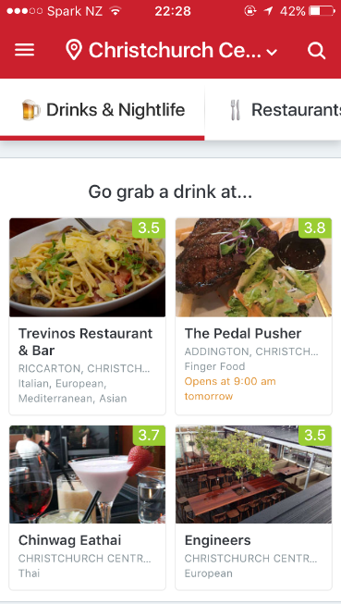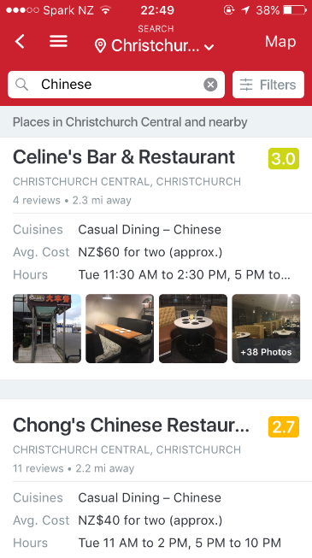
Even though Trip Advisor and Google Maps provides information and comments reviews just like Zomato, but what it provides here is so much more, like you can explore everything of the restaurant without even being there. I know there are foodie lovers out there, time to download it and find out!

Trade Me

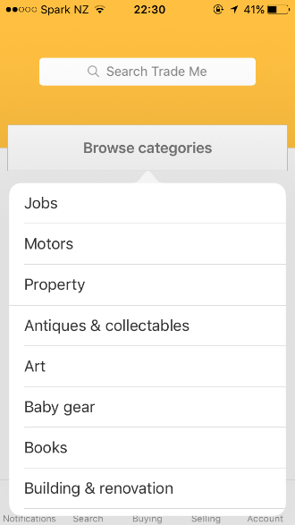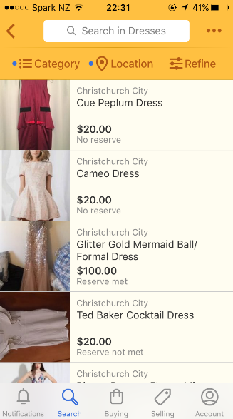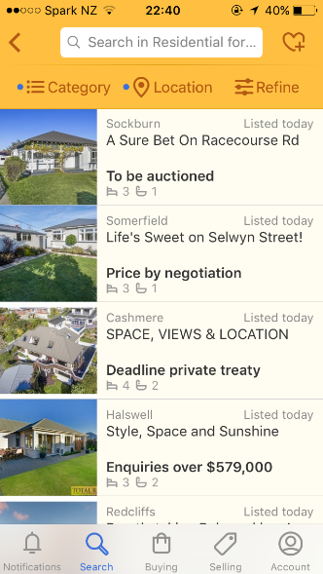
Trade Me is a very popular second hand purchasing platform, its app provides all kinds of products and services, and all these are purchased via bidding. If you’re interested in a product, you need to bid it to reserve the product until the time runs out. There are all categories of products on Trade Me, small down to a pretty dress and big up to property selling. It’s an amazing world in this little app, but don’t get too addicted.
Tips: The first step of using Trade Me to bid products is to create a Trade Me account, which requires topping up for the account credit. There are financial transactions crossed over, so please make sure your information is not leaked in any way.

Spotify

I know, I know, Spotify is known by all people. Of all the music stream applications like Pandora, Apple Music and YouTube Music, Spotify may be the easiest to use in New Zealand. (Don’t judge my music taste, Taylor Swift is great )

What I’m introducing here is that it’s annoying to listen to the ads in between songs, and functions of shuffling songs as much as you want when you use the free account of Spotify. New Zealand Telecom Company, Spark, has several plans including free Spotify Premium, in which you can enjoy the music just the way you want.

Meetup

Meetup is a magical app, it contains all app users around the world with the same interests. Just like what the name represents, go meet up with the ones who share the same interests. Make a group and do something. It’s quite popular in New Zealand, because New Zealand is famous for its friendly people and outdoor spirit.
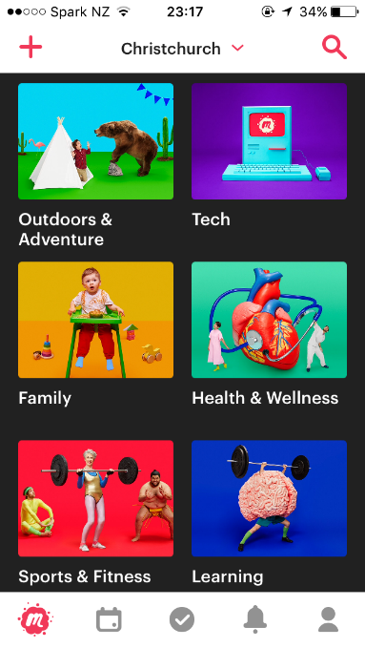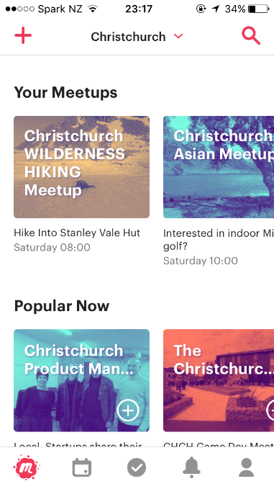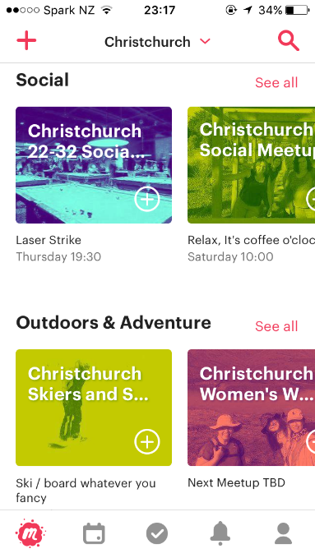
Given that I love trekking, I met up with a few groups before, and during the trekking, I encountered quite amount of people with so much interesting stories to share. Backpacker from Germany having a gap year in New Zealand to have new experiences, Chinese immigrated from Singapore who works in finance trying to a relaxing weekend, Bulgarian working for a European company but relocating here in New Zealand for a year and also wanting to meet up new friends. It’s international and meaningful since at least one share topic can be brought up on table. Those who like to make new friends and always love a crowd, try meetup some interesting people here.

GrabOne

GrabOne is a New Zealand local group purchase app, it’s so popular here because it offers the best deals in products, activities and experiences. There are the newest updated discount information and deals in the app, and the categories vary: outdoor activities, massage and beauty, clothes and fashion, electronics, vege&fruit discount, professional course and holiday deal, etc. If you’re interested, there’s no harm download and give it a try
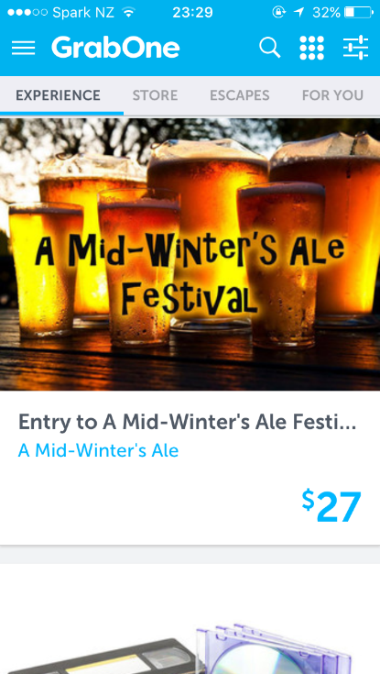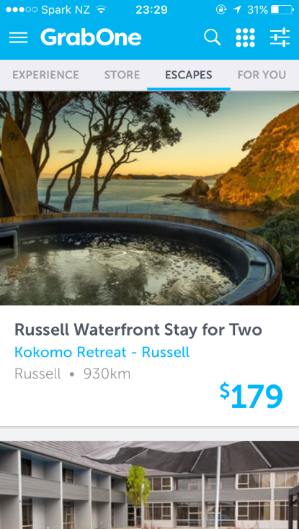

Christchurch Student Guide

Lastly, with the biggest welcome of the Christchurch Student Guide, from Christchurch Educated. (clapping emoji)
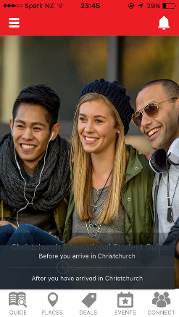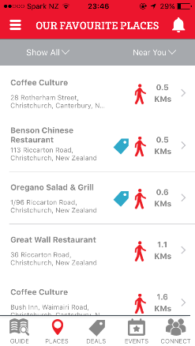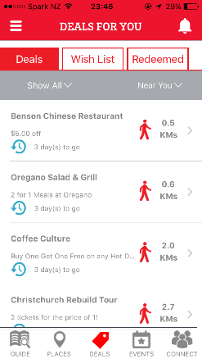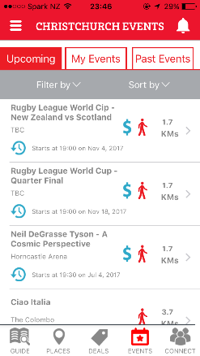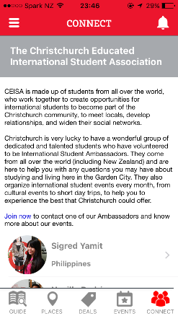
- In the app there are tips for international students for settling in Christchurch before and after arriving Christchurch.
- Of course we have selected all the places around for users to explore around you.
- There are student discounts for all the app users in all the cafés, restaurant, cinemas and tour sites which are cooperated with Christchurch Educated.
- Heaps of events happening every day in Christchurch, and for international students only, we selected few events extremely interested in and update them in time.
- Lastly, the profile of our CEISA (Christchurch Educated International Student Association) Ambassador are in the app, so if you have any queries, feel free to get in touch with each one of them.

