Mosgiel Taieri Safe Access Ways – Road Safety Study Survey
The ‘Mosgiel Taieri Safe Accessways’ project is a Mosgiel/Taieri Community Board and Dunedin City Council joint project to improve road safety and active travel to and from schools.
Codes to use on the map:
C – I have problems crossing the road here
H – I have been hit by a car while travelling here
N – I have had a near-miss with a car here
P – I have problems finding a parking spot here
S – I am concerned about my safety here
T – I am usually delayed by traffic/queues here
X – I have had a crash/collision driving here
O – I have some other issue here (explain overleaf)
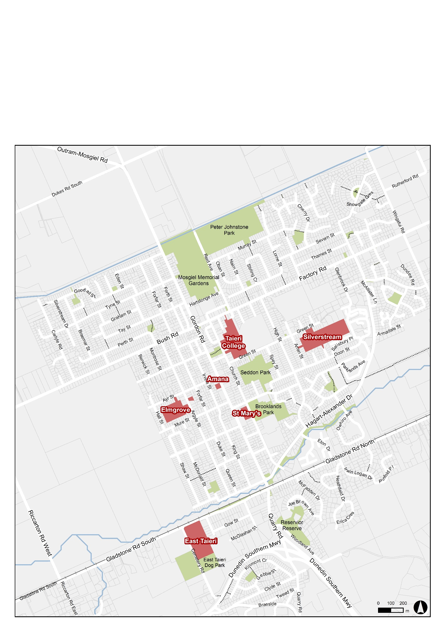
Instructions for pupils and their parents/caregivers:
We are interested in your travel route to/from school and after school sports.
- Please indicate your usual route to school on the map –
mark with a pen a line on the map showing the route
- Please indicate (using the codes to the right) where you have any issues – write the letters directly onto the map

I usually travel to school by: (circle main option below):
CAR / TAXI / BUS / BIKE / WALK / SKATE / SCOOT
I sometimes travel to school by: (circle other options if need be)
CAR / TAXI / BUS / BIKE / WALK / SKATE / SCOOT
Please circle your school below:
Taieri College St Mary’s School
Silverstream School East Taieri School
Elmgrove School Amana Christian School

Please return this to your school by Friday 7th December– Thank you!
Any other comments? Please write them on the back of this sheet.

