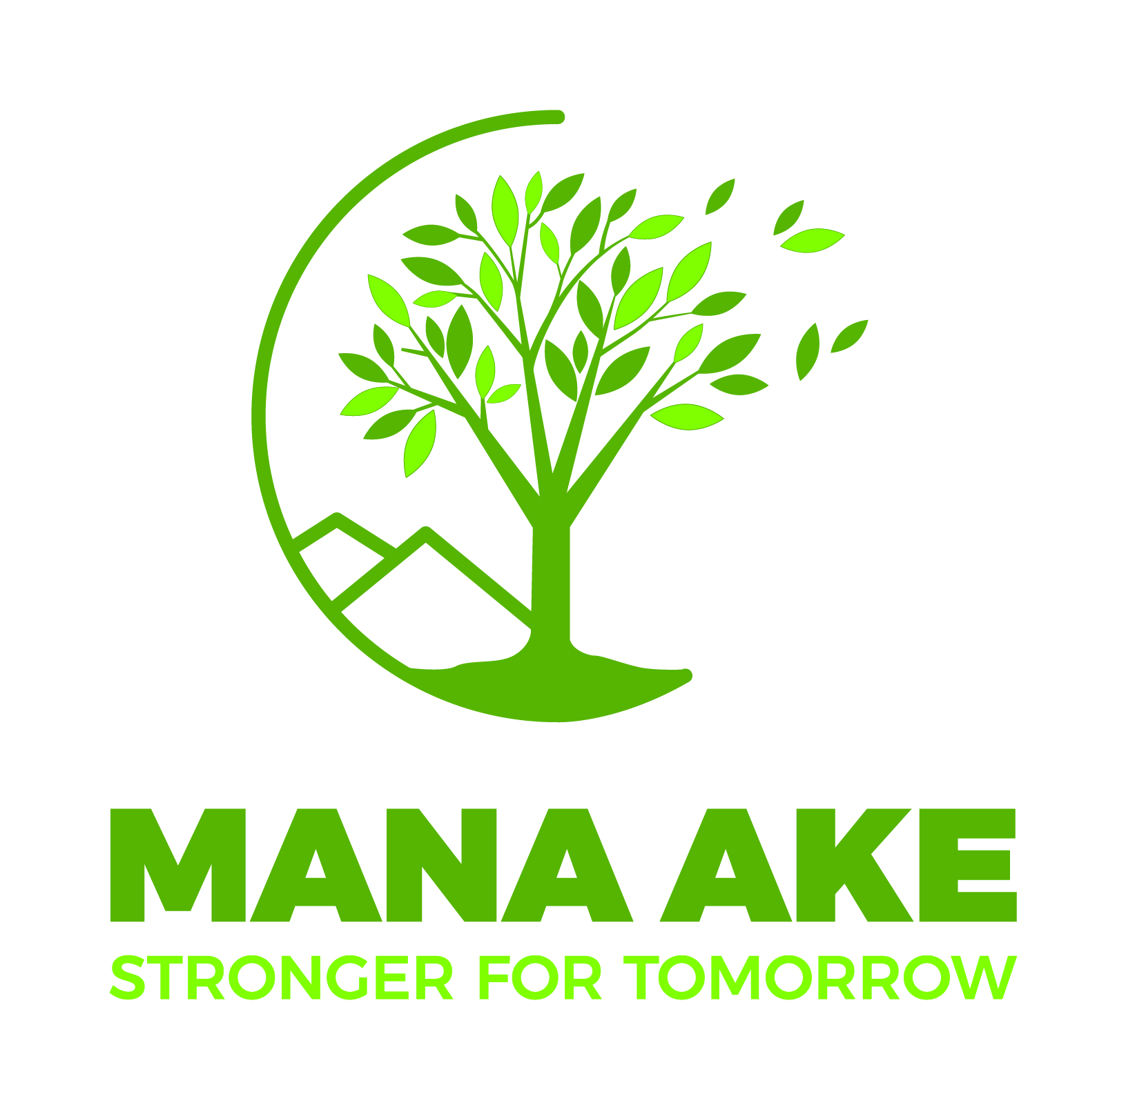  Mana Ake promotes wellbeing and positive mental health for children in years 1-8.  Mana Ake kaimahi can help promote and maintain wellbeing for all students.  They can also support groups of students or individuals who are experiencing ongoing concerns that impact their wellbeing, such as anxiety, social isolation, parental separation, grief and loss and managing emotions.  Let your child’s school know if you are interested in Mana Ake support.  For more information about Mana Ake visit the  Canterbury Clinical Network website at www.ccn.health.nz
  The Mana Ake service is provided by people with a range of skills including social workers, whānau ora kaimahi, counsellors, youth workers, nurses and psychologists.
  ____
  The Mana Ake service can support individual children, groups of children and provide information and workshops for parents.
  ____
  Mana Ake kaimahi are available to support children and their families/whānau at school and at home and they will be in your child’s school regularly.
  You can provide feedback about Mana Ake by emailing:
  manaakefeedback@cdhb.health.nz

