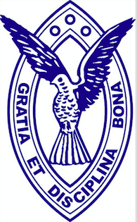
SAVE THE DATE.........

Columba College
Golf Tournament

 2021

Friday 10th September 2021
St. Clair Golf Club

