9 August 2018

Dear School Parent

**CENTRAL CITY SCHOOLS CLUSTER SAFETY IMPROVEMENTS – CONSULTATION**

The Dunedin City Council is working on a range of measures to improve road safety in Dunedin’s central city schools cluster. Improving safety for pedestrians is the highest priority for this project.

The area includes Otago Boys’ High School, Arthur Street School, Kavanagh College, Otago Girls’ High School and St Joseph’s Cathedral School (shown on our website).

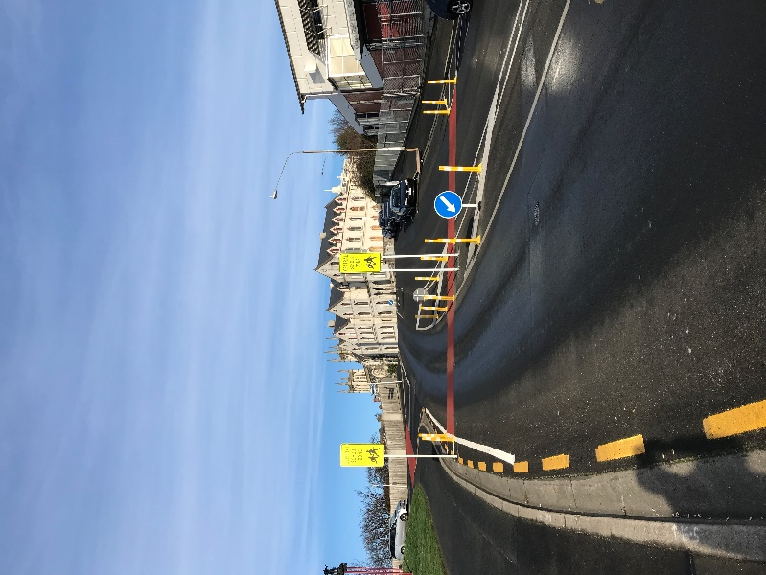Previous consultation with schools identified several key concerns including difficulties faced by pedestrians when crossing roads and intersections, problems with parking near schools, especially for short-term visitors, and the high speeds of vehicles on some streets.

In response to the problems identified, we are working on four consistent safety measures, which may be extended to other schools in the city if this trial proves successful.

**1. Gateway thresholds**

We’ve installed signs, bollards and painted lines at the entry points to the area to let drivers know they are entering a school zone. This encourages reduced speeds and provides crossing points. The next step would be to replace the bollards with permanent kerb buildouts and install electronic signs.

*Gateway – Smith Street*

**2. Crossing points**

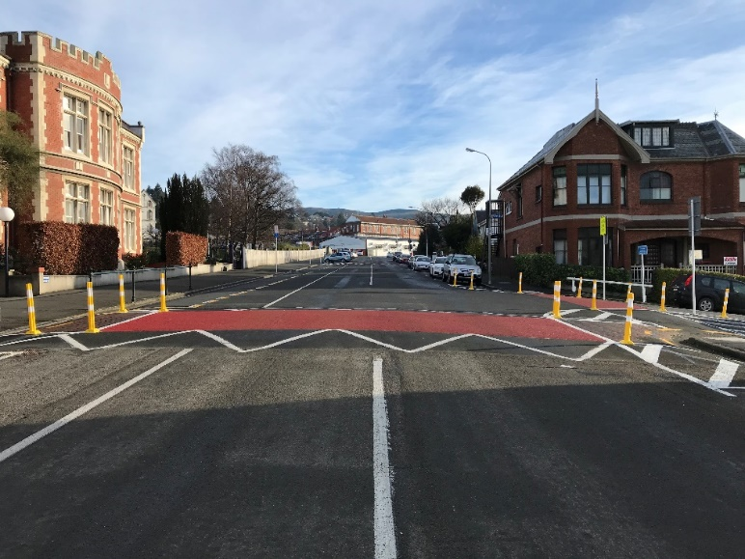A number of crossing points have been painted to reduce traffic speed and improve pedestrian accessibility and safety. The next step would be to install either raised crossings or kerb buildouts with a pedestrian refuge island in the centre.

**3. Parking**

We’re looking at changes to the layout of car parks in some areas. The first place we would like to make some changes is York Place/Cargill Street and we will be in touch with residents in that area soon to let them know about the proposed changes.

*Crossing point – Tennyson Street*

**4. Speed management**

We would like to reduce traffic speeds by introducing a part-time or permanent 30 or 40 km/h speed zone.

**Feedback**

We would like to know what you think of these changes. Please go to [www.dunedin.govt.nz/dunedins-central-city-schools-cluster-feedback](http://www.dunedin.govt.nz/dunedins-central-city-schools-cluster-feedback) to fill out our online survey or email your feedback to [transportadmin@dcc.govt.nz](mailto:transportadmin@dcc.govt.nz). Feedback is open until 5pm, 31 August. If you would like a hard copy of the survey, please email the address above or call us on 477 4000.

You can find more information about this project at [www.dunedin.govt.nz/central-city-schools-cluster](http://www.dunedin.govt.nz/central-city-schools-cluster).

Yours faithfully



Hjarne Poulsen

**Transport Engineering and Road Safety Team Leader**