**SPECIAL OFFER TO ‘CHRIST THE KING’ FAMILIES**

Help support our school fundraising

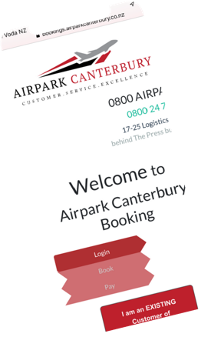

# Book

## airparkcanterbury.co.nz

USE PROMO CODE: PTACTK

1. **Save**

BEST PARKING RATE GUARANTEED

(AT LEAST 30% OFF AIRPORT RATES)

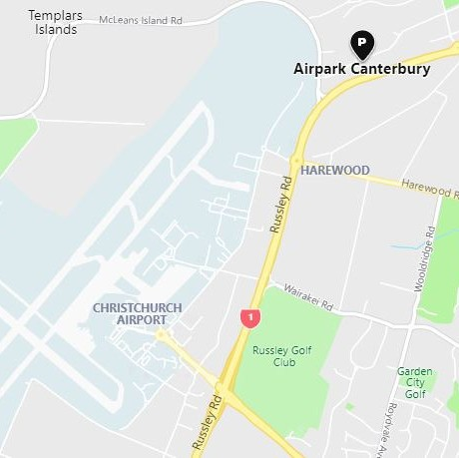

# Park

## 5 MINS DRIVE TO THE TERMINAL

(OUR VANS WILL DROP YOU OFF, AND PICK YOU UP)