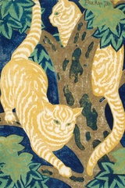
Cats in Trees
Eileen Mayo

Tabbies on the hunt
Where cats rule the night
Tabbies hunt in packs like assassins
Hidden against the golden bark or autumn leaves
While black cats hunt alone
Camouflaged in the dark night lurking in the shadows
Silently creeping on their claws
The tabbies ascend the rough oak tree
Looking for an unsuspecting Magpie for a late night snack
Once they sport their victim they sneak up on them
Snap!
They pounce on the bird they have no time to react
Slick and sly with hazel eyes of a hawk
They slowly descended down to the ground
Looking yet another bird to make easy snack of

Ryan Hann

