NEW BOOKS:
OCTOBER 2023

FICTION
A defunct shopping mall is closing, and a group of colleagues have the final shift. When the power goes out and the manager disappears, one of them find a body. Now they must escape the murderer in their midst…
323 pages, suitable for any year level.
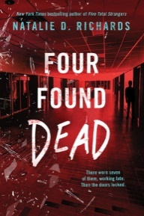
Jay lives at a resort, and he loves his life. However, when things go from bad to worse in the outside world, rich families start arriving and refuse to leave. Jay is horrified when he finds the resort management has been selling shares in an end of the world oasis – and part of the deal is that the staff will wait on the rich…
400 pages, suitable for any year level.
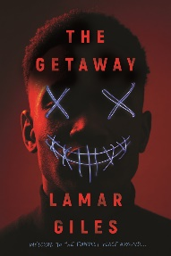

Kaine and Roxy are sports focused twins, both on track for stardom. They hate each other, but when a tragedy happens, they must find a way to come together, before it’s too late…
307 pages, suitable for any year level.
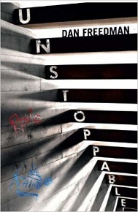

In this graphic novel, an intergalactic game of basketball called BASH is the sports everybody talks about. Rudy has grown up in a poor neighbourhood, but he has the skills to be a star. However, sinister forces are jealous of his talent…
130 pages, best suited to Years 9-10.
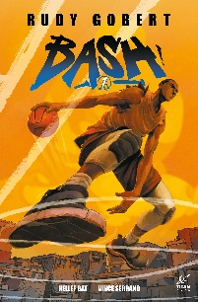

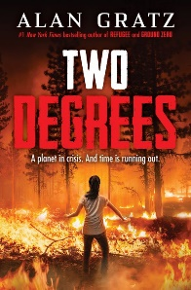
In this multiple perspective adventure story from a very popular author, four children find themselves fighting for their lives as a result of climate change – fire, ice and flooding.
384 pages, best suited to Years 9-10.

Football is Isaiah’s life, but when he gets knocked out, he is forced to think about what his life would be like without the game. Isaiah must decide how much he is willing to sacrifice for the sport he loves, and whether he is strong enough to give it up.

247 pages, best suited to Years 9-11.
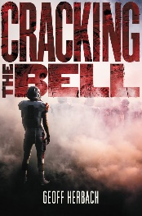

The D Zone has been damaged beyond repair after a series of quakes, and those left trying to survive are ‘illegals’. However, Jonah can glimpse quakes before they happen, and this power attracts the attention of both a cult and a business. Both are desperate to control him, but Jonah has his own priorities.
288 pages, best suited to years 9-11.
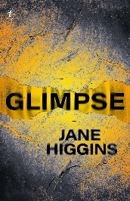

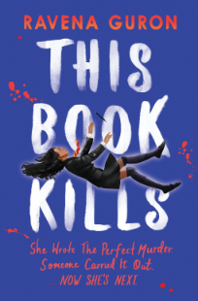
A murderer is on the loose in an elite boarding school, and everybody is wondering who will be next. Jess finds herself at the centre of the investigation when it is revealed that the murdered boy has died in the same way as a character in a story Jess has written.
384 pages, suitable for any year level.

In this funny, easy read, Marcus finds himself at an outback boarding school for kids who don’t fit in. Will he be able to survive Bad Grammar?
288 pages, best suited to year 9.
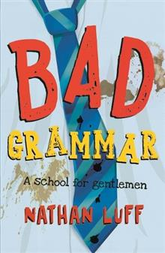

When ten of America’s hottest teen influencers are invited to an exclusive resort, they have no idea they were invited because of their deadly secrets. Somebody has decided it’s payback time, and they may not get to come home.
320 pages, suitable for any year level.

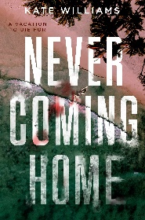

When a group of students set out to teach their malicious teacher a lesson, they start off with harmless pranks. However, when people begin to die, the group must accept that one of them is a killer.
288 pages, suitable for any year level.
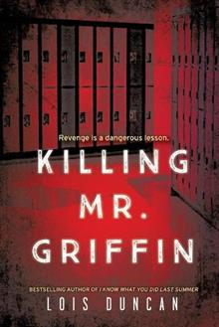

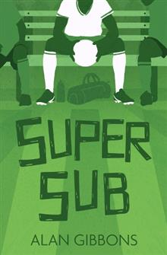
In this dyslexia friendly quick read, Smithy can’t work out why star player Bengo is so often benched. Could it be his anxiety?

80 pages, best suited to years 9-10.

When Declan’s sporting dreams as a pitcher are hampered by injury, he starts spending a lot of time gaming. When he meets Finn, he is swayed into channeling his resentment and anger into something very dangerous and deluded…
336 pages, best for years 10 and up.
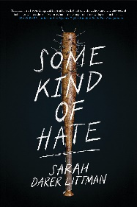

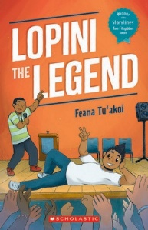
When Lopini is replaced as the kapa haka leader at school, he feels like a failure. Because he’s a perfectionist, he can’t handle the feeling. He decides to practice failing, so he will be able to handle it in the future, but will it affect his reputation as a legend?
176 pages, best suited to years 9-10.

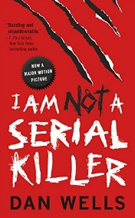
In this horror novel, John knows he could be dangerous, so he lives by a strict code of rules. Even so, he can’t help being fascinated by serial killers and death. When police find a body, John knows there is more to it, and it forces him to confront a danger outside himself. This novel is now a movie.

272 pages, best suited to years 11 up.

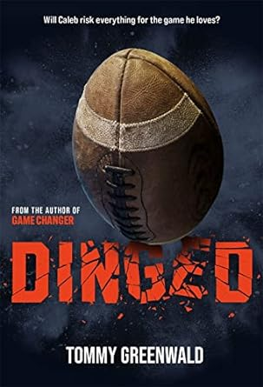
Caleb is an up-and-coming football player, and scouts are already interested. However, at home, his dad is rapidly deteriorating as a result of injuries he sustained playing the sport. Is Caleb ready to give his life to the same career that has left his father a shadow of his former self?

288 pages, best suited to years 9-10.

Quan is bright, but he’s sitting in a youth detention centre. A dead cop and his fingerprints on the weapon have put him there. His experience of being black and ensnared in the broken American justice system is told through a series of letters to Justyce. Great for personal response.
288 pages, suitable for any age.
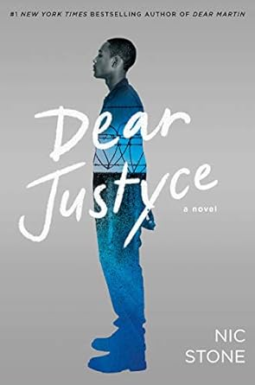

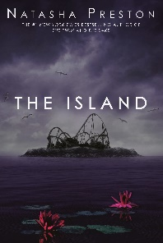
Jagged Island is an amusement park for the rich, and when a bunch of social media influencers are invited to review it before opening, they are stunned by how incredible it is. However, they soon discover getting off the island alive could be tricky…
336 pages, suitable for any age.

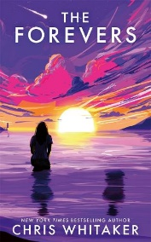
What would you do if you knew the world was going to end in a month? For many, it means life has no consequences, and grudges turn deadly. If you could get away with anything, what would you do?

355 pages, suitable for any age.

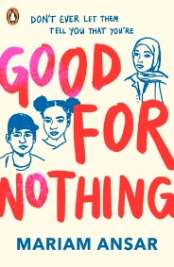
When three teens are landed with a community service order, they learn more about themselves and the true cause of Amir’s brother’s death. This is a coming-of-age story about police prejudice, the power of friendship and growing up in a small town.

336 pages, suitable for any age.

NON-FICTION

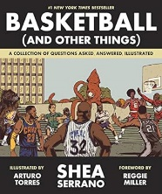
This book contains a range of questions and answers from basketball history, explained with humour and fun tangents, and accompanied by art.

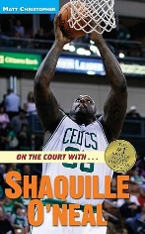
The ‘On the Court With…’ series looks at the life and careers of basketball stars. We have Shaquille O’Neal and Kobe Bryant.

This is a behind the scenes look at the highs and lows of the world of F1. McKenzie is known for her brilliant and tough interviews, and here she shares her highlights.
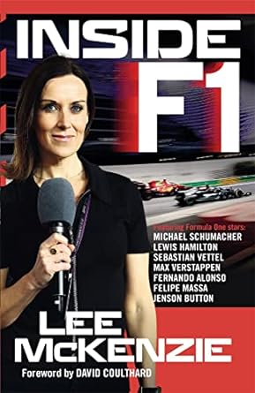

This book is full of information about football’s best players, complete with facts, stats, and colour photos. Quick and easy reading – and we also have The Big Book of Who Basketball.
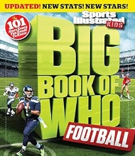

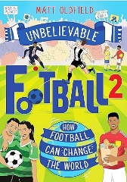
An inspiring collection of stories about how football has changed the world for the better. Great for reluctant readers.


This pictorial book uncovers the stories and accomplishments of the world’s greatest basketball players.

This information packed book contains everything you need to know about your favourite teams and athletes, with lots of fun trivia, facts, key events and statistics.
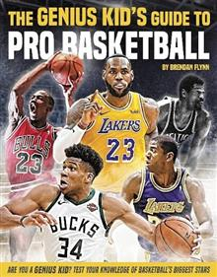

The Sports Superstars and Football Superstars series includes inspirational stories, jokes, quotes and cartoons. Very easy reading, good for reluctant or struggling readers. We have Hamilton, Neymar, Kane, Mane and Aguero.
