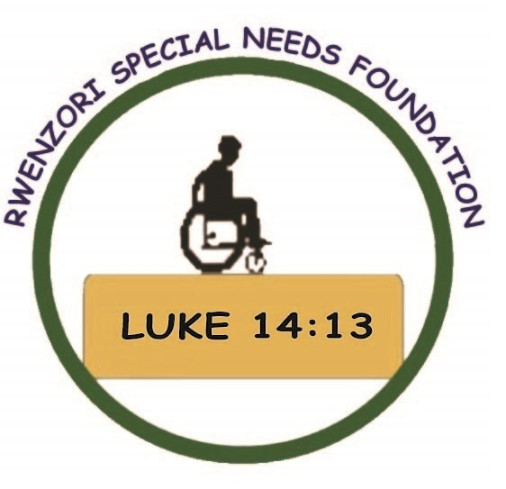  Wishing you the many blessings of a joyous Christmas and a happy New Year.  from all the people from rwenzori special needs foundation  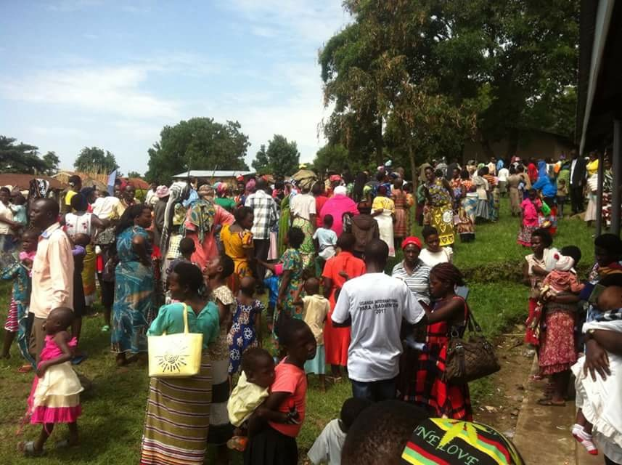  Giving Hope and Love to people in need  Thank you for your generous support  Blessings  Dot and the team | RWENZORI  SPECIAL  NEEDS  FOUNDATION  Fort Portal  Uganda  ────  $26,000 in 2018 has been raised and sent to help children with a special need.  With this we were able to support…  205 families with education, nutrition, farming and wellbeing  273 cleft and palate surgeries  120 medication/other surgery support  560 people assessed by specialists.  $10,000 from Anglican Missions  Towards a 4-wheel drive truck to transport people to hospital and appointments.  4  ────  One More Point Here!  ────  Add More Great Info Here!  ────  You Have Room for Another One Here!  Company Name  Street Address  City, ST ZIP Code  Telephone  Web Address  Dates and Times

