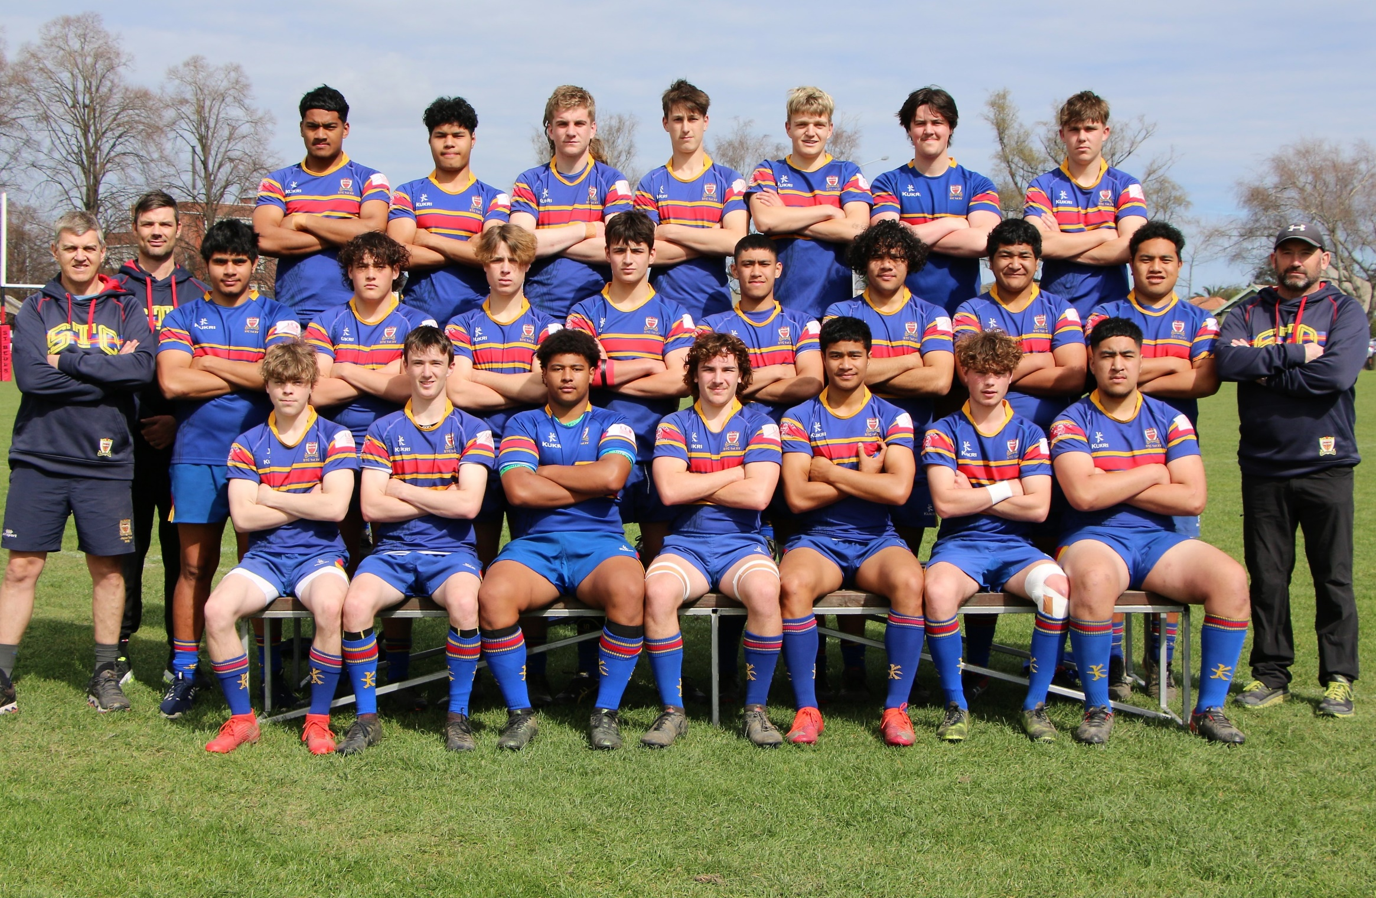
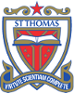
2020 STC Second XV

Winner of Section One – Under 18 Final: STC - 15 vs St Bedes - Nil
Back Row: Norman Palu, Joseph Ripley, Finn Keogan, Seth Collins-Craig, Mitchell Barrett, Rhys Buckley, Fletcher Due
Middle Row: Andrew Barrett, Hamish Barclay, Siosifa Amato, Lachlan Harris-Tatana, Isaac Redman, Cooper Te Hau, Letone Loto, Finley-J Esera, Epati Auvae, Tai Ierome, Phil McKendry Front Row: Tom Hart, Josh Lennon, Aubrey Gilmour,
Mykah Lumb ©, Tevita Faitotonu, Connor Stanley, Heneli Mosaati.

