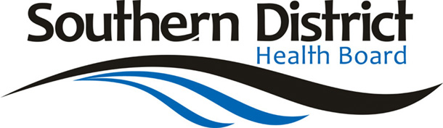
Public Health South
Main Block, Level 2, Wakari Hospital
Taieri Road, Dunedin
Private Bag 1921, Dunedin 9054
Tel: 03 476 9800 Fax: 03 476 9858

* Please put the following information in your Newsletter, thank you.

YEAR SEVEN VISION SCREENING

The Vision Hearing Technicians from Public Health South will be visiting your school to screen all year seven students for distance vision.

- Distance Vision (Amblyopia & Hyperopia)
This determines how well your child is able to see at a distance. It involves reading an eye chart. (Not required if child wears glasses)

If you do not wish your child to be screened please fill out an opt-out slip, which are available at the school office before our visit.

