For further information, please follow our social media pages:
Instagram – HGHS Careers Department
Facebook – Hamilton Girls High School Careers Department

 | Canterbury University  Information Evening | Wednesday 25th May | 6:00pm | FMG Stadium,  Hamilton
   | Feed your Future  Food & Fibre Young Professional Panel | Wednesday 25th May | 5:30pm  –  7:30pm | DairyNZ,  Cnr Ruakura & Morrinsville Rds
 | University of Waikato  Open Day | Friday  27th May &  Saturday  28th May | Fri: 9am – 2pm  Sat:10am  – 2pm | Hamilton Campus
 | CONNEXIS  Girls with Hi-Viz  Engineering Day | Wednesday  8th June | 8:45am  –  3:00pm | Various Hamilton  Sites
 | Waikato University  Scholarship Information Session | Thursday  9th June | 1:30pm | HGHS Library
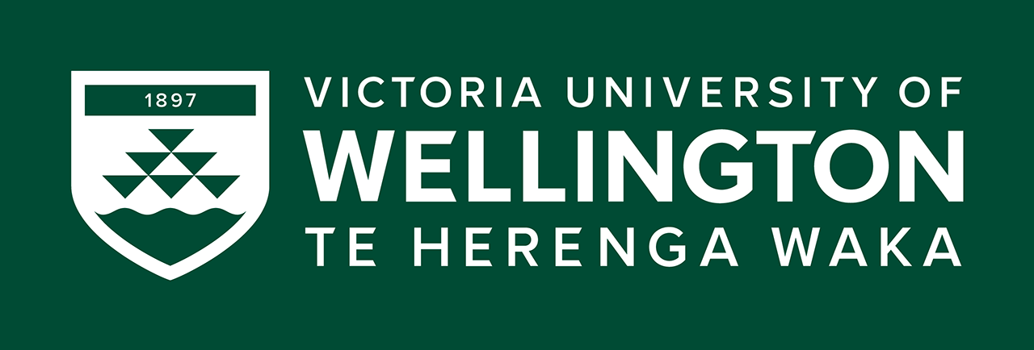 | Victoria University  Information Evening | Thursday  9th June | 6:00pm  –  8:00pm | Claudelands Event Centre
 | Waikato Career Expo | Sunday  12th June &  Monday  13th June | 10:00am  –  3:00pm | Claudelands Event Centre
 | University of Waikato  Tauranga Campus  Open Day | Friday  17th June &  Saturday  18th June | Fri: 9am – 1pm  Sat: 10am – 2pm | Tauranga Campus
 | Hamilton City Campus  Rotokauri Campus  Hamilton Gardens Campus  Information Sessions | Tuesday  21st June  Wednesday  22nd June  Thursday  23rd June | 3:30pm  –  5:30pm | Hamilton City  Rotokauri  Hamilton Gardens

