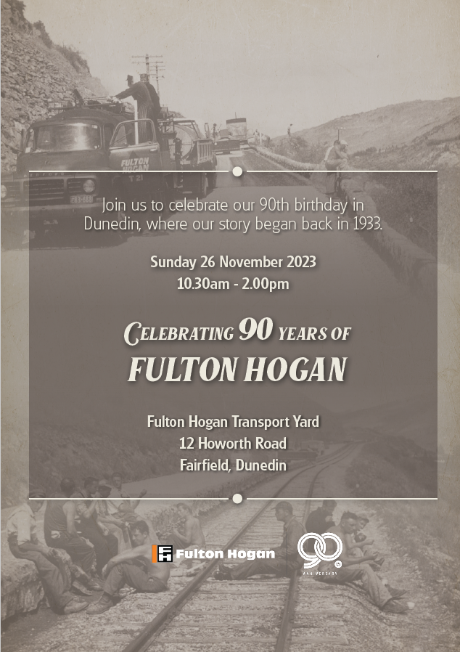

What’s happening …

- Historic videos and photo boards
- Static machinery displays
- 45 mins return narrated bus trips through Blackhead Quarry
- Truck rides into Walton Park Sand
- Food trucks
  - Citizens
  - Wild Az Venison
  - Green Island Lions Caravan
  - Frosty J Icecreams
  - Churros Olè
  - Coffee Carts
- Pippity Pop
- 3 Enormous bouncy castles
- Sand pit
- DOC Takahe info tent
- Interactive session with Fulton Hogan Laboratory
- Activity booklets to complete
- Face painting / temporary tattoos
- Fairfield School Kapa Haka performing

Please note that our site is a non smoking / non vaping environment
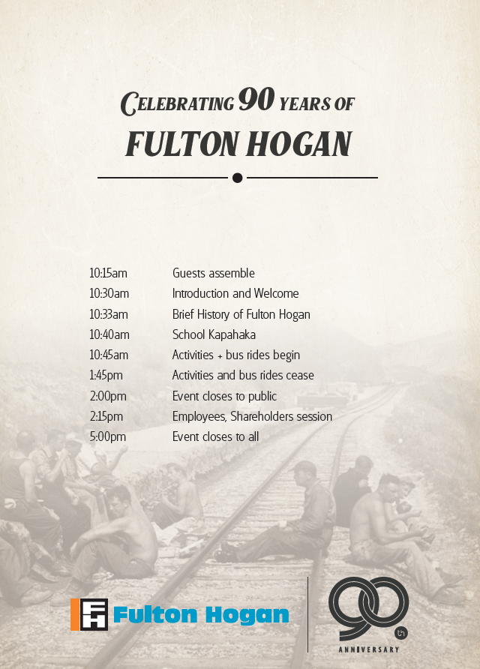
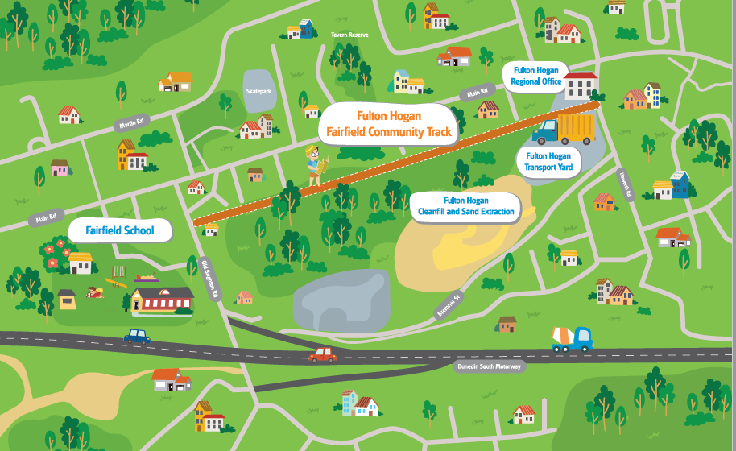

Parking at the event will be at a premium. We suggest you take the opportunity to come via the community walking track.

See you there!!

