**Love this?**



**Then try fencing!**

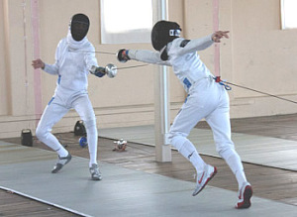

A five-week adult and children’s beginner’s fencing course starts on Monday the 18th of February 6.00pm – 7.00pm. The course costs $80.00 and all equipment is provided. It is a great introduction to this exciting sport.

Where else do you get to have fun attacking your friends with a sword!

For more information and enrollment email us at claymoreswordsclub@gmail.com