NEW BOOKS:
JUNE 2023

FICTION
In this gory slasher horror/thriller, a group of teens arrive on an island to compete in an Iron Teen competition for a huge cash prize. Things turn ugly quickly when they start attacking each other…
416 pages, best suited to Year 10 and up.

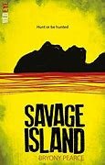
In this new fantasy series, the daughter of revolutionaries and a devious prince have to learn to trust each other as they investigate the truth behind her mother’s death.
400 pages, suitable for any year level.

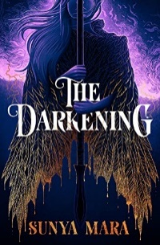

This moving war story follows the lives of five different teenagers living through WWI and experiencing different aspects of the war.
390 pages, best suited to Years 9-10.

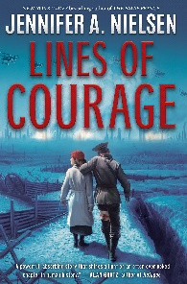

Two boys try to keep themselves safe from the gangs roaming their streets, but violence soon seeps into their lives as one makes a desperate bargain..
284 pages, suitable for any year level.
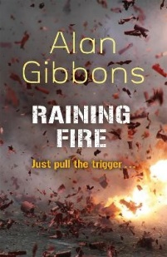

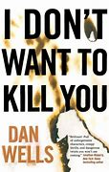
John has always known he’s different – he has a dark side which he has to keep in check by following a rigid set of rules. However, its these same dark qualities that put him in the perfect position to save the people of his town from a killer…
320 pages, best suited to Year 10 and up.

In this quick, easy read, Xander thinks an old hospital will be the perfect place for his role-playing games. However, Xander and his friends soon find the hospital is haunted – and maybe not just by the ghosts of former patients…

144 pages, best suited to Year 9-10. Great for reluctant readers.
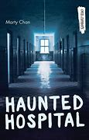

Return to the world of Scythe with this set of stories set in the Arc of a Scythe world. Includes new and origin Scythe stories, and continuing storylines!
432 pages, suitable for any age.
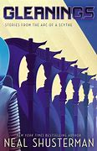

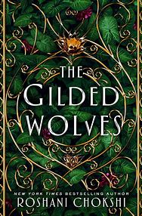
In this immersive fantasy novel, treasure hunter Severin is on a mission to find out the truth about his inheritance. With a group of talented friends, he needs to find an ancient artefact in order to get his questions answered…
388 pages, suitable for any age.

The latest Diary of a Wimpy kid novel sees Greg tagging along with his brother’s band in order to help them become legends…
244 pages, best suited to Year 9-10.
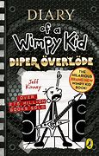

Dry meets Hatchet in this survival skills story where a teenage girl must lead a group of friends across the country to her father’s survivalist compound – the very place she has tried to forget after a tragedy drove her away.
448 pages, suitable for any age.
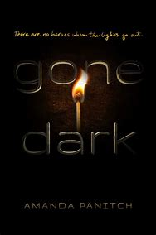

In this supernatural thriller, a group of teens must spend a week hiding out in an old amusement park. If they win, they get a large cash prize. However, when people start disappearing, they are forced to band together…
244 pages, suitable for any age.
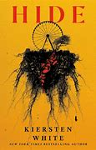

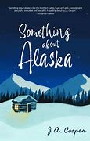
Zac travels to Alaska to reconnect with his estranged father, but when things spiral out of control he is forced to hitchhike to escape a storm, and he finds himself sharing a cabin with a stranger…

221 pages, suitable for any age.

When his parents take over a ski lodge, Nelson sees a chance to reinvent himself. However, when he tells a few white lies he ends up in the middle of a love triangle and a ski race he is nowhere near good enough for…
320 pages, best suited to Years 9-11.
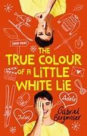

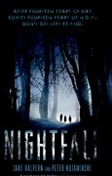
In this horror novel, every 28 years on Marin’s Island, nightfall happens. Everybody must leave to wait out the long night, but when a friend goes missing, Marin and Kana decide they must find him. They have left it too late to leave the island, and as night falls, the island changes…
346 pages, best suited to Years 9-10.

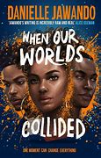
When 14-year-old Shaq is stabbed, three teens from very different lives are brought together and they question the racism and prejudice that exists within the police, media and society. Highly rated, great for personal response.

400 pages, suitable for any age.

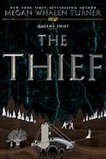
Gen is the Queen’s thief. When he is landed in prison, he is offered a chance to win his freedom, but to do so he must go on a quest to steal a legendary object. However, Gen has plans of his own…

280 pages, best suited to Years 9-10.

A group of teen Tiktok stars have it all, but when one of them turns up dead, the police discover all of the remaining teens have secret and reasons for wanting their friend dead…
304 pages, suitable for any age.
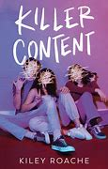

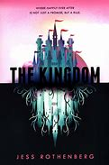
The Kingdom is a fantasy theme park, where dreams come to life and half-androids help grant wishes. When a murder occurs, one of these androids is placed on trial after experiencing feelings against all her programming…
352 pages, suitable for any age.

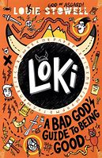
In this Wimpy Kid style book, Loki is banished to live on earth as a normal boy after one trick too many. Forbidden from using his powers, he must show moral improvement, but as he records his life in his diary, its clear he doesn’t know where to start. The second book is also available.

240 pages, best suited to Years 9-10.

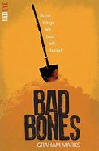
When Gabe finds a shallow grave, he doesn’t think twice about stealing a gold bracelet, but he has no idea what he’s awakening…
This is part of the Red Eye horror series, which also includes Fir, Flesh and Blood.

336 pages, best suited to Years 9-10.

NON-FICTION

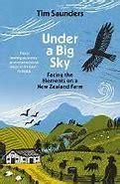
Saunders writes about his life and work on the farm that has been in his family for five generations, covering drought, financial pressures and the push to become more environmentally friendly.

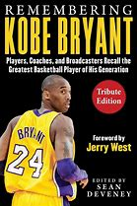
This book contains stories from Kobe’s opponents and teammates about what it was like to play with the legend.

This is the story of how a small group of men transformed Formula One from a niche sport to what it is today. It covers how they operated like a sporting Mafia, then were ultimately pushed out.
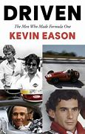

This is the inspirational story of Brisco, and how he hit rock bottom, lost all confidence in himself and almost quit farming. Here he shares the tools that helped him rebuild and cope with the physical and mental strain of a life in farming.
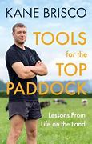

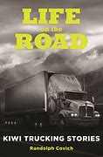
Kiwi truckies share their incredible stories of life on the road.

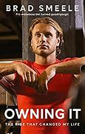
Smeele’s life as a professional wakeboarder ended when a tragic accident left him a quadriplegic. This is the story of his struggle to find peace and a new life. Inspiring and moving…

Taylor is one of New Zealand’s best know criminals. After spending 38 years in jail and masterminding two notorious escapes, he now advocates for criminals and has redeemed himself. In this book he tells his gripping stories of prison life.
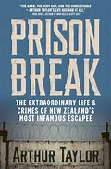

This pictorial book tells the story of Formula One from 1950 to the present day. Includes photos and interviews.
