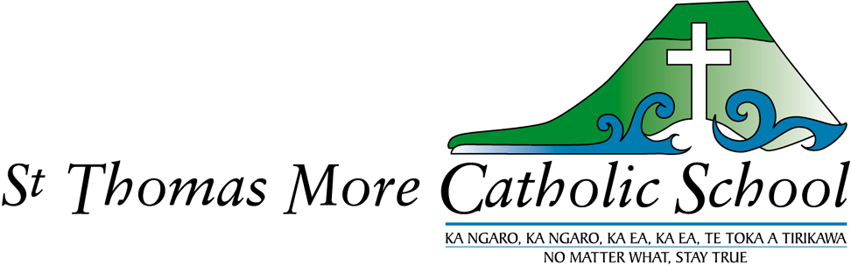
Strategic Plan 2024-2025
Mission: We are Christ’s body in this world – Head, Heart and Hands.

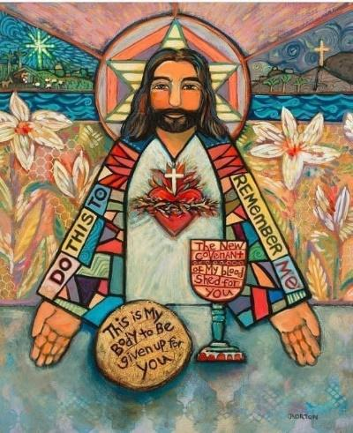
Strategic plan 2024-2025

3-4 | Head- Learning – Transformation and Excellence
5-6 | Heart – Faith – Catholicity and Relationships
7 | Hands – Service – Justice, Equity and the Common Good
8 - 11 | Strategic planning 2024-2025

“Christ has no body now on earth but yours.”
St. Teresa of Avila.

HEAD
LEARNING
We value EXCELLENCE TRANSFORMATION
Principles | Practices | Proof
Our school has high aspirations for every learner and we support these aspirations by partnering with their whanau to design and deliver education that responds to their needs and which sustains their identity, language and culture. | Partner with family/whanau to equip every learner/akonga to build and realize their aspirations.  Assist staff to build their awareness of bias and low expectations, and of how these impact learners/akonga, staff and whanau.  Ensure all learners have ongoing opportunities to develop key capabilities including communication, problem solving, critical thinking and interpersonal skills. | Every student in the school is able to attain their highest standard in educational achievement.  Regular data reviews and reports to parents/whanau and the board are part of the picture. Being able to share the back story for each student with a full understanding of their learning is essential for teachers and the leadership team.  Every learner/akonga gains foundational skills in language, literacy and numeracy.  Explicit teaching of phonics and word knowledge using NZ based pedagogy/ structured literacy to achieve best practice.  Evidence of learner agency and student engagement; collaboration, integration and real contexts, inquiry, digital fluency, sustainability and ecological awareness.
Quality teaching and leadership make the difference for learners and their whanau.  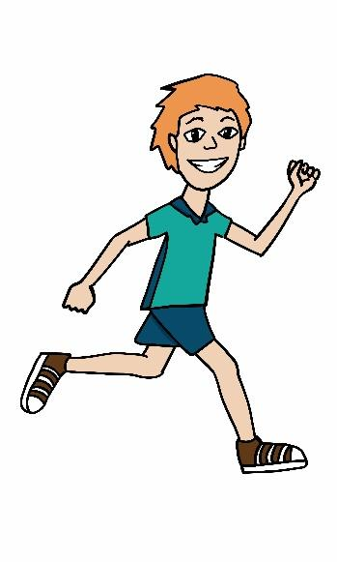 | Through appraisal, strengths and gaps in teaching capability are identified leading to investment in opportunities for teachers and staff to strengthen teaching, leadership and learner support capability.  Expect and support teachers to build their understanding of learners’ contexts, including languages spoken at home, histories, stories and cultural values, to provide culturally responsive teaching.  Develop tools for rich records of learning to capture aspirations, strengths and learning progress.  Curriculum designed to provide contexts which enhance learning in Hauora, Health and Physical Education. | Regular cycles of inquiry and review are part of the school’s appraisal and professional development processes. Each teacher will be involved in a programme which builds on inquiry and best practice and which includes research and peer review – a professional learning cycle.  Evidence of culturally diverse environments, celebrating the differences and sharing the significant events in children’s lives.  Rich records of learning are evident alongside a variety of methods to connect with family/whanau to share information about learners/akonga.  Regular updates to parents on student learning are provided and learning is recorded through SEESAW journals.  Evidence of the four dimensions of hauora in the everyday practices of the school (M.Durie Whare Tapa wha). Healthy Active Learning initiative (Sport NZ and MOH/MOE) introduced and active in the school for a three year period from 2022-2024.  Toolkits to help create: a healthy food and drink environment; a healthy and active learning environment; and better connections to local community groups will be used effectively by teachers and leadership team.  Regular workshops provided for staff to learn how to implement the HAL principles in daily teaching practice.
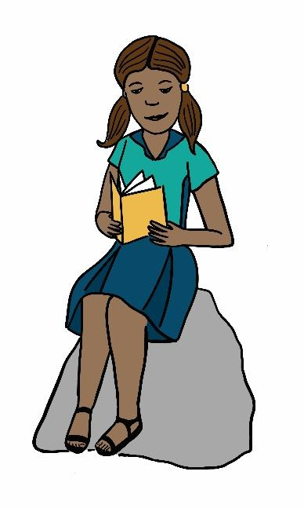 | Curriculum reflects local history, matauranga and aspirations of Ngai Te Rangi. | All students have opportunities to learn te reo Maori through a weekly focus on kupu and tikanga. Annual on-site visits to places of significance arranged for all students.  Connections made with student groups from local schools e.g. participation in Ngai Te Rangi ECE Ra Whakangahau, Catholic Kahui Ako annual Ahurei and other cultural events.  Evidence of the inclusion of Aotearoa New Zealand history curriculum at all levels of the school; Know Understand Do revised curriculum.  Knowledge and understanding of Ngai Te Rangitanga , Matauranga Maori and teaching of Te Reo Maori.  Including – Te Tai Whanake ki Tauranga Moana local  Curriculum  - Paritaha kaitiaki model  - Maori Achievement Collaborative (MAC)

HEART
FAITH
CATHOLICITY RELATIONSHIPS
Principles | Practices | Proof
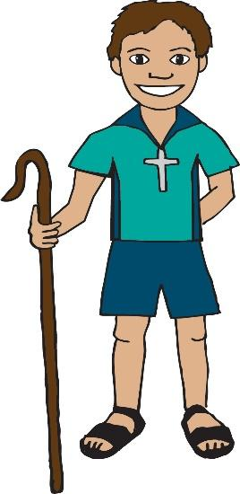  Our school is a Catholic school, a school with special character.  Within our uniquely Catholic faith community students  are encouraged to develop  a personal relationship  with Jesus Christ.  Our Catholicity is defined by our beliefs, our rituals and our religious education curriculum. Our school is part of the parish of All Saints by the Sea.  We are the face of the church to many of our school parents and families.  We are the body of Christ present in this world-Head, Heart and Hands. | Our proprietor (RC Bishop) is kept informed of the strengths and the challenges the school community faces.  Professional learning mandatory for all teachers introducing the new RE curriculum and support provided for teachers to undertake study papers through TCI.  Each year our school will focus on one step of the Diocesan Strategic Plan in relationship with our parish so that we can make meaningful connections between aspirations and reality.  2024 Partnerships  2025 Empowering people. | Catholic character review and report every three years completed by Diocesan team 2022 + 2025.  Proprietor’s annual report is completed by the board’s Catholic character committee by June each year.  Teachers are upskilling in religious education courses and study each year.  The RE curriculum is taught in each classroom by qualified RE teachers.  Regular reviews are undertaken by the DRS to support each teacher to grow in confidence and to build capability in RE.  The relationship between Head, Heart and Hands is explicit in everything we do.  Prayer is a significant part of daily life.  Our school and parish community are interconnected.  Teachers are role models.  Spiritual growth is supported and affirmed.
Our school acknowledges the principles of Te Tiriti o Waitangi and the bicultural foundations of Aotearoa New Zealand.  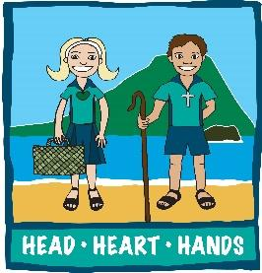  The school curriculum will honour the Treaty partnership by recognising and valuing the unique position of Maori in New Zealand society.  The aspirations of Ngai Te Rangi for their tamariki are supported through the strengthening relationships developed through the work of Kahui Ako in the Tauranga Moana rohe.  Catholic schools representatives will work alongside nominated representatives from Ngai Te Rangi to support and grow a Maori Catholic network in the Tauranga Moana rohe. | Professional development is provided to all to ensure that Te Tiriti o Waitangi principles are understood and put into action in our school.  Advice from Maori is requested on how best to include tikanga Maori in values, practices and organisational culture.  Valuing local reo, history and culture in an inclusive curriculum enables all learners to benefit from the unique language, knowledge and customs that belong to this rohe (region).  The whare tapa wha model (Dr Mason Durie) presents the four dimensions of hauora which are fundamental in our daily lives. In this time of constant change our children need resilience. They need to know God loves them and will always love them, no matter what.  Taha Tinana physical wellbeing; Taha Hinengaro emotional wellbeing; Taha Wairua Spiritual wellbeing and Taha Whanau Social wellbeing. | The principal reports to the board on the review of practices which are implemented to achieve equitable outcomes for Maori students.  Plans, policies and local curriculum reflect tikanga Maori, matauranga Maori and te ao Maori.  The school board will undertake a review of cultural competencies with the Hautu tool and with the guidance of MAC facilitator.  Our relationship with Ngai Te Rangi is continuing and can be tracked by following the Rima ma Rima statements of intent outlined in Te Paetukutuku- the framework of governance, school leadership, teachers, curriculum and whanau. The school’s curriculum will bring particular focus to narratives and places of significance.Through our involvement with Te Tai Whanake ki Tauranga Moana our Kahui Ako schools can work together to develop greater understanding.In partnership with whanau and staff, the board has regular hui to exchange ideas, to report progress and to realign aspirations for Maori students and their learning journeys.
Our school curriculum will reflect cultural diversity, so that the cultural identities and languages of all our students are recognised, valued and celebrated. | Opportunities for students to share their experiences, histories and traditions so that all students learn about diversity within our community.  Culturally appropriate strategies for building stronger relationships with the diverse cultural groups within our parent community. | Diversity and cultural awareness evident in the learning environments within the school and outside (the face that meets the world).  The STM curriculum will  -include contexts which promote the involvement families through consultation so that ethnic groups within the school feel empowered and included  -provide opportunities and invitations to become involved in learning about cultural perspectives and celebrating important events,  -consult with groups to find out what their aspirations are for their children at STM.

HANDS
SERVICE
SOCIAL JUSTICE EQUITY the COMMON GOOD
Principles | Practices | Proof
Our school is a safe place of learning, inclusive and free of racism, discrimination and bullying. | Policies and procedures ensure that learners and their whanau are at the centre of education | The board reviews policies regularly to ensure that all reasonable steps are in place to eliminate racism, stigma, bullying and any other form of discrimination within our school.
Our school gives effect to Te Tiriti o Waitangi | Professional development is provided to all to ensure that Te Tiriti o Waitangi principles are understood and put into action in our school.  Plans, policies and local curriculum reflect tikanga Maori, matauranga Maori and te ao Maori.  All reasonable steps are taken to make instruction available in tikanga Maori and te reo Maori. | The leadership team regularly reports to the board on the review of practices which are implemented to achieve equitable outcomes for Maori students.  In partnership with whanau and staff, the board has regular hui to exchange ideas, to report progress and to realign aspirations for Maori students and their learning journeys.
Students with additional learning needs have a right to access education and to be accepted for who they are.  We will be an inclusive community which supports students with additional learning needs and their families.  We will continue to build the Learning support group to maximise services and support (Kahui Ako) | An additional learning needs support team is working collaboratively to provide a wrap-around service for learners and their whanau.  The development of teacher confidence and competence to teach diverse learners and to modify teaching approaches through access to courses, training and resource people from various agencies. | Evidence and feedback about inclusivity is analysed to support improvements and changes to practices or resource tools which are identified as required.  Support for students is co-ordinated, cohesive and seamless.  Students and whanau are able to transition into intermediate/college with robust transitional plans in place, facilitated by the Learning support team (Kahui Ako)
Catholic education is accessible to all families, especially families who need financial support. | Enrolment processes emphasise the support that is available to reduce financial barriers to accessing Catholic education. | Clear communication between school and Diocese is maintained to achieve this goal.
Sources of information for this strategic planning document include: The Statement of National Education and Learning priorities in schools; the Education and Training Act 2020, section 147 and the Catholic Character Review report 2022 – recommendation

A. Learning programmes and teaching delivery.
Overall Goal | 2024 | 2025
Religious Education  To enable staff to teach the RE curriculum confidently with a high level of knowledge. To ensure that all staff feel supported in their personal faith journeys. | Consolidate teacher knowledge and confidence teaching the new Faith curriculum (Year 1-3).  Encouragement to evangelise and to reach out to families to become involved in the sacramental programmes. Experienced teachers to support teachers who need and ask for it. Connecting school families with the church through ceremonies, liturgies, welcomes and events.  Professional development for teachers – one course in 2024 from Te Pukenga (in partnership with either St Mary’s, Tauranga or Suzanne Aubert, Papamoa)  Co-ordinating special events with our neighbouring Catholic schools. | Consolidate teacher knowledge and confidence teaching Year 4-6 of the new Faith curriculum.  Continue professional development for teachers – one course completed in 2025 through Te Pukenga (in partnership with either St.Mary’s, Tauranga or Suzanne Aubert, Papamoa)  Develop leaders with experience to share their faith with other children. Regular attendance at Friday Masses.  Appraisal system to identify needs.  Cross curricular planning to provide real life contexts- science, technology and biology/living world.
Writing  To support priority learners | Structured literacy (reading and writing) is being rolled out across the school with regular PLD sessions provided by ASCs and lead teachers.  Modelling, moderating and real contexts for writing will be the focus. Dyslexic students will be identified quickly and supported through regular SPELD in school time.  Parents will be encouraged to connect with SPELD tutor through LSC. Support will be available for families who find it difficult to cover the cost of the assessment and tutoring from Special Education Grant. English Language Learning funding application for students – providing teacher aide time in-class. | Structured literacy (reading and writing) is being consolidated throughout the school with regular PLD sessions provided by ASCs. Observations, modelling, co-teaching lessons, moderating and real contexts for writing will be the focus. Dyslexic students will be identified quickly and given support through regular contact with our SPELD tutor. Ongoing support provided for students who aren’t able to access SPELD. Teacher aide assistance including STEPS programme. Assistance from speech language therapist for students where required.  English language Learning funding application to provide teacher aide time.
Digital technology  To provide staff and students with the resources and the opportunities. | Support the development of online journals as the basis of collaborative conferences.  Assistive technology sourced for students needing Learning Support. Partnering with whanau to support learning and well-being.  Assessments completed on line for Year 5-6 students ( e-astle and PATs). Year 6 learn techniques in film making. Year 4-6 practice coding. | Increase digital resources and provide easy steps for all teachers to include in classroom teaching and learning; distance learning where required.  Assistive technology sourced for students needing Learning Support. Partnering with whanau to support learning and well-being.  Assessments completed on line for Year 5-6 students ( e-astle and PATs).
Healthy Active Living | PLD for teachers; workshops and staff meetings  Surveys about playground behaviour. Games to play in the playground led by senior students ( part of the HAL PALS).  Introduction of games e.g. kiorahi (Maori games), string games, rakau in conjunction with a focus on Matariki celebrations. | PLD for teachers; workshops and staff meetings
Maths  To monitor and improve student achievement. | Clear learning progressions- students and teachers are aware of strategies and skills needed to problem solve. Focus on fast and accurate recall of basic facts, number knowledge and simple operations at all year levels. Introduction of Prime maths across the school – professional development for all staff (The Learner First Maths) in conjunction with our Kahui Ako schools.  Ensure that equipment and materials are easily accessible and an integral part of the learning process. | Practical hands on mathematics- real contexts for learning. Lead teacher sharing expertise and developing resources alongside the team.  Continue using Prime Maths as a the main structured mathematics programme with additional maths teaching and learning from the TLF Maths.
Te Reo, Aotearoa NZ History | Continue developing stages (taumata) and gather resources for STM localised curriculum including the digital platform developed by Tauranga Moana iwi Te Tai Whanake ki Tauranga Moana.  Share with whanau. Arrange trips to significant places. Staff join with the Mount Kahui Ako to learn more about the narratives connected to Mauao. Arrange a Noho marae for the senior school at Matapihi, if possible.  Across schools teacher/Matauranga Maori assisting with preparations for Ahurei and noho – all Year 4-6 to participate.  D.Manning (MAC facilitator) supporting teachers to introduce Level 1 Te Reo Maori. Study leave for AP – total immersion te reo. | Carry on with connecting whanau roopu with teachers – seek out expertise, grow kapa haka. Whare Tapa wha templates (conferencing with whanau).  Across schools teacher/Matauranga Maori assisting with preparations for Ahurei and noho – all Year 4-6 to participate.  D.Manning (MAC facilitator) supporting teachers to introduce Level 1 Te Reo Maori to Year 0-3 and Level 2 Te Reo Maori to Year 4-6 students (TKI).  Using videos from kapa haka online – to teach action songs, waiata, and conversational phrases.

B Reviewing operations.
Overall Goal | 2024 | 2025
Policy review | Review cycle followed as advised by Schooldocs. | Review cycle followed as advised by Schooldocs.
Consultation  To ensure that clear lines of communication are maintained between all stakeholders in our school community. | Parent consultation evenings to discuss strategic direction and to share policies – how are we tracking against goals?  Regular whanau hui to share progress in meeting the principles of Te Tiriti o Waitangi. | Phone surveys- two questions a year.  Health curriculum ( sexuality education)- ensure parents are informed on the content and intent of teaching programmes.  Regular whanau hui to share progress in meeting the principles of Te Tiriti o Waitangi.
Human resources  To ensure that staff are treated in an equitable manner and the BOT are good employers | Presiding member and delegated board member to meet with groups of teachers to survey morale, health and safety, areas of concern, matters on top.  Refer to the EEO policy and procedures. | Presiding memebr and delegated board member to meet with groups of teachers to survey morale, health and safety, areas of concern, matters on top.  Refer to the EEO policy and procedures.
Review teams | Self review team: mathematics (Prime Maths) | Catholic character review. ERO review
C. Personnel.
Overall Goal | 2024 | 2025
School board.  Members of the board are able to contribute to the effective governance of STMC School with confidence through an increasing level of knowledge and understanding of roles. | Attend NZSTA workshops as needed.  Update the annual plan in the charter.  Involvement with the Faith based Kahui Ako – strategic planning, membership and value added for STM.  Ensure Hautu recommendations are reviewed and updated.  NZ Catholic Education conference – June,Wellington.  Manage changes in roll growth and staffing.  Advertise and recruit a new Principal for 2025. Seek advice from NZSTA and the Catholic Schools manager. | Upskill on finance matters and employment matters through attendance at NZSTA workshops.  Update the annual plan in the charter.  Involvement with the Faith based Kahui Ako – strategic planning, membership and value added for STM.  Ensure Hautu recommendations are reviewed and updated.  Workshops with Diocesan manager for cluster schools in regards to matters covered in Proprietor’s handbook.
Staff  Members of the staff are able to contribute to the achievement of school goals through continuous upskilling and personal growth in all aspects of their job. | Review job description and responsibilities. Allocate fixed term units. Permanent part time contracts for principal release teacher- CRT and Kahui Ako release.  First aid training/certification for teacher aide and administration staff refreshed.  Learning support co-ordinator supporting teachers and families. PGC effective in supporting teachers. | Review job description and responsibilities. Allocate fixed term units.  First aid training/certification for teacher aide and administration staff refreshed.  Learning support co-ordinator supporting teachers and families.  PGC effective in supporting teachers.

D. Finance and Property
Overall Goal | 2024 | 2025
Maintenance of property  To provide a safe and attractive environment in which to work for staff and students through a cycle of repair and maintenance. | Board funded:  Painting the exterior of the administration block.  Sails taken down, cleaned and stored for winter.  Chemwash exteriors.  Staining seating in front of school.  New signs to raise visibility.  PTFA funded  Annual warrant of fitness for adventure playground. Repairs completed.  Working bees- to keep grounds tidy and attractive. | Board funded:  Internal doors repainted.  Chemwash exteriors  PTFA funded:  Annual warrant of fitness for adventure playground.  Repairs completed.  Working bees arranged. Additional pieces of equipment planned from consultation with students (HAL).
Capital works  (Diocese) | Dependent on Diocesan property plan - tba  Construction of a waharoa at the entrance to the school. | Dependent on Diocesan property plan - tba

E. Health and Safety.
Overall Goal | 2024 | 2025
To ensure that students, staff and all members of the school community are emotionally and physically safe while at school. | Evacuation procedures practiced each term including:  Fire, Earthquake and Reverse evacuation/lockdown.  Tsunami (Te Maunga flyover) walk once a year.  Hearing and Vision testing.  Dental treatments arranged (twice a year @ Arataki).  Compliance schedule monitored, annual checks on fire and emergency systems maintained.  Air conditioning systems maintained.  Fund flu vaccinations for staff.  Pastoral care committee active and aware of people or groups that need assistance in our school.  Use restorative justice principles when dealing with conflict or breakdown of relationships. | Evacuation procedures practiced each term including:  Fire, Earthquake and Reverse evacuation/lockdown.  Tsunami (Te Maunga flyover) walk once a year.  Hearing and Vision testing.  Dental treatments arranged (twice a year @ Arataki).  Compliance schedule monitored, annual checks on fire and emergency systems maintained.  Air conditioning systems maintained.  Fund flu vaccinations for staff.  Restorative justice principles when dealing with conflict or breakdown of relationships.  Pastoral care committee active and aware of people or groups that need assistance in our school.

Supporting Documentation 2024-2025 (Key school documentation that informs the St.Thomas More Catholic Strategic Plan 2024-2025.)
Curriculum:
- New Zealand Curriculum Framework
- Literacy Learning progressions, Action plans and Outcomes Reviews
- Associated Guidelines (Schooldocs)
- School Assessment Schedule
- Reporting to the BOT on student achievement
- Te Paetukutuku – Guidelines for Culturally responsive Schools. Ngai Te Rangi (2013)
- Te Whanake ki Tauranga Moana – Kahui Ako and iwi partnership (2020-23)
- Ngai Te Rangi Paritaha Model (2023)

Finance:
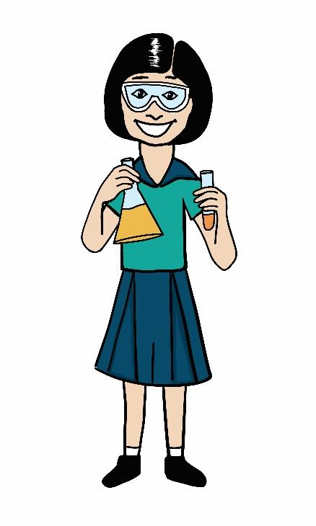
- Asset Registers
- Auditors Report – Annual report (Copy available on website)
- SUE Reports
- Annual Budget and Monthly accounts
- Associated policies, guidelines and procedures (Schooldocs)
- 10 Year Cyclical Maintenance Plan

Health and safety:
- Evacuation procedures
- Associated policies, guidelines and procedures (Schooldocs)
- Accident and medical Register
- Compliance Schedules
- Diocesan property inspection reports
- Building Warrant of Fitness – completed by the Diocesan agents.

Human resources:
- Job descriptions/Appraisal Documents
- Personnel and Curriculum Guidelines (Schooldocs)
- Performance agreements/Employment contracts
- Administration handbook
- School Parent Information Booklet
- Accident and medical register
- Staff professional development plan.

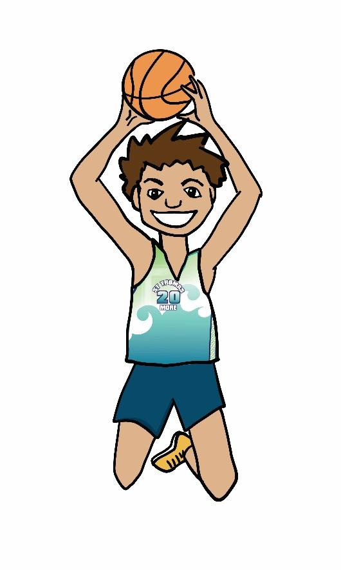
Kahui Ako – Rotorua Faith based Community of Learning.
- Memorandum of Agreement
- Strategic Plan 2024-5.
Property:
- 10 year Cyclical Maintenance Plan
- School Insurance – Crombie Lockwood
- Associated Guidelines including Health and Safety Procedures (Schooldocs)
- Compliance Schedules
- Evacuation Procedures
- Emergency Management Plan
- Capital Works schedule- CISO

Special Character:
- Religious Education ‘Faith’ Curriculum
- Proprietor’s appointees’ annual report to the Bishop.
- Newsletters, Diocesan magazine ‘ Kete Korero’

