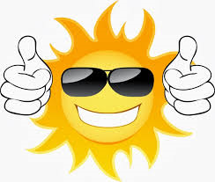
MĀPUNA SUMMER READING
Full name: Year/ Class:
What was the last book you read and enjoyed?

Have you read? (please circle)
GRAPHIC NOVEL BIOGRAPHY QUICK READ SHORT STORY

What’s your favourite movie or TV show?

What’s your favourite genre? (please circle)
ROMANCE FANTASY SCI-FI ADVENTURE ACTION SPORTS HORROR FRIENDSHIP

What’s your favourite book/book series?

Name your top 3 interests/favourite hobbies (please circle)
MOUNTAIN BIKING FASHION SKIING SURFING RUGBY DANCE SCIENCE MOVIES RACING CARS

Enjoy your summer of reading!
Māpuna Library Team

