
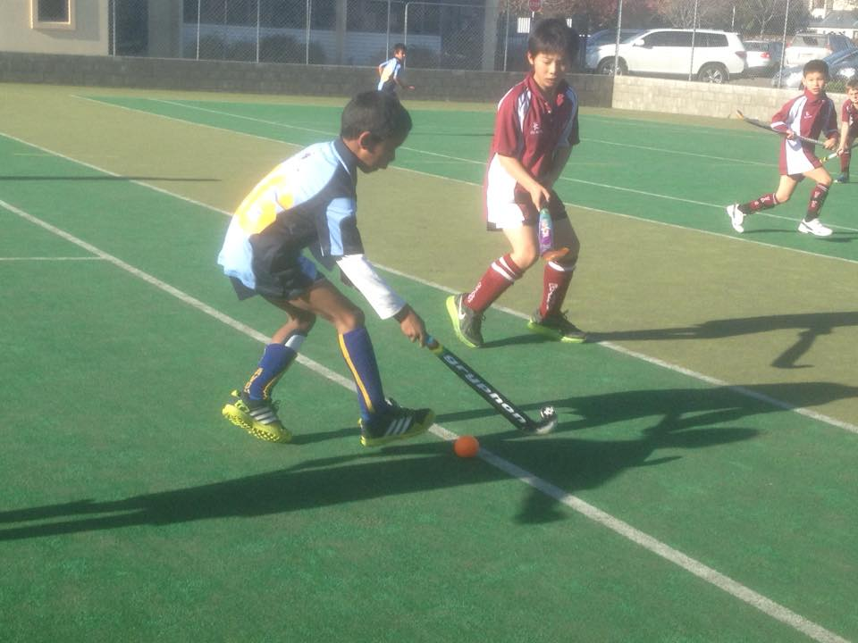
Avon/St. Michael’s
Junior Hockey Club
Avon/St. Michael’s Junior Hockey Club welcome players from all over Christchurch.

We offer hockey to all junior ages, from Year 1 right through to Year 8.

Come along to our practices and Trials @ Shirley Boys High School turf
Start Dates:
Year 7-8 Players: 14 March,
Boy’s: 5.30 -6:30pm, Girl’s 6.30 – 7.30pm
Year 5-6 Players: 21 March, 5:30-6.00pm
Year 3-4 Players: 21 March, 4:30-5:30pm
Year 1-2 Players: 2 May at 4:30-5:30pm
We offer a 12 week “fun sticks” course for these players

To register your interest;
- Junior Club Registrations online link https://goo.gl/forms/zhfeQhCyhfJUldaB3
- Contact our club Captain: Hugh Williams Email: juniors@avonhockey.co.nz
Also, check out our Facebook page: https://www.facebook.com/AvonSt.MichaelsHockey
Website: www.avonhockey.co.nz

