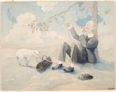
Ken
Lambs
Kennay Henderson

A Peaceful Sight to See

The reverend slumps under the maple tree
binding a necklace of wild flowers
bumpy horizon is all the eye can see
possibly sitting there for hours and hours

A young lamb keeps the reverend accompany
whilst licking his walking stick
It's fur the shade of snow
It's feet scraping the dry surface

Wilted flowers paint the ground
shaded by maple leaves
harmony fills the air
what a beautiful place to see

By Azaria King

