2019 Girls’ and boys’ football draw
Punctuality is very important - teams should be warmed up and ready to play on time.
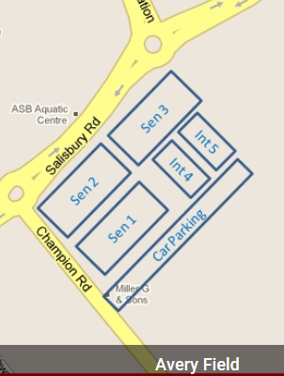

Groups
Boys Pool: Group 1  (11 a-side)  WIS 1  NIS  PREP  Golden Bay  Renwick | Boys Pool Group 2  (11 a-side)  WIS 2  BIS  Bohally  St Josephs  Buller | Girls Pool A (9 a-side)  1 BIS  2 NIS  3 GB  4 BOH  5 WIS  6 RENWICK

THURSDAY (Games are 20 minutes)
Thursday | Pitch 1 | Group | Pitch 2 | Group | Pitch 3 | Group
10 am | WIS 1 vs Prep | 1 | NIS vs Golden Bay | 1 | WIS 2 vs BIS | 2
10.45 am | BIS vs Buller | 2 | Renwick vs Prep | 1 | NIS vs WIS 1 | 1
11.30 am | Buller vs St Jo’s | 2 | Bohally vs WIS 2 | 2 | Golden Bay vs Renwick | 1
12.15 pm | NIS vs Prep | 1 | BIS vs St Jo’s | 2 | Bohally vs Buller | 2
1 pm | WIS 1 vs Golden Bay | 1 | NIS vs Renwick | 1 | WIS 2 vs St Jo’s | 2
A Medimax ambulance will be in attendance close by at Saxton Fields for any emergencies
GIRLS | Group | Pitch 4 | Pitch 5
10 am | A | NIS vs WIS | BIS vs Bohally
10 .45 am | A | Renwick vs GB | NIS vs Bohally
11.30 am | A | WIS vs GB | BIS vs Renwick
12.15 pm | A | NIS vs Renwick | WIS vs Bohally
1 pm | A | BIS vs GB

FRIDAY (Games are 20 minutes)
10 am | St Jo’s vs Bohally | 2 | WIS 1 vs Renwick | 1 | Golden Bay vs Prep | 1
10.30 am | BIS vs Bohally | 2 | WIS 2 vs Buller | 2
 | Semi Final 1 |  | Semi Final 2
11 am | 1st Group A vs 2nd Group B |  | 1st Group B vs 2nd Group A
 | Play Off Games
11.30 am | 5th Group A vs 5th Group B |  | 4th Group A vs 4th Group B |  | 3rd Group A vs 3rd Group B
 | Final
12.00pm | W Semi 1 vs W Semi 2

GIRLS | Group | Pitch 4 | Pitch 5
10 am | A | NIS vs GB | BIS vs WIS
10.45 am | A | Renwick vs Bohally | NIS vs BIS
11.30 am | A | GB vs Bohally | WIS vs Renwick

