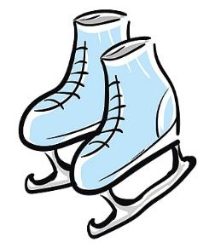

ICE SKATING TRIP TO TEKAPO
Friday 19th August 2022

VENUE: Alpine Springs and Spa Winter Park
FOR: Any student interested
DATE: Friday 19th August 2022
TIMES: Meet 10.30 at Tekapo
COST: Skating paid for by school
TRANSPORT: Parents are to transport their own children or make arrangements with other parents.
Staff will assist you with this where possible.
FOOD: Bring own lunch, morning/afternoon snacks, and drinks. Food can be purchased at the venue.
SAFETY: Please ensure all skaters are wearing gloves for hand protection. Cycle helmets are now compulsory for all skaters, so students must bring their own. We also recommend the wearing of warm clothing and advise a change of clothing.
Orange school vests must be worn at all times to identify our students.
SKATE FITTING: It is helpful for the staff if children are aware of their shoe sizes.
CANCELLATION: Listen to Port FM/ Classics Hits / 99FM / School Facebook page on the day for postponements

While there are other activities available on site at Tekapo (eg spa pool, snow tubing) these will only be
available to those children who are accompanied by their parents on the day. We will indicate to the provider
the number who wish to do these activities with parents after 2.00pm to ensure space is available.
These arrangements and payments will need to be made at the venue by parents.
Children who are not skating are to be at school on this day.

Many Thanks
Brenna

PLEASE RETURN THIS SLIP BY FRIDAY 12th AUGUST TO THE SCHOOL OFFICE

Name ________________________________________________________________

Number of children skating________________

Please indicate what level your child is skating at Beginner Advanced

I can / cannot provide transport for my child _________________________
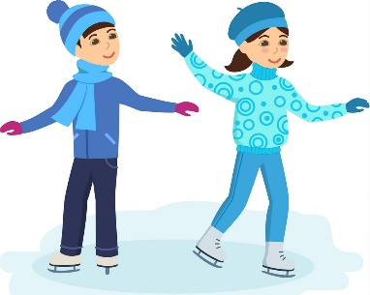
I can take ___________ extras (i.e. not including my own child) in seat belts

I am a licenced driver YES / NO

My vehicle has a current warrant of Fitness and is registered YES / NO

I will transport pupils in my car directly from school to the venue and return YES / NO

We would like to go snow tubing after 2.00pm @ (paid direct to the venue) YES / NO

Number _________________

Name: ______________________________________________ Date____________________________

Signature____________________________________________

