NEW BOOKS:
MARCH 2023

FICTION
The fifth in the very popular Robin Hood series, this fast-paced book sees the rebels hired by a billionaire to undertake the biggest hacking operation of their lives. The object? To locate some kidnappers…
218 pages, best suited to Years 9-10.

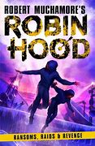
In this acclaimed story, when three boys follow local soldiers onto the moor and discover a cache of weapons, their rivalry develops into something dangerous and sinister…
304 pages, best suited to Years 9-11.
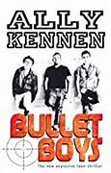

In this NZ adventure story, River is offered a trip on his uncle’s trawler with his cousin Huia. When an accident leaves them stranded, they must work together to get to safety.
163 pages, best suited to Years 9 & 10.

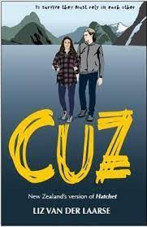

When someone close to Ava is murdered and she becomes the main suspect, she starts to wonder if the legends surrounding the curse on her town are true. One thing she is sure of? There is a killer on the loose, and they have a vendetta against her family…
400 pages, best suited to Years 9-11.
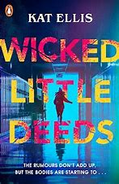

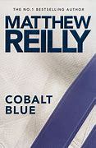
This short novel reads like a Marvel superhero movie. Russia and American each have their own superhero, but when America’s dies, Russia launches an attack. Which of the American superhero’s children can stop the annihilation?
208 pages, suitable for any age. Good for reluctant readers.

Tristan’s dad is a crim who wants his help to commit a robbery at Tristan’s school. He needs to pull it off to repay a bunch of dangerous people the money he owes them. However Tristan’s mum is a cop, and Tristan is torn between his loyalty to each of them…

256 pages, best suited to Years 9-10.
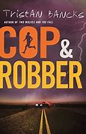

In Germany, 1941, Karl is looking forward to joining the Hitler youth. When he father is killed, he starts to question Hitler. What does it mean to be a good German, and who is the real enemy?
304 pages, best suited to Years 9-10.
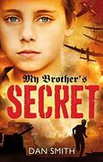

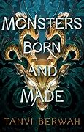
In this fantasy novel, Koral’s family are forced to capture monstrous maristags for the Glory race, a competition for the elite. The prize is gold and fame, and Koral needs the money for her sick sister. Her only option is to cheat her way into the race. Expect danger, action, corruption and intrigue!
352 pages, suitable for any age.

In this moving novel, gang member Shorty is trapped in the rubble of a Haitian earthquake. As he hopes for rescue, he reflects on his life in the slums.
337 pages, suitable for any age.
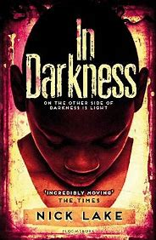

Saker is a member of The Clan, a group who hire out child renegades. There is no escape from The Clan. When he is sent to India on a mission he disagrees with, he finds himself on the run, and when he meets Sinter, he starts to dream of a different future.
256 pages, best suited to Years 9-10.
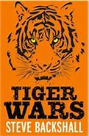

Hugh has a great future as a cellist, but he has a secret – he loves car racing. When his newly discovered grandfather Poppy asks him to go on a road trip, he reveals a secret that will unravel both of their lives.
228 pages, best suited to Years 11-13.
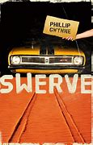

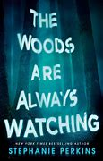
In this twisty horror, two girls go backpacking in the woods, and meet up with a serial killer. What happens next will test them in the worst of ways…

240 pages, best suited to Year 10 and up.

When two girls get caught in a blizzard and a man shows up at their cabin, they are immediately suspicious. When a fire forces them out into the storm, it becomes clear they are being hunted, and they will need to survive more than just the storm…
352 pages, suitable for any age.
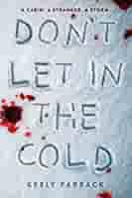

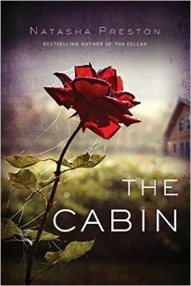
When six friends go to a secluded cabin and find two of their number dead by morning, one of them launches their own investigation. It soon becomes clear the group had many secrets, and a web of sins is revealed. Each of them is a suspect…
327 pages, best suited to Year 10 and up.

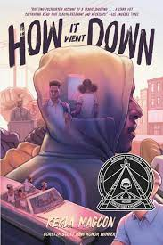
When teenager Tariq dies from gunshot wounds, there is a community uproar. Tariq was black and the shooter was white, and no two accounts of the incident line up. The truth continues to be obscured, and Tariq’s family and friends try to come to grips with how it went down. Great for personal response.

352 pages, best suited to Year 10 and up.

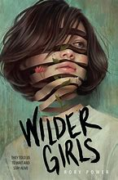
It’s been 18 months since the school was put in quarantine. Teachers died, students turned savage and the Tox makes the outside world dangerous. As they wait for a cure, the Tox takes more and more of them, and soon Hetty must braves the horrors of the outside to find her friend…

357 pages, suitable for any age.

NON-FICTION

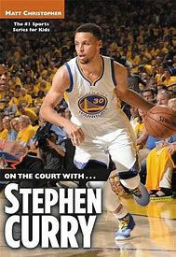
This short and simple biography tells the story of Curry, both on and off the court. Complete with photos and stats, it’s an easy but informative read.

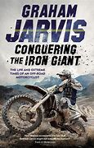
Jarvis has been at the top of off-road motorcycling for over 25 years. In this biography, he tells us where it all started, and how he became such a success at one of the most dangerous sports there is.

Born dirt poor, Dunlop went on to become one of the greatest road racers of all time. This is a great read for anyone interested in motorcycling, with a good dose of triumph, tragedy and humour.
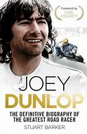

This is the inspirational and emotional story of the soccer team trapped in a cave in Thailand for 17 days. They were rescued against almost impossible odds by an international cave diving team.
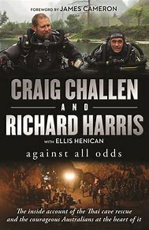

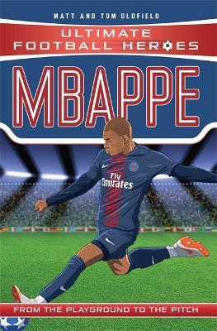
The Ultimate Football Heroes series are quick, easy reads about football stars. They follow the individual’s progression from the playground to the pitch. We have 18 books in this popular series.

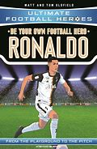
This is a pick-a-path book, with many possible endings. The reader must navigate their way through the world of professional football and make the right choices…

Balotelli is a man with a big reputation – not just for his skill and talent, but for his antics off the field. He has been described as unmanageable, and has had numerous run-ins with police. Here Caioli talks to his friends, family and teammates to try to get to the bottom of who Balotelli is…
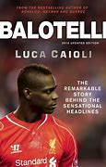

Rossi is one of the most loved motorcycle racers of all time. He has raced at Grand Prix level for over 20 years and he has seen it all. This is the definitive biography of the legend and the man.
