**School payments online with Kindo**

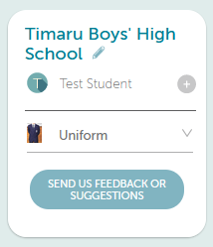

We are excited to let you know about on online Kindo school shop!

Uniform items are now available for purchase and we will be adding other things to our shop as the year progresses too.

It’s easy, convenient, and open 24/7 and available on our school website.

**Setting up an account**

Creating an account is easy!

[New Users can click here](https://shop.tgcl.co.nz/shop/q2.shtml?shop=Timaru%20Boys'%20High%20School) and select the Create an Account option. Simply follow the prompts and in three easy steps you are ready to go!

***If you already have an ezlunch or myKindo account***, you can simply log in.

**Payment**

There are a number of ways you can choose to top-up your account, and this can be done at the checkout, or by selecting the ‘top up account’ icon.



POLi No fees. Instant transfer. **RECOMMENDED**

Credit/Debit Card 50 cent charge + 2.5% fee. Instant transfer.

Visa / MasterCard / American Express and China UnionPay available.

Bank Transfer No fees. Allow 2 days for processing.

**Shopping**

Items can be added to your shopping cart, by clicking on your child’s initial next to an item.

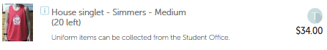

Once you have made all your purchases click on the ***Checkout*** option to complete your transaction.

If you have sufficient funds, then simply click ***Place Order*** at the checkout and you’re done!

If you have insufficient funds, you will be required to top up your account first.

Your order will automatically go through to the School, and you will receive an email receipt confirming your top-up and/or purchase!

**myKindo App**

myKindo app is also available to download for both android and iPhone.

 **Need assistance?** Our Kindo helpdesk is open 8am to 4pm weekdays.

**Freephone:** 0508 4 KINDO (0508 454 636) **Email:** [hello@mykindo.co.nz](mailto:hello@mykindo.co.nz)

**Online support**: [support.mykindo.co.nz](https://support.mykindo.co.nz/support/home)