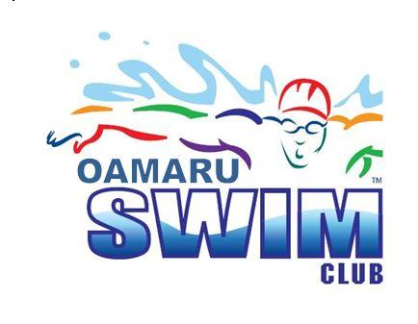

FAST and FURIOUS
Friday 21st May 2021
Warm up 5.30pm Start 6pm
Waitaki Aquatic Centre

All ages welcome!
Free to Enter!
Great opportunity to give racing a go!
Find out more about joining Oamaru Swim Club so you can attend swim meets!

Fill in an entry form with your name and swimming/squad level or age beside the events you would like to take part in.

Return forms to the Pool Reception by Wednesday 19th
or email fastandfuriousoamaruswim@gmail.com

