Rotary & InTERPLAST
A good News Story
For more information contact your Interplast District Chair or Interplast Rotary Engagement Coordinator Janette Etherington on janette.etherington@interplast.org.au

Motivated by altruism and a passion to see reconstructive surgery skills “spread where they are needed”, Dr Proudman spends hours late at night with Dr Sonam, assisting him to hone his knowledge.

Mindful of the time and experience necessary to complete a plastic and reconstructive surgery training program, Dr Proudman is currently working to enable Dr Sonam to travel to Australia, to continue training under his capable guidance, and further their shared dream of providing life-changing surgery to those who need it most.
Tim Proudman & Sonam Jamtsho in Bhutan before the pandemic
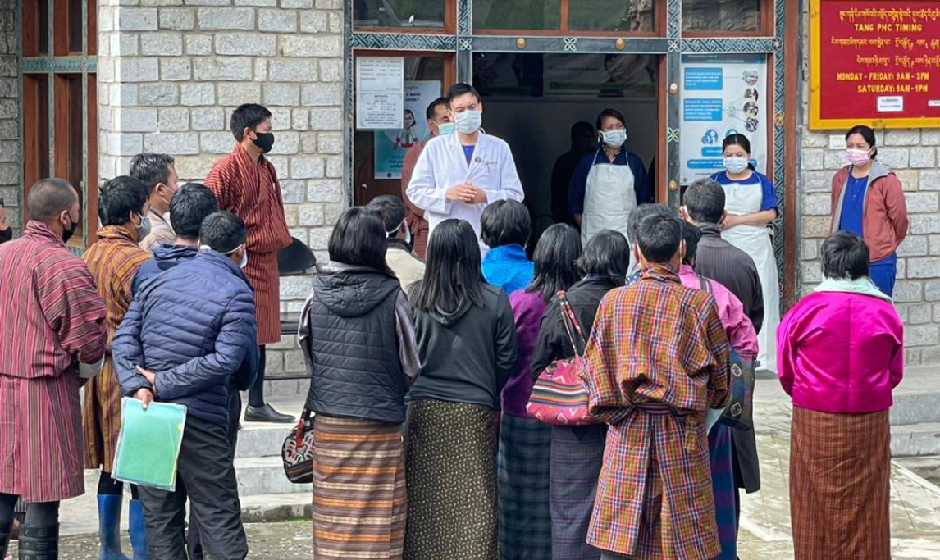
Dr Sonam in June 2021 talking to patients at the Tang health centre in central Bhutan, during an outreach clinic.
During the COVID-19 pandemic, Interplast and its volunteers across Australia & New Zealand continue to provide life-changing care to patients. Interplast is providing virtual training and remote mentoring to surgeons, anaesthetists, nurses, and allied health professionals in 24 developing nations.

With the support of Interplast and Rotary, doctors like Bhutanese Sonam Jamtsho continue to receive necessary training and mentorship, which enables him to continue changing the lives of Bhutanese patients in desperate need.

Motivated by a desire to make an impact, Dr Sonam credits his mentor, Australian plastic and reconstructive surgeon, Dr Tim Proudman, for pursuing a path as a surgeon.

“I had the opportunity and honour to work with Tim since 2015. One of the reasons I was so interested in plastic and reconstructive surgery is because of the work that I have seen the Interplast team do and how much change he has brought to the Bhutanese population,” Dr Sonam explains.

While Covid-19 has limited Dr Proudman from travelling to Bhutan, and Dr Sonam’s scope for clinical training, it has nonetheless provided an opportunity for collaboration and learning. Enabled by his relationship with Dr Proudman - Interplast’s country coordinator for Bhutan – the junior and his mentor have met online more than 60 times since March 2020. “He has been very instrumental despite the pandemic causing obstruction to my training, I have been receiving the training from his side continuously. He has done more than he has been required to,” Dr Sonam says.

