The Milky Way

Natures jagged cliffs rule Switzerland
Wind echos through the cracks
Big toblerone mountains
Keep growing taller

The Swiss Alps hide the clifftops
They blossom beneath the sunlight
Chocolate fingers with green tips look like they are beginning to crawl down the cliff face as if there is a piece
of chocolate at the bottom

The current gushes into the rocks like a river of warm milk
The waterfall is frothy like milk on a Nespresso Coffee
Crashes of the water are hissing

The sky is a bluey tinge with wispy Flat Whites scattered throughout the picturesque scene
Whistles of wind hitting my face
Marshmallow clouds start to roll over
Milky Chocolate shadows fall down

It’s the Milky Way

By Caleb Cottom

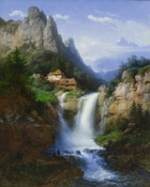
Swiss Landscape
Charles Euphrasie Kuwasseg

