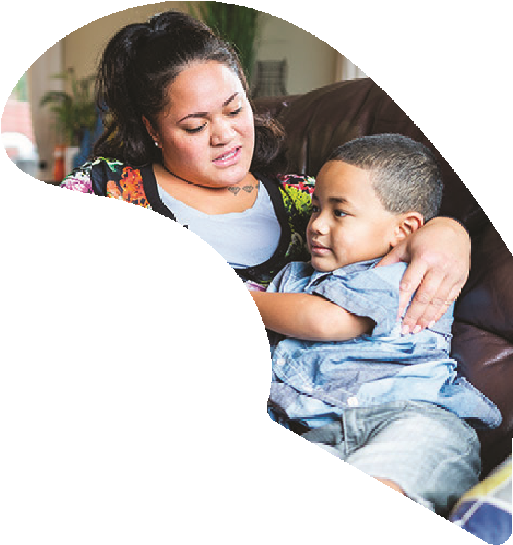

Free webinar seriesWhat’s Going On for My Child or Teen?
Do you want to help your child or teen who may be exhibiting challenging behaviours or experiencing distress?
Join us for this series of free webinars, presented by expert facilitators to learn strategies to support your child or teen. Parents, caregivers, teachers, and those working with children can gain the confidence and tools to address a range of issues that may affect children and teens. Attend the entire series or choose which webinars you’d like to attend.

The Importance of Self-Care and Self-Regulation
1

Wednesday 19 October, 7.00pm – 8.30pm
Gain an understanding of the importance of looking after yourself first, and learn tips and tools for self-care. Facilitated by Mel Johns.

Strategies for Challenging Behaviour
2

Tuesday 25 October, 7.00pm – 8.30pm
Explore what might drive challenging behaviour, and develop strategies that can be used when this behaviour arises. Facilitated by Catherine Gallagher.

Anxiety in Children and Teens
Contact
education@mherc.org.nz
or
0800 424 399
for more information
e
Register Her
Register at
mherc.org.nz
3

Tuesday 1 November, 7.00pm – 8.30pm
Develop your knowledge and understanding of anxiety in children and learn ways you can support them. Facilitated by Catherine Gallagher.

School Avoidance
4

Tuesday 8 November, 7.00pm – 8.30pm
Explore the issue of children avoiding school, discover how this is often linked to anxiety, and gain tools to address school avoidance. Facilitated by Catherine Gallagher.
(It is highly recommended that you also attend the session on anxiety as this is often a key driver of school avoidance).

Supporting Children and Teens Through Big Emotions
5

Wednesday 16 November, 7.00pm – 8.30pm
Gain an understanding of how you can support your child or teen who may be experiencing intense feelings. Facilitated by Sarah Drummond.

The Importance of Healthy Sleep Habits
6

Wednesday 23 November, 7.00pm – 8.30pm
Explore the importance of sleep habits and learn ways to establish healthy routines. Facilitated by Ruth Troughton.
Supporting Children and Teens in a Digital World
7

Wednesday 30 November, 7.00pm – 8.30pm
Consider the effects on children and teens living in a digital world and explore tools and strategies which can be used to have discussions about wellbeing and safety online. Facilitated by NetSafe.

