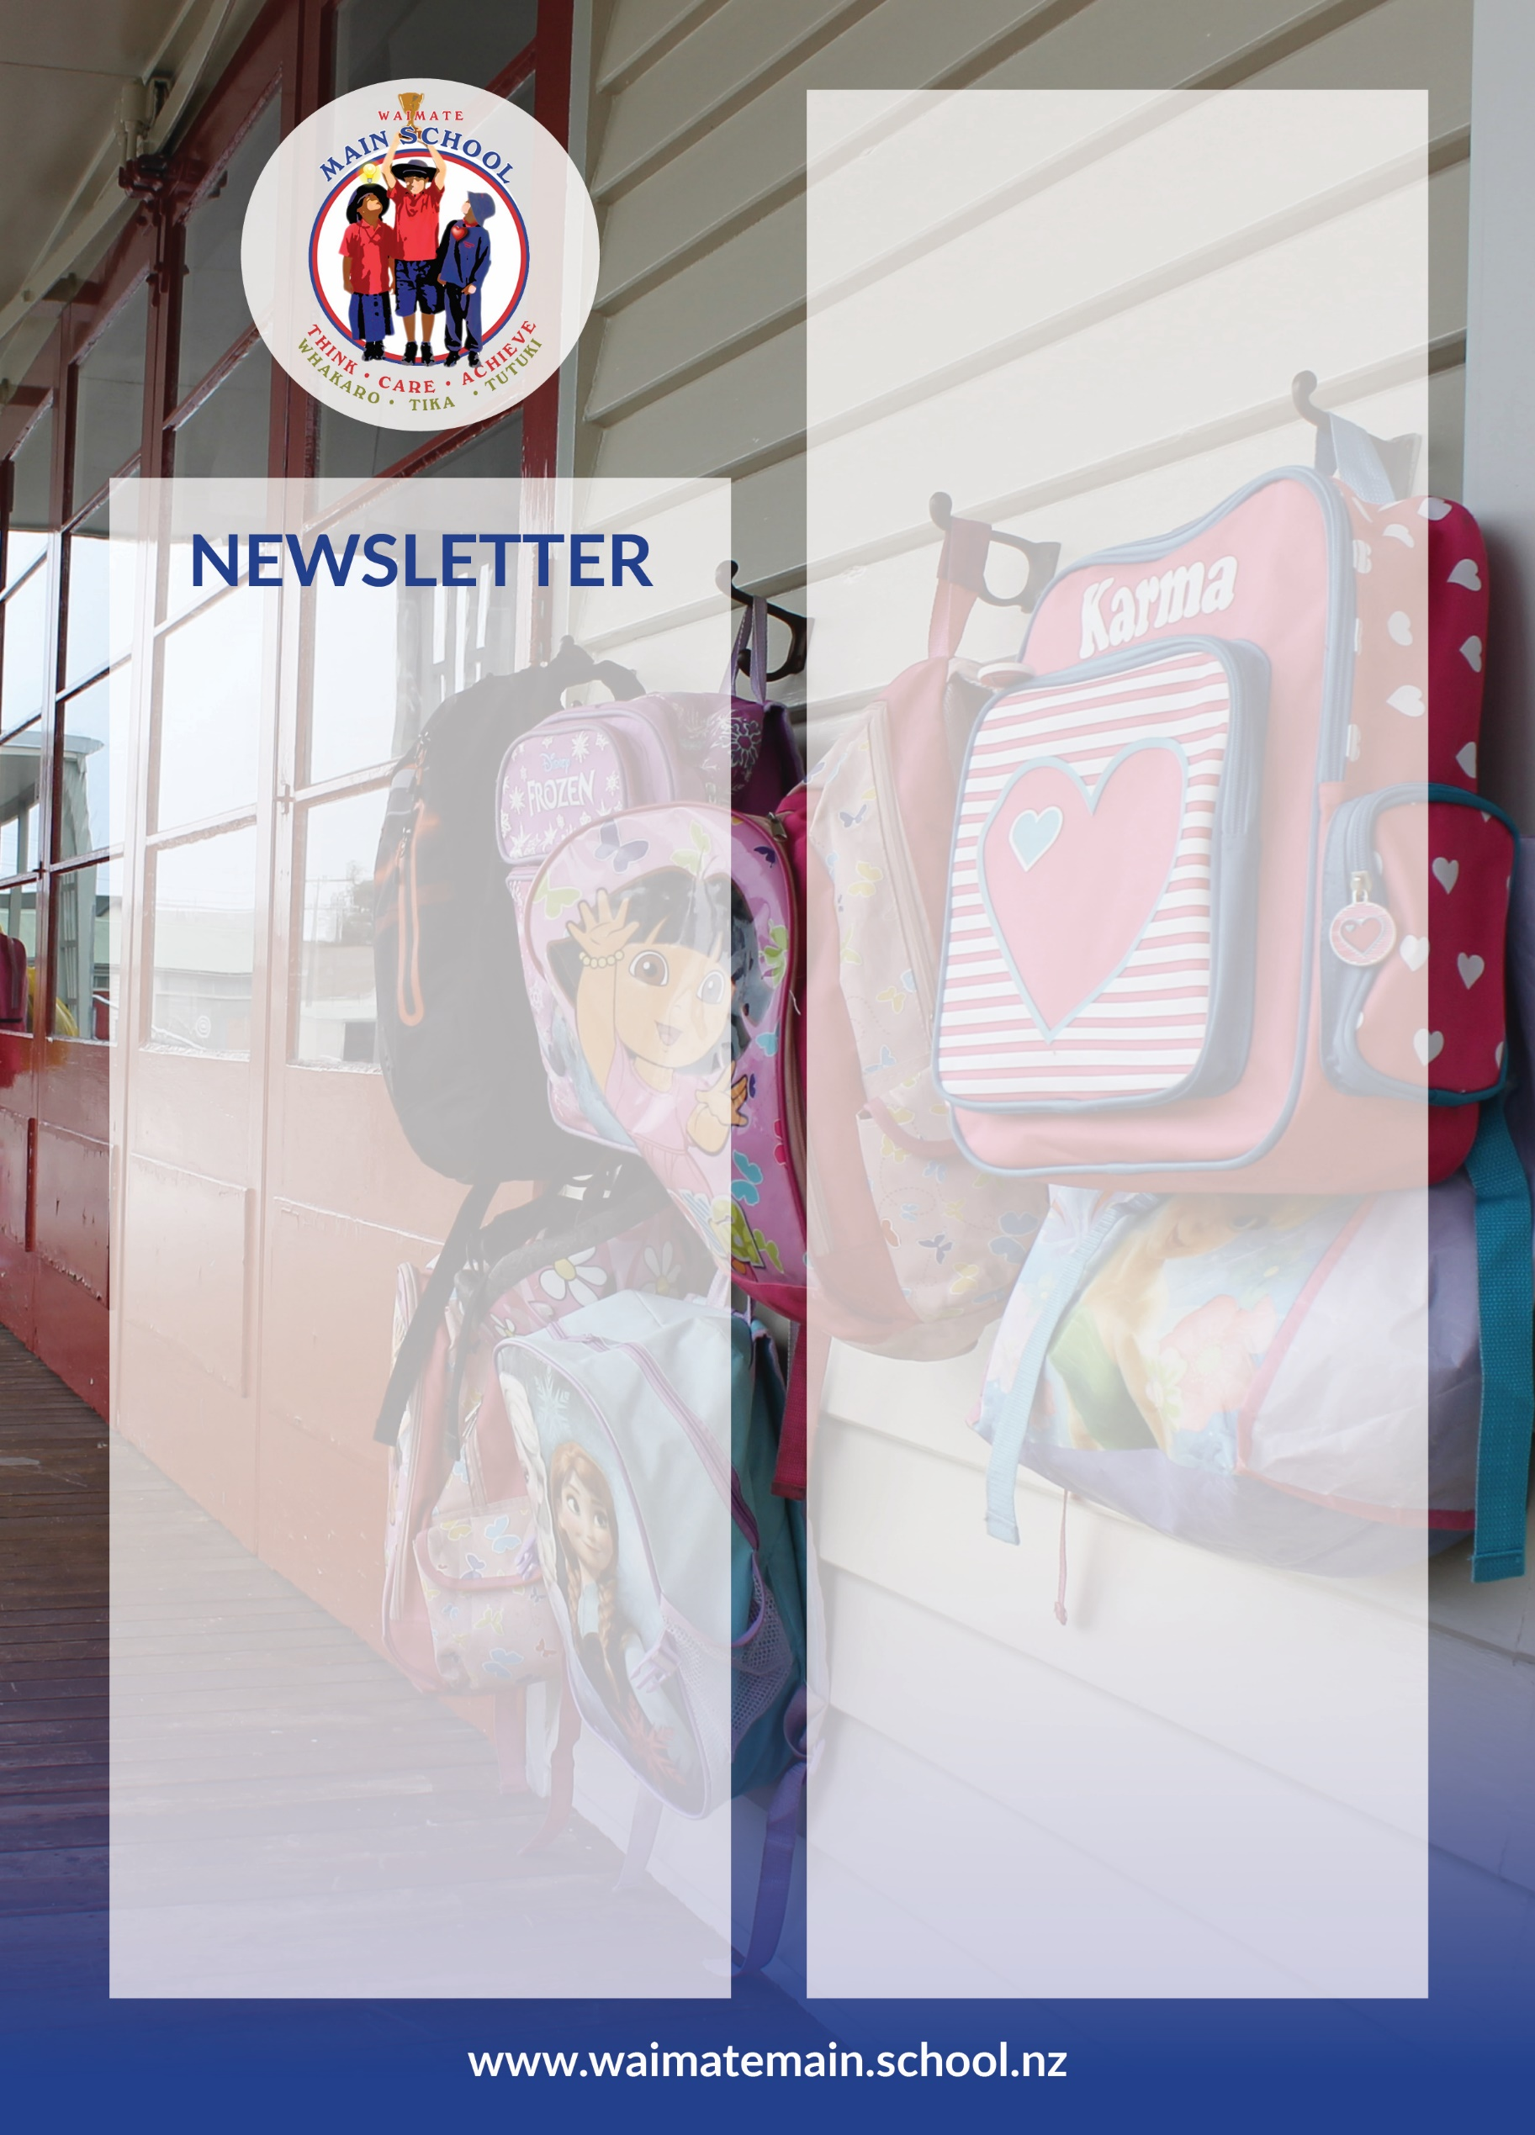

Kia Ora Everyone

Welcome to Week 1 Term 3 2021

Welcome back. We hope you had a fantastic holiday break with family.

On your return you will have noticed our 5th classroom, Kauri, which is occupying the space of the Parenting Hub and is now home to 14 junior students. Lauren Buckingham is teaching in Kauri and at the moment I am taking them for three afternoons per week.

We also welcome back Joanna Miller, who will be our Friday teacher in Pohutukawa, and also covering teacher release. It’s great to have her back, and I’m enjoying hearing her infectious laughter coming from the direction of the junior school!

On Monday we had a very successful teacher only day over at the high school, with around 120 people in attendance from all of the schools and ECE’s in Waimate. The focus was on cultural competencies, and on learning practical steps for how, as educators we can bring to life competencies such as manaakitanga, the process of showing respect, care and support for others. Thank you to you as parents for your patience around the school closures that day.

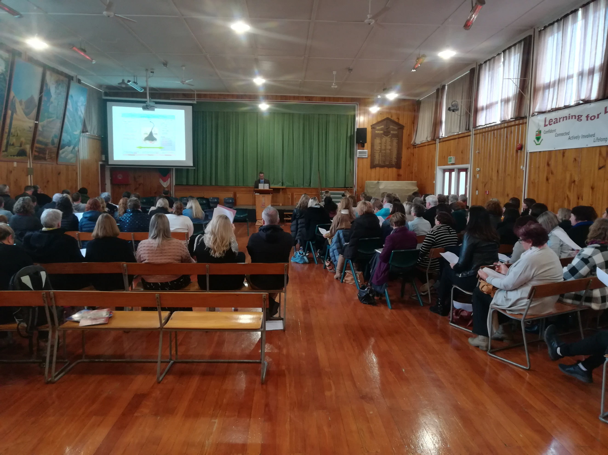

Healthy Lunches - Term 3
The healthy lunches are going reasonably well, with only a few hiccups, as expected. The menu is tasty and filling and designed to appeal to children. There are currently 8 different menu items, with more in the pipeline, which gives the children plenty of variety. So far the food is going down pretty well. Each day there are also two sides of either fruit, cheese, a biscuit or muffin.

There has been a wee bit of confusion around morning tea and food from home. So, to clarify - We are offering the children food at morning tea, normally fruit and/or a bar. They do not have to take this and can still eat from their own lunch box. At lunch time all of the children come over to the kitchen and are given a main meal and two sides. There is also heaps of extra fruit available for them to take If they are still hungry they can get something from their own lunchbox.

Parent Interviews
We will be holding parent interviews from 1pm on Wednesday 18th August. These will be a chance for you to speak to your child’s teacher regarding their mid-year progress and achievement as well as generally catching up on how they are going at school. We will be creating a booking link in the coming week. On the day of the interviews we would appreciate if the children could be picked up at 12:40pm if possible. If you are unable to collect them they will be in the hall with me for the afternoon.

Musical – Cinderella
We have booked the theatre in for Thursday 4th November, which is Week 4 of Term 4. This term we will be holding auditions for senior children wanting main parts, and we will be practising songs and dances. Closer to the time we will need lots of help with costumes, props, food and so on.

Covid Update - We are at Alert Level 1 which for us means… Heightened hygiene, and contact tracing. We have the contact tracing QR code displayed at the front office, and at every entrance to the school. Please use it if you are coming on site. If a child is sick, please keep them home. We continue to monitor the situation very closely and will communicate very quickly if there is a change to the alert levels.

Reminders

Attendance
We would consider a normal rate of attendance to be between 90 - 95%, with below 90% attendance classified as, ‘Cause for concern’, and below 80% attendance often leading to a referral to the attendance officer.
Egg Cartons needed – Please drop at the office

School Policy Review this Term

This term board, staff and parents will have the opprotunity to review our ‘Behaviour Management’, and ‘Concerns and Complaints’ policies.

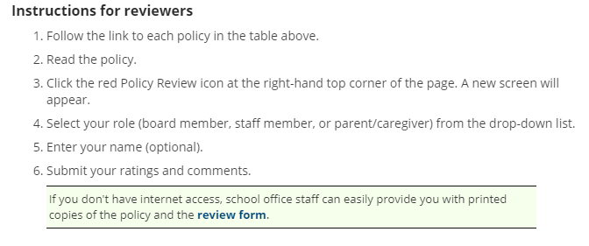

To review or read a policy at any time– Google School Docs (For all school policies and procedures)
User name – waimatemain
Password- thinkcareachieve

Key dates this term…

-Monday 26th July – Teacher Only Day – All of Waimate
-Tuesday 27th July – First day Term 3
- Friday 6th August – NZ Playhouse Theatre – Rumpelstiltskin
- Monday 9th August – BOT Meeting 4pm
-Friday 13th August – Pohutukawa Assembly
-Wednesday 18th August – Parent Interviews from 1pm
-Friday 20th August – Kahikatea Assembly
-Friday 3rd September – Totara Assembly
-Friday 17th September – Rimu Assembly
-Friday 1st October – Pet Day
Friday 1st October – Last day Term 3 2021

More dates will be added as we finalise things for Term 3. We are planning on running a weekend ski trip, and a trip to the Eco Sanctuary.

If you have any questions please come and see me anytime Monday to Thursday. On Fridays in 2021 I will be co-leading the Waimate Community of Learning off site.

Have a great week

Paul Cartlidge

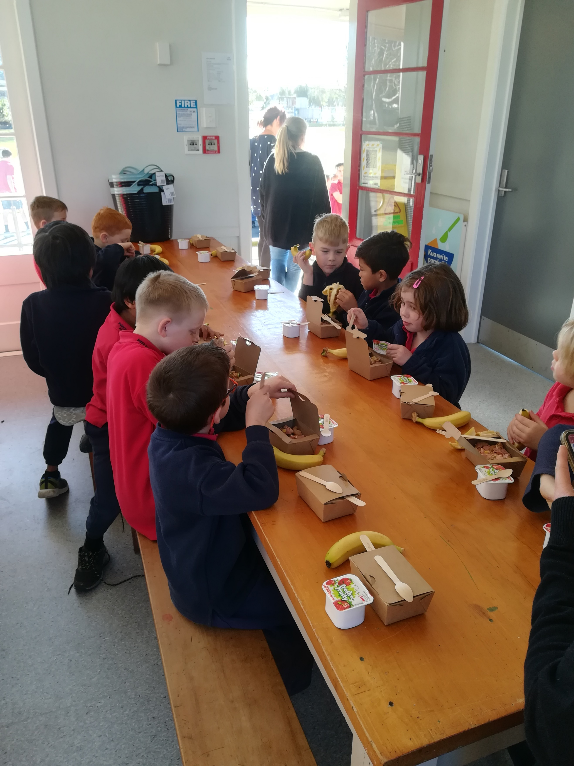
We are also educating the children around healthy eating as we are really wanting to see the end of highly processed, packaged food at school.

