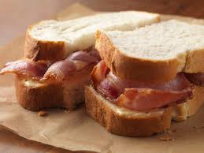

[10ECO]
same students from 10eco are doing are fundraising activity with all profits going to Maddy Collins. and we were wandering if your form class are interested in buying our bacon butty combos.

What it contains
.1bacon sandwich .1drinks
.1muffins all for $5 that’s a pretty good price. All of our profits are going towards Maddy Collins. we were hoping to do this by next Friday,27 of October before all senior leave. This will be ready at the end of assembly all order form and money need to be returned to Miss Shields by 2:30PM Tuesday 24 of October.

