

SCHOOL CANTEEN
PRICE LIST 2019

Sandwiches/Rolls
Beef/Chicken/Ham and Seasonal Salad | $5.00

Hot Food
Wedges | $3.50 |  | Spaghetti Bun | $2.50
Butter Chicken Wrap | $3.50 |  | Miso Soup | $2.50
Cheese Toastie | $3.00 |  | Nachos | $4.00

Cold Food
Muffin – Assorted | $3.00 |  | Cookie Time | $1.00
Juicies | $1.00 |  | Pop Corn | $1.00
Moosies | $1.50 |  | Rice Wheels | $1.00
Fruit Salad (Seasonal Fruit) | $3.50 |  | Yoghurt Pottle | $1.50

Lunch orders are taken in classrooms
at 8.40am each day

SUSHI YA PRICE LIST

Flavours for Sushi, Rice Balls and Half Rolls
- Teriyaki Chicken - Tuna - Crispy Chicken
- Teriyaki Beef - Salmon - Vegetarian

Sushi – 4 piece $4.50, 6 Piece $6.50, 8 Piece $8.50
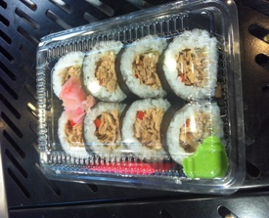
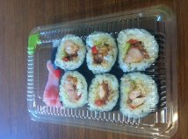
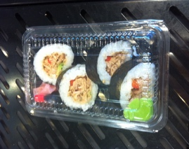

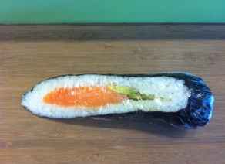
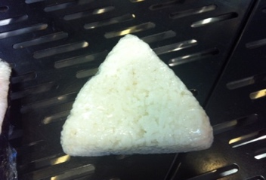
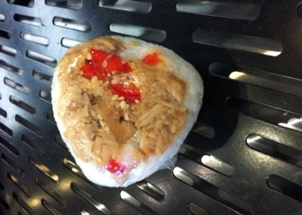
Rice Ball Half Roll
- Mini $4.00 $4.00
- Large 5.50

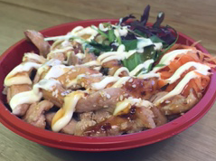

Mini Bowls $9.00
- Teriyaki Chicken
- Crispy Chicken

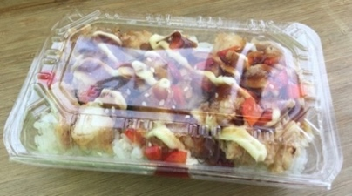
On Rice
- Teriyaki Chicken $6.50
- Teriyaki Salmon $6.50
- Crispy Chicken $7.50

Gluten Free option is available for all Sushi

