South New Brighton School
Thanks the below businesses for sponsoring our school app:





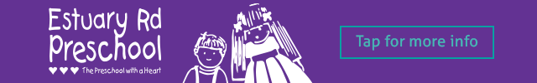







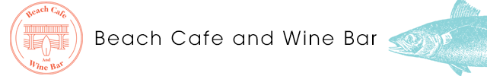













If you would like to advertise on the South New Brighton Skool Loop App please email Content@skoolloop.com

To download our app: In Google Play & App Store search
‘Skool Loop’ & choose South New Brighton School once installed.

