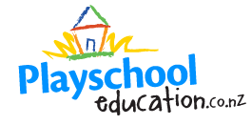

Do you have a family member, friend or private nanny who regularly looks after your child/children?
Did you know you could be receiving a childcare subsidy?! (Must have at least one child under 5)
Want to receive a fun educational activity monthly for your child, an art box full of fun art and craft materials and a first aid kit all FREE

Want more information? Check out our website www.playschooleducation.co.nz or send me an email jo@playschooleducation.co.nz

