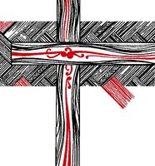
Te Korowai o te Rangimārie – The Cloak of Peace: cultivating bonds of affection through theologies for partnership and bicultural development.
Theological Colloquium: October 1 & 2, 2019
College of St John the Evangelist, Meadowbank, Auckland, NZ

What are the theological foundations of bicultural partnership? Te Pouhere, the constitution of the Anglican Church in Aotearoa, New Zealand and Polynesia, names partnership and bicultural development as an undergirding principle. Following the 2017 conference on Te Pouhere, St Johns College in Auckland invites papers that reflect on the nature of partnership. Papers are invited that draw from a range of theological disciplines: biblical, systematic, historical, pastoral, and contextual. Te Pouhere and the Anglican church is the primary context, but we welcome papers that offer a broader framework. Publication of selected papers is planned.

Please send an abstract of 300-500 words to Dr. Don Moffat (d.moffat@stjohnscollege.ac.nz) by 29th May. Papers should be 4,000 – 7,000 words in length, including footnotes.
The colloquium will convene at St Johns College, Meadowbank, Auckland, on the morning of Tuesday 1st of October 2019.

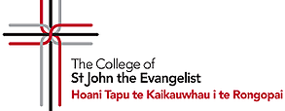
Contact: Don Moffat
Email: d.moffat@stjohnscollege.ac.nz
Ph. 64 9 557 0643

