Dear really swag elderly,

My name is Levi and I go to Nayland College. I have a cute little cat named Cosmo and I have a weird older sister. I live down the Marsden Valley and I love going on walks with my family. I enjoy playing football and gaming on my PS4.

Throughout self-isolation I have been going on walks and playing football out on my yard. I also have been playing on my PS4 with my friend Brock. I’m kind of worried about the whole COVID-19 thing but I'm sure it will go as quickly as it came. Most of the time if I get bored or lonely, I go and pat my cat or hangout with my family.

I hope you are doing well and remember that I am here for you. Are you having good sleeps? Are you feeling ok? I know that you can make it through this tough time. Here is a photo of my little cat Cosmo that will hopefully cheer you up.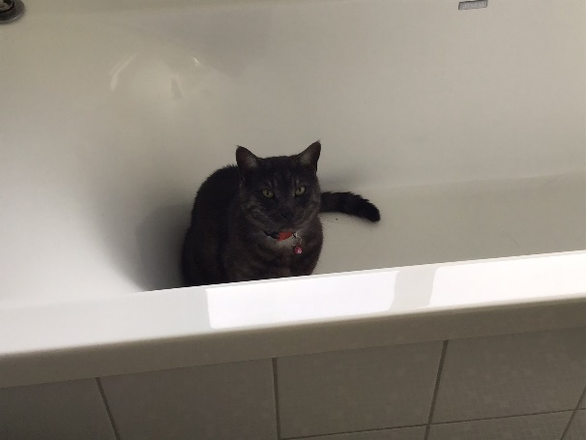

Kia Kaha. (stay strong)

From you swag friend Levi