

Welcome to Bluestone School

Bluestone School was created in 2005 following a district wide Education Review. Timaru West School and Timaru Main School were merged and Year 7 & 8 students returned after the only local intermediate was closed. Bluestone’s roll sits around 500 students.

The name Bluestone relates back to when Mount Horrible erupted and it oozed a layer of basalt or bluestone over the local area. This is depicted in a mural painted by senior students on the end of the Year 7 & 8 classroom block. Both Timaru Main and Timaru West had bluestone featuring in early building designs. Bluestone is now exported from our area and features in many modern buildings and pathways. So it seems appropriate that the current school carries the name of Bluestone to represent the solid foundation on which it is built, and to represent the bringing together of the best of the past with the best of the present.

Classes cover two-year age ranges. New Entrants/ Yr 1 (Te Tahi), Year 1 & 2 (Creative Creatures), Year 3 & 4 (Team Explorer), Year 5 & 6 (High Flyers), and Year 7 & 8 (Think Tank).

We have a strong school-wide approach to teaching and learning and to behaviour management. We believe school should be a great place of learning for students. We recognise that many students will have several jobs in their lifetime (many not yet thought of). Therefore their education needs to encourage and give them the skills to become confident and flexible problem solvers, utilising higher order thinking skills (able to analyse, apply, synthesise and evaluate). We expect learning to take place, where possible, in authentic settings so that students realise the purpose of their learning.

We invest heavily in teacher professional development because we believe the most important aspect of successful teaching and learning is what happens between students and teachers. We continually strive for improvement and quality.

We place a strong emphasis on numeracy and literacy, especially in the first four years. Bluestone’s library is well stocked and open to the students throughout the day including at lunchtimes. Adult and student librarians ensure that the resources are easily accessible. Chromebooks allow for students to access the web for research information.

Our school wide values of honesty, excellence, aroha, respect, and tolerance (HEART) are central to all that we do. They are reflected in student and staff actions and interactions.



HONESTY EXCELLENCE AROHA RESPECT TOLERANCE

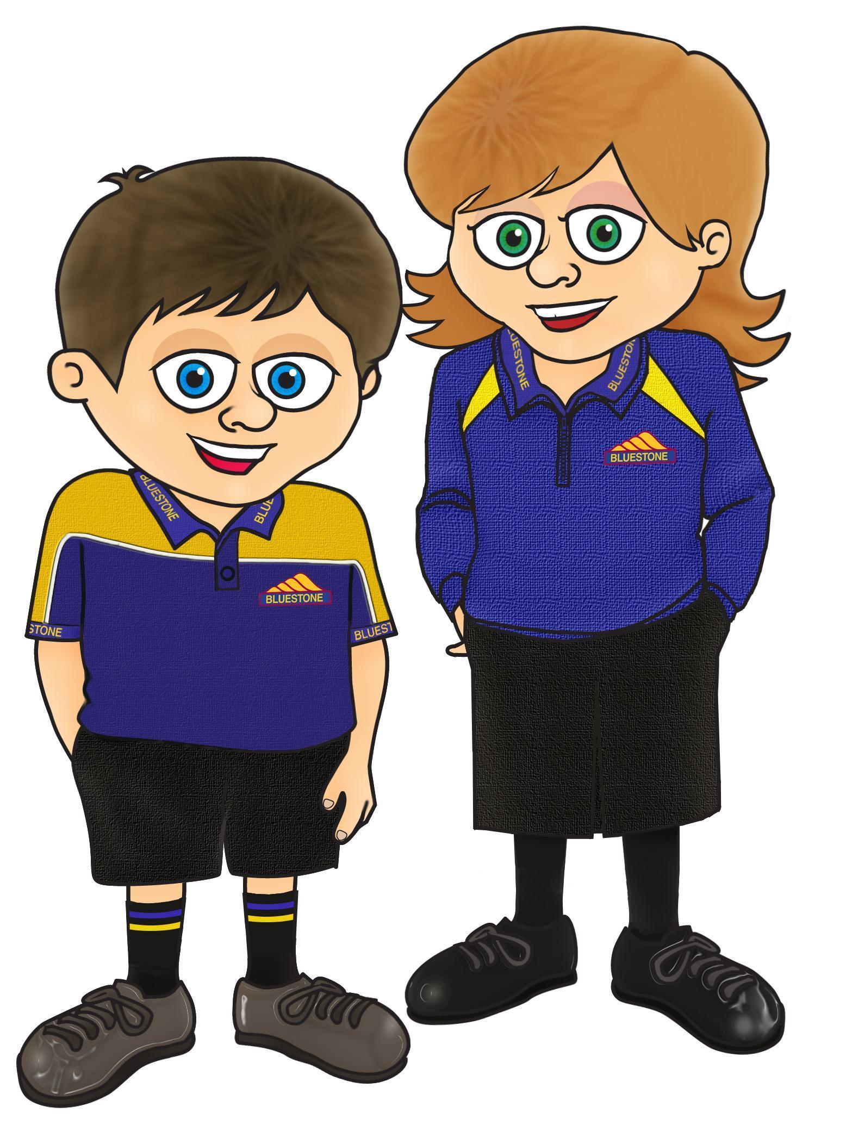
The Principal and members of the staff are always willing to make themselves available to discuss all aspects of your child's life at school any time you feel the need.

Parents should have no hesitation about telephoning or calling at the school to discuss any point concerning their child's education.

Inspiring creative, lifelong learners

We welcome you to come and look around Bluestone School. We are proud of what our students achieve and proud of the wonderful tone and family atmosphere present in our school.

Call our office on 684 3706 to make an appointment for a guided tour. Alternatively you can email admin@bluestone.school.nz. We look forward to meeting you and your child.

BLUESTONE SCHOOL Office hours: Monday - Friday 8.15am - 3.45pm
46 Raymond St, TIMARU
Telephone: (03) 684 3706

PRINCIPAL OFFICE MANAGER
Darren Smith Lindsay Welch
principal@bluestone.school.nz admin@bluestone.school.nz

COMMUNICATION

Our website www.bluestone.school.nz is full of up to date information. When you open our website there are two ways for you to find the information you need:
- By scrolling down the page you will find our school calendar and articles of information. You can also find publications such as our fortnightly school newsletter, publications for sport news and sport draws, library news, art, and music. Publications called Our Information, Our People, and Our Learning, will give you all you need to know about how our school runs.
- The second way to access information on our website is to click on the menu bar at the very top of the front page. This will quickly take you to our latest articles and publications.

To open an article or publication, simply click on the photo. Articles will have information to read and often there are related photos to enjoy at the bottom of the article. When there is a special event at school we usually have an article on the website or on our Facebook page that day. Many people enjoy the photos of their children that go with these articles

STUDENT MANAGEMENT SYSTEM - HERO
We use the HERO app for communication. It is important that you provide us with email addresses of whom you want to see these communications for your child. To set this up download the HERO app on your phone and put in your email address and set a password. All our community notifications will go out via this app, whether it is for sports teams, whole school, different classes or year levels. If you need any help accessing this please contact the school office for assistance.

HERO by LINC-ED

SCHOOL STAFF 2024
Principal |  | Darren Smith
Deputy Principal |  | Rebecca Hamilton
Deputy Principal |  | Georgia Jackson
 | Room 1 | Sharlene Heaphy | Year 1 / 2
Team Leader | Room 2 | Amanda Morgan | Year 1 / 2
Team Leader | Room 3 | Carmen Brown | NE / 1
 | Room 4 | Asher Bennie-Slocombe | NE / 1
 | Room 5 | Corinna Brook | NE / 1
 | Room 6 | Faith Turner-Walker | Year 1
Team Leader | Room 8 | Nikki Geddis | Year 2 / 3
 | Room 9 | Ashley Arthur | Year 3 / 4
 | Room 10 | Ann Schaab | Year 3 / 4
 | Room 11 | Georgie Mohuanga | Year 3 / 4
 | Room 12 | Beth Torrie | Year 3 / 4
 | Room 13 | Monica Genet | Year 7 / 8
Team Leader | Room 14 | Nicole O’Sullivan | Year 7 / 8
 | Room 15 | Kate Vaughan | Year 7 / 8
 | Room 16 | Gabriel Weibl | Year 6 / 7
 | Room 17 | Angus McKnight | Year 7 / 8
 | Room 18 | Macy Browning | Year 5 / 6
 | Room 19 | Ross Godwin | Year 5 / 6
 | Room 20 | Juliet Maude | Year 5 / 6
Team Leader | Room 21 | Phillip Barnett | Year 5 / 6
Part-time Teachers | Siobhan Wilsher, Erna Linyard, Rebecca Fennessy, Rebecca Shepherd, Pip Mcleod, Emma Morton, Courtenay Van Maastricht, Pip Cleverley, Inge Dirkzwager, Marilyn Ross, Hannah Sewell
Administration | Lindsay Welch – Office Manager  Julie Langford – Office Reception
Property Manager | Al Walker
SENCO | Emma Morton
ESOL | Emma Morton
Librarian | Amanda Hawker
IT Technician | Alex Towart
Teachers’ Aide | Jenny MacPherson, Lorraine Bennett, Dale McKay (Music), Jodie Stewart, Claire Hamilton, Michelle Foster, Kristy Davis, Mark Diehl, Claire Hargest, Mindy Stockwell, Amy Stewart, Lisa Hull, Kasey Thomson

ENROLMENT AT BLUESTONE SCHOOL - Pre-enrolment procedures
Enrolment at Bluestone School is governed by an enrolment scheme, details of which are available from the school office or on the Bluestone School website: www.bluestone.school.nz
Applications for out of zone places are called for each term. The exact number of places will depend on the number of applications received from students who live within the school’s home zone. The year group spaces available also depend on the current roll numbers.
Below is the information for out of zone applications for 2024
The board has determined that 48 places will be available for out of zone students in 2024 across all areas of the school. The exact number of places will depend on the number of applications received from students who live within the school’s home zone. We will continue to have 4 enrolment periods each year, to keep our roll healthy. Details of how applications are to be made:
Meet with the Principal, Enrolment form completed, Student’s Full Birth Certificate (Original), Immunisation record, Relevant proof of (in zone) address.
If the number of out of zone applications exceeds the number of places available, students will be selected by ballot.
- Details relating to the first enrolment period for 2024 as set by the Ministry of Education and in line with all other local schools are as follows;
Length of enrolment period: Wednesday 31st January - Friday 12th April 2024
Deadline for receipt of applications: Wednesday 11th October 2023
Date of ballot: Monday 16th October 2023
- Details relating to the second enrolment period for 2024 are as follows;
Length of enrolment period: Tuesday 30th April - Friday 5th July 2024
Deadline for receipt of applications: Wednesday 21st February 2024
Date of ballot: Friday 23rd February 2024
- Details relating to the third enrolment period for 2024 are as follows;
Length of enrolment period: Monday 22nd July - Friday 27th September 2024
Deadline for receipt of applications: Wednesday 22nd May 2024
Date of ballot: Friday 24th May 2024
- Details relating to the fourth enrolment period for 2024 are as follows;
Length of enrolment period: Monday 14th October - Friday 20th December 2024
Deadline for receipt of applications: Wednesday 14th August 2024
Date of ballot: Friday 16th August 2024
- Details relating to the first enrolment period for 2025 are to be set by the Ministry of Education, in line with all other local schools. This date is yet to be confirmed.
Length of enrolment period: Monday 27th January - Friday 11th April 2024
Deadline for receipt of applications: TBC - Date of ballot: TBC

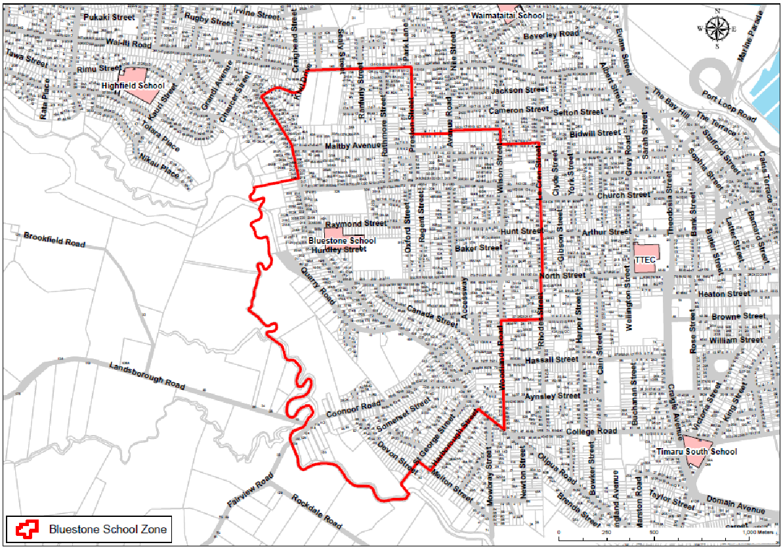
Boundary Streets

Kiwi Drive | 5 – 29 | 4 – 30
Wai-iti Road | 107 – 153 | 140 – 112
Preston Street | 3 – 49 | 2B – 60
Guthrie Street | 3 – 9 | 4 – 14
Avenue Road | 3 – 67 | 2 – 70
Lough Street | 3 – 23 | No houses
Wilson Street | 1 – 81 | 2 – 54
Mere Mere Street | 1A – 13 | 2 – 18
Le Cren Street | 19 – 139 | 14 – 134
Rhodes Street | 3 – 13 | 2B – 14
Archer Street | 17 – 27 | 24 – 38
Woodlands Road | 1 – 31 | 4 – 64
Otipua Road | 79 – 265 | 100 – 276
Harborough Street | 1 – 35 | 2 – 32A
Melton Street | 1, 1A, 3 | -
Devon Street | 2 – 56 | 1 – 53
Coonoor Road | 4 – 118 | 13 – 95
Quarry Road | 9 – 71 | 4 – 66
Watlington Place | 3 – 19 | 4 – 18

SCHOOL DAY
A morning bell goes at 8.45am for students to get to class which begins at 8.50am each morning.
10.00am until 10.20am morning break.
The lunch break occurs at 12.30pm until 1.15pm.
School closes at 2.50pm daily. 3.15pm clearing bell for all students to be offsite.
School closes at the usual time at the end of term and before long week-ends.
End of the school year Term 4 only finishes at 12.30pm

SCHOOL TERM DATES - 2024
Term 1 - 31st January (Wednesday) - 1st Day of Term 1
6th January (Tuesday) - Waitangi Day
28th March (Thursday) - Teacher Only Day
29th March (Friday) - Good Friday
1st April (Monday) - Easter Monday
2nd April (Tuesday) - Easter Tuesday
12 April (Friday) -Last day of Term 1

Term 2 - 29th April (Monday) - Teacher only day
30th April (Tuesday) - 1st Day of Term 2
31 May (Friday) - Teacher Only Day
3rd June(Monday) - King's Birthday Observed
28th June (Friday) - Matariki Holiday
5th July (Friday) - Last day of Term 2

Term 3 - 22nd July (Monday) - 1st day of Term 3
20th September (Friday)- Teacher only day
23rd September (Monday) - South Canterbury Anniversary
27th September (Friday) - Last day of Term 3

Term 4 - 14th October (Monday) - 1st day of Term 4
28th October (Monday) - Labour day holiday
15th November (Friday) - Teacher only day-Curriculum refresh
20th December (Friday) - Last day of Term 4

PUNCTUALITY, ATTENDANCE AND ABSENCE
We like students to be at school by 8.40am so that they can be ready for class at 8.50am and all their unpacking done. We prefer that students are not at school prior to 8.30am. If students are late we appreciate a phone call from you so that we know your child is safe and that the lateness is justified.

It is important for students to attend school regularly. Because we have your child’s safety as a focus we ask that you let us know if your child is going to be absent, explaining the reason and date you expect your child to return to school. This can be either by note, leaving a message on our answer phone, texting or by using the HERO App. If your child is away from school or late for any reason you need to contact the school before 8.50am to advise us of their absence. It is very important to advise us of the reason for the absence otherwise the absence is recorded as an unjustified reason and this information is also shared with the Ministry of Education. It is vital that we know where your child is and the reason for the absence so we can ensure your children are safe! Our school day starts at 8.50am and absences can be left on our phone before school by contacting 684 3706 or you can text 027 460 7149. Student absences that are not explained will be reported as truant.
So that we can be sure that students are not unaccounted for, we contact parents if a student is not at school by 8.50am if we are unaware of the reason. This takes up considerable time each day and slows down our response time so please help us to help you by keeping us well informed.

PRESCHOOL PRE-VISIT & ENROLMENT
Transition visits
After you have enrolled your child you will be contacted by Carmen Brown our New Entrant Team Leader to discuss your transition visits. These usually take place 3 weeks prior to your child starting school. A letter will also be emailed to you with the dates for the visits. If for any reason you do not receive a letter please contact the school office for details.

This is to introduce your child to the school, the class they will begin in and the teacher. Parents are most welcome to join us at this time. Parents enrolling children should make an appointment with the Principal prior to the visits. Please contact the school office for an appointment time on 684 3706. New entrants may be enrolled before their fifth birthday, but cannot legally attend school before that date.

A parent is required to provide an original Certificate of Birth before a child can be enrolled. This can be obtained from the Registrar of Births, Deaths and Marriages. A certificate showing immunisations completed should also be brought to the enrolment for viewing. If you are living within our school zone a current and relevant proof of address must be provided for every new enrolment. e.g. utility bill, rates bill, tenancy agreement etc.

MOVING TO A NEW SCHOOL
If your child is moving to a new school please inform the class teacher so that arrangements can be made to forward the necessary information to the next school. This will also allow us to gather up your child's belongings and the books etc. belonging to Bluestone School.

ENROLMENT AT SECONDARY SCHOOL
Both Year 8 students and their parents are given the opportunity to visit secondary schools in the Timaru area to familiarise themselves with the new school, its buildings, teaching programmes and environs, before enrolling. Secondary schools are given year 8 contact details to enable them to invite parents and students to visit the secondary schools.

SCHOOL GUIDELINES

Students must not leave the school grounds during the school day without permission.
- Parents are asked to name children's clothing and underclothing.
- Approved bicycle helmets must be worn whenever bicycles are used to and from school, and on school activities. It is recommended that helmets be worn when scootering too.
- It is recommended that students are not to bring lollies, chewing gum, matches, expensive toys, jewellery, or guns of any description to school.
- Students are expected to make their way home at the end of the day, with the exception of any teams or groups who may have practices. All students not involved in practices must be off school grounds at 3.15 when the clearing bell rings.
- Parents/caregivers who wish to take their child/ren out of class early will need to ring or come to the school office to gain a leave early pass which needs to be handed to the teacher on collection of your child.


RIDING CYCLES TO SCHOOL
Students shall be in Year 5 & 6 before riding a bicycle to school. This expectation arises from concerns over the safety of students. We do not believe younger students can accurately judge the speed of vehicles on the road or react quickly enough on our busy streets and roads.If a parent chooses to override this school expectation, then the school requires a letter from parents acknowledging total responsibility for the child’s safety. All students shall wear safety helmets when riding to and from school.We recommend that students riding scooters to school also wear helmets.It is illegal to ride a bike on the footpath. Doubling is illegal.

AFTERSCHOOL CARE PROVIDERS
If your child/ren require after school care there are a couple of providers that pick up from our Bluestone gate. For more information go to Mash Programme - mashkids.co.nz, or email info@mashkids.co.nz Chipmunks - ph 688-8848, timaru@chipmunks.co.nz or chipmunks.aimyplus.com Arrangement for these programmes are parents responsibility, if children are booked in for these services it is also recommended that if your child is absent from school that you contact your provider and advise them of this.

LOCAL EMERGENCIES
Evacuation practices are held regularly to acquaint students with what to do in an emergency such as an earthquake or fire.Should a major disaster occur students would be cared for at school by the staff until it is deemed safe to send them home. Then they will go in groups under the care of a teacher.

MISPLACED PROPERTY
Articles found in the playground are returned to their owners if named. We return named articles of clothing. If clothing has no name a lost property rack is located by the hall.

SICK STUDENTS AT SCHOOL

As the school can not provide adequate attention for a student who becomes sick at school the parents are contacted and asked to come for the child.If your child is to have medication while at school the class teacher must be informed. It is school policy for staff to supervise the administering of medications at school. Medications for allergies are stored in the sick bay with necessary instructions.While we take the utmost care to prevent accidents they will happen. To assist us please help us keep our records of parent phone numbers, emergency contacts and family doctors up to date.

Regular Medication:- We ask that you sign a form available from the office before we distribute regular medication

LUNCH ORDERS
Tuesdays - Spud Supreme $6.50 Order online @
https://spudssupreme.nz/order/schools/ Other options include: pies, cheerios, wraps, filled sausages, nachos.

Wednesdays and Thursdays
Butter chicken pie $6.00
Sausage roll $4.50
Potato top pie $5.50
Mince pie $5.50
Falafel wrap (vegetarian) $5.00
BBQ pork rib burger $6.00
Chicken slab pizza $5.50
Cookie caramel slice $3.50
Lasagna toppa $4.00
Crumbed satay chicken salad $5.50
Mince & cheese pie $5.50
Chicken burger $6.00
Beef Burger $6.00
Baked potato $5.00
Bean nachos $5.00
Chicken sandwich $5.50
Vegetarian sandwich $5.00
Ham roll $5.50
Chicken salad $5.50
GF Cheese & Rice Crackers $3.00
Original Cheese & Crackers $3.00
GF Beef burger $6.50
GF angus pie $6.50

You can order your favourite lunch meals and snacks from Thomas House’s menu through ezlunch. Orders are made online through your my kindo account. One account for the whole family. Get started – go to www.mykindo.co.nz or www.ezlunch.co.nz to start ordering. Orders close at 9:00am on the day of delivery, so book ahead.


SUBWAY ORDERS – Friday only
$6.00 | A six inch roll  An apple  A cookie
$10.00 | A twelve inch roll  An apple  A cookie

BLUESTONE SCHOOL UNIFORMS/OTHER COSTS:
Eftpos is available at school - Online payments are accepted or set up an automatic payments, 03 - 0887- 0229331 - 00

Girls:Black skirt, Black shorts (Bluestone black shorts with logo, or plain black cotton drill or rugby knit), Black Culottes, Black Trackpants (fleece or taslon), Bluestone polo shirt, Bluestone sweatshirt or Polar Fleece, running shoes, black shoes, sandals for summer, bucket style navy sunhat. Plain black tights or leggings may only be worn under skirt/ culottes.

Boys:Black shorts (Bluestone black shorts with logo), Black Trackpants (fleece or taslon), Bluestone Sweatshirt or Polar Fleece, running shoes, black shoes, sandals for summer, bucket style navy sunhat. Plain black tights or leggings may only be worn under shorts.

Other:Black shoes or sandals (in the summer months) are also an option for boys and girls.
Students are not to wear slip on casual or fashion type shoes.
Navy or black thermals or undergarments are permitted underneath. See link for these at the Warehouse: https://www.thewarehouse.co.nz/c/clothing-shoes-accessories/kids-clothing-shoes/kids-thermals
Items available at the school office — Yes we now have Eftpos (other items are available at The Warehouse):
- Polo shirt $30.00
- Polar Fleece $55.00
- Sunhat $ 7.00
- Black shorts with Bluestone logo $25

Representative Sports Uniform - Bluestone jacket and Bluestone sports tops/ bottoms/ dresses are provided on loan from the school for the duration of the event/ season and must be returned by the following Monday after the event/ season has ended. This uniform is not for general school wear.

House Group Uniform - House group shirts are to be worn on house/ sports events as arranged by the school in advance. Normal school shirt to be worn for the remainder of the school day. The house coloured tops/bibs are to be worn when required, they are provided by the school and are to remain with your class teacher.

Sunhats - School sunhats are available at school for $7.00 each. Sunhats are compulsory in Terms 1 & 4. No hat - no play.

Shoes - Shoes that the children wear to school must be suitable for school, the weather and physical education. Gumboots can be worn to and from school but children must bring something to change into. Gumboots, jandals or fashion shoes are not school uniform.

Special Notes - Students are not permitted to wear makeup, jewellery or nail polish. One pair of plain stud earrings only are acceptable.
We ask that any student with long hair has this tied back in order to avoid the catching or spreading of head lice.
Head bands should be school colours or plain navy, black or brown. Hair ties should be plain coloured. Big, brightly coloured bows are not part of our school uniform.
Cultural or Religious items may be worn if discussed with and approved by the Principal.

YEAR 7/8 TTEC FEE

Students are bused to and from Bluestone to our Technology Centre which is on the corner of North Street and Grey Road. There is an annual fee of $61.00 for Year 7/8 students who attend TTEC this is to cover the cost of the take home component.

EOTC (Education outside the classroom)
Costs may be asked for to help with travel and overnight accommodation.

SPORTS TEAMS
All students who play for a Bluestone Sports Team will be charged a fee. This fee is to register your child with the sports association and cover affiliation fees. Each sport will have a fee to pay before the season starts.

SCHOOL FINANCE
The Board of Trustees receives a bulk grant from the Ministry of Education which is supposed to pay for everything connected with the school except teachers’ salaries.

Additional fund raising is necessary if extra equipment and facilities are to be provided. Two main sources of this income are fundraising activities and voluntary contributions. The Board of Trustees received an additional grant, so there will be no family donations requested, voluntary contributions towards travel, food, accommodation can be requested.

The Home and School will decide on major fundraisers throughout the year. Your support is most appreciated.

BLUESTONE SCHOOL BOARD
The school operates under the direction of the Bluestone Board who are responsible for setting policy and overseeing the work of the school. The Board consults with parents when preparing policies, and is always interested in parent’s views about the operation of the school.

Our School Charter details the Board's responsibilities and the strategic direction of the school - a copy is available at the school office for you to read.

The Board holds monthly meetings 8-10 times per year and anyone interested is most welcome to come along. The dates and times of meetings are mentioned in the school newsletter.

The minutes once approved at the following meeting are available at the school office.

Members of the Bluestone School Board are as follows:

Presiding Member | Tess Taylor
Secretary | Lindsay Welch | 684-3706 School
Treasurer | Davinia Howard
School Principal | Darren Smith | 684-3706 School
Parent Representatives | Rachel Fenwick  Noeline Codyre  Kelly Karton  Rebecca Rush
Staff Representative | Kate Vaughan | 684-3706 School

HOME AND SCHOOL
Bluestone has a supportive Home and School group who work tirelessly to ensure that students and staff are provided with a great environment for teaching and learning.

The Home and School holds regular meetings for parents and teachers. If you are interested in supporting the Home and School with your help please support us by attending meetings or contact the President.

President - Naomi Bastion
Vice Chair - Kelly Karton
Treasurer - Julia Wheatley

DEPARTMENT OF HEALTH

This is intended as a guide to you now that your child has started at primary school.
District health boards are responsible for providing programmes for the early detection of health abnormalities, surveillance and the health needs of children at school.
The health education syllabus is implemented by schools with assistance from District Health Board personnel. Parents experiencing difficulties with child health services should contact the general manager of the local area health board.

Hearing and Vision Tests are carried out in the primary school and maybe repeated at a later stage during the progress of pupils through the school years. At any stage, testing is undertaken for children suspected of having hearing or vision difficulties, and you should ask for a test for your child if you are worried at any time. You may contact the Technician Ann Rooney at Ph 684-1545.

Immunisations: If your child has not completed the full immunization programme for pre-school children and you want it completed, contact your family doctor or practice nurse, the child health nurse or the area health board so that immunization can be started as soon as possible.

Specialist Child Health Clinics are available in some districts. A child may be recommended by the school or family doctor.

Health Camps accommodate children aged 5-11 years who have special health problems. Usually recommendations for admission are made through the school, the public health nurse and the family doctor.

Dental Treatment - Our Dental Therapist visits our school twice a year for an assessment. If treatment is required, an appointment will be made to attend the Community Centre on Woollcombe Street, Timaru. Phone: 687-2640

The Public Health Nurse visits our school on a regular basis. If you have any queries about your children’s health or wellbeing you may wish to seek help or advise from the nurse. You can contact the nurse directly yourself or through the class teacher or Principal, who will arrange for you to complete a referral form for the nurse to contact you. It may also be that the classroom teacher may ask the nurse to follow up a health query with you.

Our current health nurse is: Judy Cooper
Public Health Nursing Service
Health South Canterbury
156 Otipua Road
TIMARU
Ph 027 200 9495

EDUCATIONAL PROGRESS
Special Education psychologists render valuable assistance by advising on problems of progress or behaviour. Their services are available through the school, your family doctor, or directly to their office.

SOCIAL WORKER IN SCHOOLS

Bluestone has the valued services of a social worker in schools. Referrals can be made by parents, staff, or by the students themselves. Contact or detail can be obtained from the Principal or from the school office. This service aims at supporting students and their families.
Sharyn Dunn and Matt Cameron are onsite during the week, please ask your class teacher or administration for referral forms.

NUT FREE POLICY
Bluestone School aims to provide a safe environment for students and staff with allergies by identifying and minimising risk, being prepared, and raising awareness. Allergies are common and can result in a range of reactions from mild to life-threatening. We support students with allergies to participate in the same educational and recreational activities as their peers.
We have children within our school who currently have nut allergies, some of which have life threatening reactions should they come into contact with nuts.
We have been strongly advised by medical professionals to implement this policy for the safety of these children attending Bluestone School.
The Bluestone School Board would appreciate your help in keeping our students safe from a nut reaction by eliminating all nuts from your children's lunch boxes.
This includes all items that contain nuts (I.e. peanut butter sandwiches, nutella, some muesli bars, home baking etc.)
We thank you in advance for your cooperation with this and keeping our tamariki safe.

Bluestone School Board

PB4L - POSITIVE BEHAVIOUR FOR LEARNING
PB4L-SW (School wide) is a new system introduced to Bluestone this year. The focus is on catching students doing the right thing and acknowledging positive behaviour.
There will always be a time and/or need for management and consequences for negative behaviour but we are striving to acknowledge those students who do the right thing. Being a positive role model for their peers is the most powerful way to guide behaviour of those still learning. Each time a student is 'caught doing the right thing'.
The Positive Behaviour for Learning School-Wide framework, also known as PB4L School-Wide, is helping New Zealand schools build a culture where positive behaviour and learning is a way of life.
PB4L School-Wide looks at behaviour and learning from a whole-of-school as well as an individual child perspective. The framework which is based on international evidence can be tailored to your school’s own environment and cultural needs.

It’s not about changing the students; it’s about changing the environment, systems, and practices you have in place to support them to make positive behaviour choices.

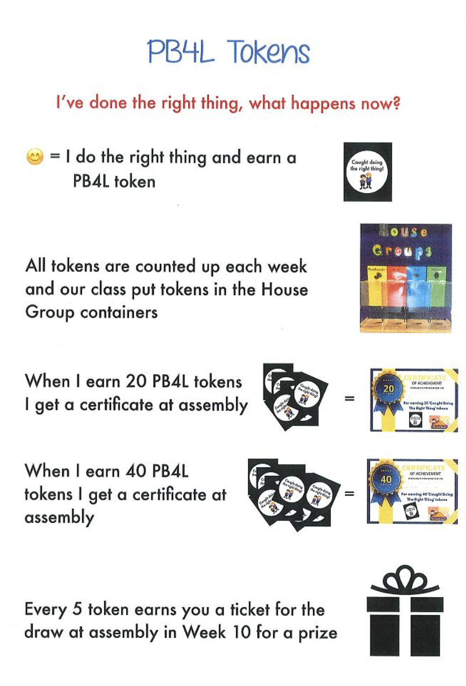

KiVa
KiVa (meaning ‘kind’ or ‘nice’ in Finnish) is a bullying prevention programme developed at the University of Turku in Finland, and now established in many schools around the world.
Essentially KiVa is a whole-school approach with three main components:
- Prevention – classroom lessons.
- Intervention – a process for dealing with bullying incidents.
- Monitoring – including annual student surveys.
These elements, together with teacher training and school commitment, form a successful framework.
Our school is a KiVa school and as such all teachers and students will engage in the lessons from the KiVa programme following the school delivery timeline. Any incidents of bullying will follow the KiVz referral process in place.

Every child in the school will receive KiVa lessons designed at their level. If incidents of bullying are identified they are then referred to a team who will follow a process to support the bully/bullies through changing their behaviour. KiVa is not a programme that repairs relationships but rather focuses on what needs to change. Parents are informed if their children is referred to the KiVa team for bullying and parents can refer their child if bullying is disclosed at home.

Judge Becroft, New Zealand's Commissioner for Children has highlighted the fact that New Zealand has one of the worst levels of bullying, youth suicide, and domestic violence in the world. This is not a record we can be proud of and we all need to do something positive to address this. Judge Becroft put a challenge out to all schools in New Zealand to get behind this issue. Bluestone School accepted the challenge becoming involved in KiVa in 2018. Like Judge Becroft, we believe our children deserve a safe school environment and healthy, supportive relationships.
KiVa originated in Finland and now exists in schools in many countries in the world with the research and data collected showing it really does make a positive impact in reducing incidents of bullying. The data is in from schools involved in KiVa in New Zealand and in all cases this shows there has been a successful reduction in the cases of bullying. This is great news and speaks volumes about the programme.
Online games that back up the messages from the class lessons follow on and parent support material helps to reinforce the messages at home.
Bullying is defined as intentional and repeated harmful behaviour. Bullying can take many forms: for example it can be verbal (name-calling, constant unkind remarks), physical (hitting, pushing), relational (social exclusion, spreading lies or rumours), or material (breaking or taking someone's belongings). When harassment occurs via modern communication technologies, such as mobile phones or the internet, it is called cyberbullying or electronic bullying. This relatively new form may include posting/circulating embarrassing photographs, sending nasty e-mails or text messages, or mocking the target on a social media site. Because it is so new we feel education around this is essential.



PERSONALISED ACTION PLAN FOR STUDENTS WITH ASTHMA

Teachers should help to ensure that students with asthma have a personalized action plan. This is kept in the medical room located in the administration area.

- Students name: _________________________________ DOB: __________

Asthma Symptoms (please describe in detail): (Example: My child usually has very mild symptoms twice each month; attacks can be severe and usually occur about three times each year; never in hospital with asthma: my child has severe asthma and has been hospitalised with asthma 3 times; asthma only is cooler conditions etc)
________________________________________________________________________________________________________________________________________________________________________________________________________________________________________________________________________________________________________________________
- Family Doctor:
Doctors Name: _________________________________________________
Address: ___________________________________________________
Phone Number: ______________________________________________
- Asthma treatment:
Medication | Doses | Inhaler kept at school
 |  | YES/NO
- Instructions for an asthma attack at school:
Medication | Doses needed | Parent Instructions
Note: Please be sure to complete this section above if your child has troublesome asthma:
Any Other relevant information (if any): ____________________________________________________________________________________________________________________________________________________________Medication at school is kept at in the Health Centre which is located in the Administration Area. Students must hand in their medication which is kept safely in a named pocket.
Please ensure that the medication is updated regularly and has not expired and to include your childs spacer to make administering the correct dosage easily.
In the event of a serious asthma attack the School will act as follows:- if your child is having a serious attack an ambulance will be called and we will contact you immediately.
Signed: Parent/Guardian Dated

HOME – SCHOOL LINKS TO LEARNING
Important things parents could share with the teacher about their child.
This information gives a parent’s view of the uniqueness of their child and it is to be used to help the teacher to engage with your child.

Please fill in the form, which will be given to your child’s teacher. If there are questions you don’t want to answer, then leave them blank. If there is not enough space, then continue on the back of this form.
Teacher: | Room: Date:
Child’s Name:

Family (Parents / Step Parents etc)

Any behavioural issues?

What is your child interested in outside school (ie interests, hobbies, sports, music experiences etc)

‘Things’ happening at home that could impact on their school life (eg Dad often away with work, whatever is relevant / important.

Outside help the child is involved with (eg SPELD, tutor)
Share concerns you have about your child

Ethnic / cultural / religious values that are important.

Other areas you think are important but not listed above.

