Name: ____________________
You will work with a buddy who will count and support you through each exercise. Each exercise you will do for one minute then swap over.
Exercise | Result or Time- first attempt | Result or Time- first attempt
Burpees - with a jump

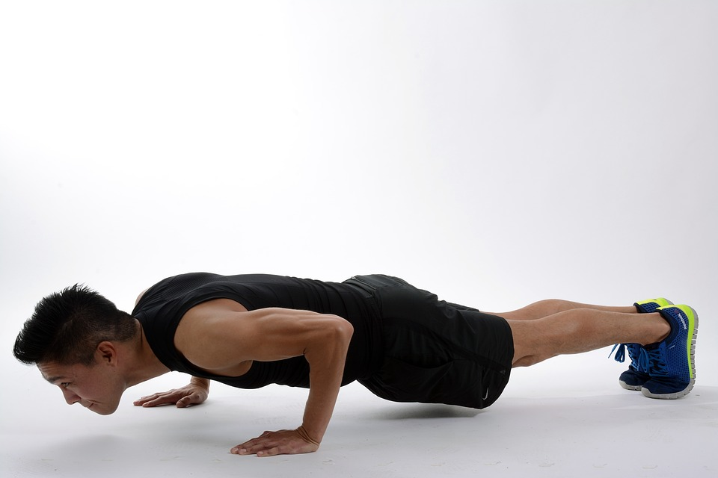

Press ups -
Toes or Knees
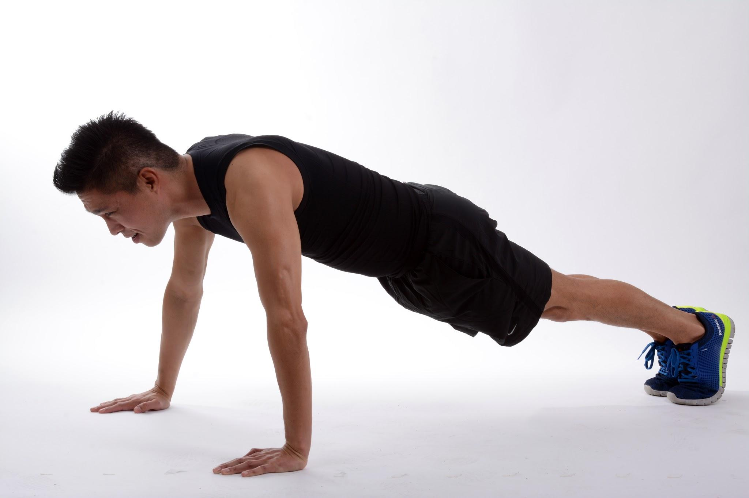
Squat Jumps
Floor or bench
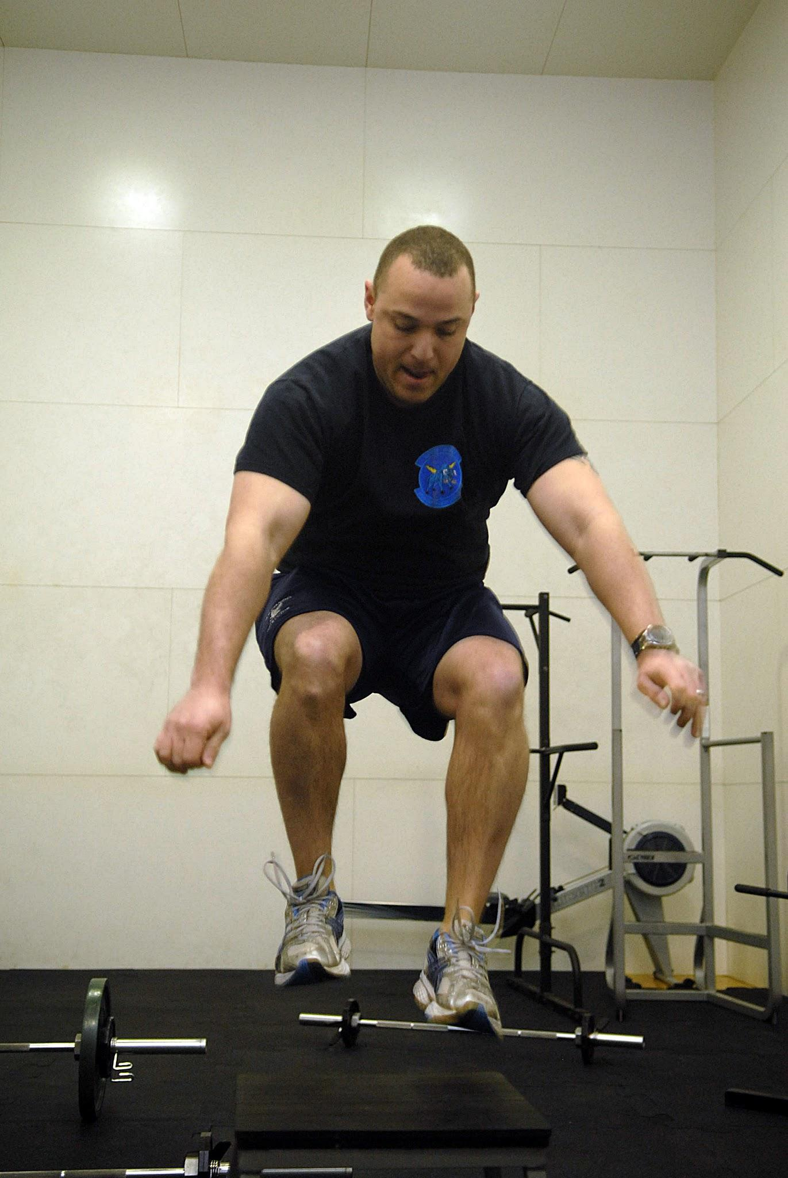
Skaters

Plank  Hands and toes  Elbows and toes  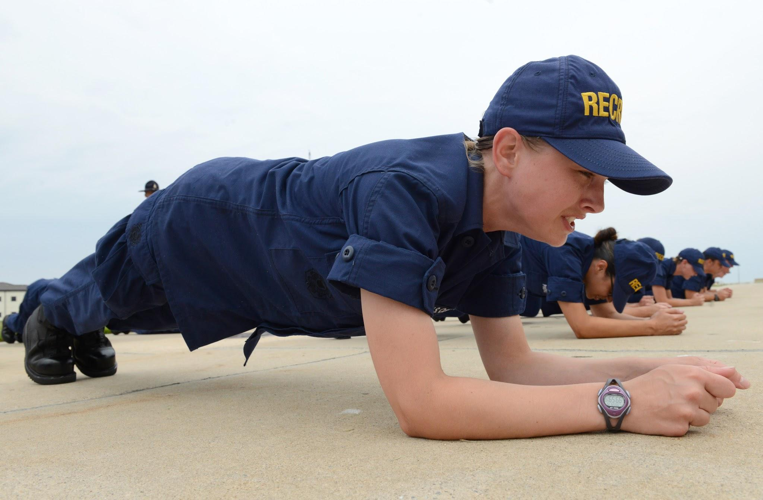 | Time
- Run to rugby club and back | Time:

