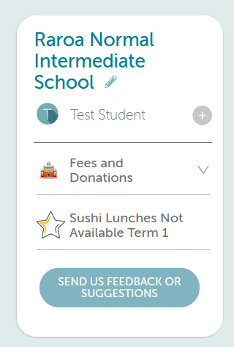
ONLINE PAYMENTS NOW LIVE WITH KINDO!

We are excited to let you know that our online Kindo School shop is now open.

All your school payments can be made in one place….with your myKindo account.
Your personalised account (Fees and Donations icon) will show you all your outstanding payments, where you can choose to make a part payment or pay the item in full.
You will also be able to purchase optional items, event tickets and support fundraisers.
This is our preferred method of payment, and we encourage all our families to sign up!

New users
New users can set up a myKindo account easily!
Click here to register & create an account. All you need is the email address the school has on file for you.

Existing users Already have an ezlunch or myKindo account?
If you have an account, you can log in here, and use the my details page to update your details.

Payment
There are a number of ways you can choose to top-up your account, and this can be done at the checkout, or by selecting the ‘top up account’ option at any time.

POLi No fees. Instant transfer. **RECOMMENDED**
Credit/Debit Card 50 cent charge + 2.5% fee. Instant transfer.
Visa / MasterCard / American Express and China UnionPay available.
Bank Transfer No fees. Allow 2 days for processing.

Shopping
There are TWO types of transactions you will be able to make using myKindo: paying personalised payment requests for your students and purchasing optional items.
Personalised payment requests will appear at the top of your screen under your student’s name.
Pay the full amount by clicking ‘+’ next to the item or make a part payment, by changing the amount before clicking the ‘+’ (if available).

There will also be the Kindo shop/optional items.
Click on your student’s initial next to an optional item to add to your cart.

Once you have made all your purchases click on the Checkout option to complete your transaction.
If you have sufficient funds, then simply click Place Order at the checkout and you’re done!
If you have insufficient funds, you will be able to top-up before completing your purchase.

Your order will automatically go through to the school or lunch supplier, and you will receive an email receipt confirming your top-up and/or purchase!

mykindo App
mykindo app is also available to download for both android and iPhone.

Need assistance? Our Kindo helpdesk is open 8am to 4pm weekdays.
Freephone: 0508 4 KINDO (0508 454 636) Email: hello@mykindo.co.nz
Online support: support.mykindo.co.nz

