

**NZ SOCIETY OF GASTROENTEROLOGY POSITION STATEMENT ON SARS-CoV-2 VACCINATION IN PATIENTS WITH INFLAMMATORY BOWEL DISEASE**

**Dr Samantha Benson-Pope**, Advanced Trainee in Gastroenterology, Southern District Health Board

**Professor Sarah Hook**, Immunologist, School of Pharmacy, University of Otago

**Professor Michael Schultz**, Gastroenterologist, University of Otago

**Key Points:**

1. We recommend that patients with IBD are vaccinated for SARS-CoV2
2. We recommend that patients with IBD accept whichever approved SARS-CoV2 vaccination is offered to them.
3. We recommend that patients with IBD continue their usual IBD medications around the time of vaccination.
4. The risks associated with of SARs-CoV2 vaccination in patients with IBD is anticipated to be very low.

**Introduction:**

The COVID-19 pandemic has resulted in significant morbidity and mortality worldwide. Since recognition of the SARS-CoV2 virus, there has been particular concern regarding the risks for immunosuppressed groups, and as a result, demand for timely research into the effect of this virus on these potentially vulnerable populations. To date, *Surveillance Epidemiology of Coronavirus Under Research Exclusion for Inflammatory Bowel disease (SECURE-IBD)*, an international registry with New Zealand participation, created to monitor outcomes of IBD patients with confirmed COVID-19, has recorded over 5000 cases of coronavirus in patients with IBD worldwide. (1) While the dataset that has been collated with this world-wide effort is still relatively small, early analysis has shown that combination therapy (thiopurines together with TNF antagonists) is potentially associated with an increased risk of severe COVID-19 compared to monotherapy. (9) However, other risk factors including age, co-morbidities and corticosteroids might also play a role. (10)

New Zealand has experienced one of the lowest cumulative case counts, incidence, and mortality among higher income countries, following early implementation and rapid escalation of national COVID-19 suppression strategies.(2) The roll out of SARs-CoV2 vaccination provides the opportunity to suppress the virus over the long-term and protect individual patients from COVID-19.

**Vaccines to be available in New Zealand:**

Vaccinations help our immune system to develop memory T-cells and B-cells that remember a COVID-19 infection and start fighting the virus before illness can occur. It usually takes a few weeks to develop this immunity.

The New Zealand Government have secured purchase agreements for four COVID-19 vaccines.(3) (4)

**Pfizer/BioNTech vaccine** – this mRNA-based vaccine contains virus material, that contains only the code for SARs-CoV2 spike protein (SARs-CoV2 is the virus that causes the disease known as COVID-19), to makes our cells produce the spike protein leading the immune system to create the memory cells to use in case of a real infection. mRNA is a bit unstable which is why this one needs to be stored at very low temperatures.

**Janssen Pharmaceutica vaccine** and **University of Oxford/AstraZeneca vaccine** – are both inactive adenovirus vector vaccines that use an inactive, unrelated virus to deliver SARS-CoV-2 genetic material for the spike protein to induce memory T- and B-cells.

**Novavax vaccine** – this protein subunit vaccine contains non-infectious coronavirus spike proteins to create the memory cells required to combat the virus in a real infection.

The **Pfizer/BioNTech vaccine** is currently the only of the above vaccinations to have been approved by MedSafe (New Zealand Medicines and Medical Devices Safety Authority). (4) All of the vaccines that will be available in New Zealand are safe to use in IBD patients on immunosuppression, as none contain any active SARS-CoV-2 virus. We therefore recommend that IBD patients accept whichever approved SARS-CoV2 vaccination is offered to them.

**Vaccination Strategy and Prioritisation in New Zealand:**

The *Covid-19 Vaccine Strategy Taskforce* consists of the Ministry of Business, Innovation and Employment, Ministry of Foreign Affairs and Trade, Ministry of Health and its regulatory agency MedSafe, PHARMAC, Treasury and the Department of the Prime Minister and Cabinet. The Task force is supported with independent expert advice from the Science and Technical advisory group, which includes representatives from across the science and research community.(5)

The sequence of the COVID-19 vaccination roll out in New Zealand is dependent on whether or not there is community transmission (see image below). Currently, vaccination is occurring based on ‘Scenario One’, with vaccination of the border, managed isolation and quarantine workforce occurring first.(6) The expectation is that patients with inflammatory bowel disease will fall into Group 3 ‘People with underlying conditions’, however it is not yet clear if this is dependent on whether they are on immunosuppressive therapy for their IBD or not. If patients with IBD were to meet any of the criteria to be included in Groups 1 or 2, then they will be prioritised and vaccinated earlier.

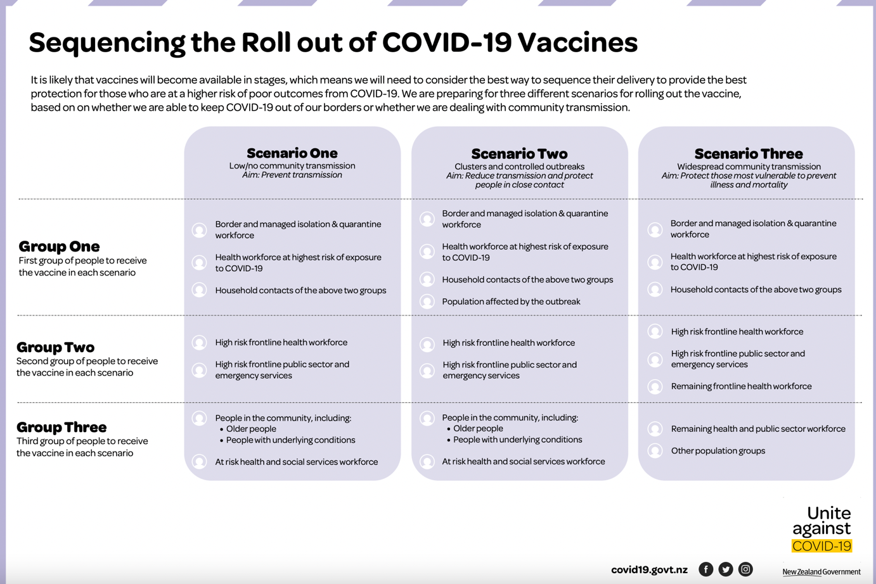

**Implications of Immunosuppressive therapy in IBD and** COVID**-19 Vaccination**

For IBD patients taking immunosuppressant medications, including biologics (infliximab, adalimumab, or other biologic agents as part of research studies or self funded), anti-metabolites (azathioprine, 6-mercaptopurine, methotrexate) and corticosteroids, the key concerns are related to the theoretical risk of sub-optimal vaccine responses, rather than the risk of vaccine side effects. For example, there is evidence to suggest that in IBD patients vaccinated for Hepatitis B, patients exposed to Infliximab were significantly less likely to have protective HBsAg titre levels following vaccination.(7) A similar association has been seen with Hepatitis A vaccination, where the seroconversion rate is lower in patients receiving anti-TNF agents.(8)

Given the current lack of data to inform whether patients on immunosuppressant therapy for IBD have a suboptimal response to Covid-19 vaccination, it is advised that patients continue taking their regular immunosuppressant medication to reduce the likelihood of a flare of their Crohn’s or colitis.

The risks of SARs-CoV2 vaccination in patients with IBD is anticipated to be very low. Patients with IBD will have questions and concerns regarding vaccination, in particular the safety profile of vaccination. At this stage there are no specific data related to vaccination in patients with IBD to address these concerns, however there are several factors that can offer reassurance. COVID-19 vaccines are being held to the same safety standards as all vaccines approved in New Zealand(6). Internationally, the SARS-CoV2 vaccinations have been tested in tens of thousands of patients with safety profiles comparable to other vaccines commonly used in IBD patients. These vaccines may have been produced quickly, however we can be confident that no shortcuts with regards to safety have been taken.

**Special Groups**

**Pregnancy and Breast-Feeding**

There are currently only limited data on the safety of COVID-19 vaccination in pregnancy and lactation. Internationally, the approach has been that a pregnant or lactating person may choose to be vaccinated after considering the risks and benefit and/or consulting with a healthcare professional.(6)

**Those under the age of 16**

The currently approved Pfizer/BioNTech vaccination is not approved for use in those under age 16(4), and overseas, none of the above vaccinations are approved for use in children under age 16. This is not due to any safety or efficacy concerns but due to the current lack of clinical data.

**Further information**

The NZ Immunisation Handbook (published by the Ministry of Health) has just been updated with  [information](https://www.health.govt.nz/our-work/immunisation-handbook-2020/5-coronavirus-disease-covid-19#23-6) on the first approved vaccine. It will be updated with the other vaccines if/when they are approved. Before vaccines are administered, general pre-vaccination screening guidelines and general contraindications for all vaccines should be checked. Special consideration is given to patients on immune checkpoint inhibitor (immunostimulant) therapy, particularly oncology patients.

**References**

1. Current Summary Data [Internet]. SECURE-IBD Database. [cited 2021 Feb 20]. Available from: https://covidibd.org/current-data/

2. Jefferies S, French N, Gilkison C, Graham G, Hope V, Marshall J, et al. COVID-19 in New Zealand and the impact of the national response: a descriptive epidemiological study. Lancet Public Health. 2020 Nov;5(11):e612–23.

3. Our COVID-19 vaccine agreements [Internet]. Unite against COVID-19. [cited 2021 Feb 20]. Available from: https://covid19.govt.nz/health-and-wellbeing/covid-19-vaccines/our-covid-19-vaccine-strategy/our-covid-19-vaccine-agreements/

4. COVID-19 Vaccine Status of Applications [Internet]. [cited 2021 Feb 20]. Available from: https://www.medsafe.govt.nz/COVID-19/status-of-applications.asp

5. COVID-19 Vaccine Strategy | Ministry of Business, Innovation & Employment [Internet]. [cited 2021 Feb 20]. Available from: https://www.mbie.govt.nz/science-and-technology/science-and-innovation/international-opportunities/covid-19-vaccine-strategy

6. COVID-19 vaccines [Internet]. Immunisation Advisory Centre. 2020 [cited 2021 Feb 20]. Available from: https://www.immune.org.nz/covid-19-vaccines

7. Pratt PK Jr, David N, Weber HC, Little FF, Kourkoumpetis T, Patts GJ, et al. Antibody Response to Hepatitis B Virus Vaccine is Impaired in Patients With Inflammatory Bowel Disease on Infliximab Therapy. Inflamm Bowel Dis. 2018 Jan 18;24(2):380–6.

8. Park SH, Yang S-K, Park S-K, Kim JW, Yang D-H, Jung KW, et al. Efficacy of Hepatitis A Vaccination and Factors Impacting on Seroconversion in Patients with Inflammatory Bowel Disease. Inflamm Bowel Dis. 2014 Jan 1;20(1):69–74.

9. Ungaro RC, Brenner EJ, Gearry RB, Kaplan GG, Kissous-Hunt M, Lewis JD, Ng SJ, Rahier J-F, Reinisch W, Steinwurz F, Underwood FE, Zhang X, Colombel J-F, Kappelman MD. Effect of IBD medications on COVID-19 outcomes: results from an international registry. Gut 2020 Oct 20; epub ahead of print.

10. Brenner EJ, Ungaro RC, Gearry RB, Kaplan GG, Kissous-Hunt M, Lewis JD, Ng SJ, Rahier J-F, Reinisch W, Ruemmele FM, Steinwurz F, Underwood FE, Zhang X, Colombel J-F, Kappelman MD. Corticosteroids, But Not TNF Antagonists, Are Associated With Adverse COVID-19 Outcomes in Patients With Inflammatory Bowel Diseases: Results From an International Registry. Gastroenterology. 2020 Aug;159(2):481-491

Other Resources Used in the Creation of this Document

*British Society of Gastroenterology Inflammatory Bowel Disease section and IBD Clinical Research Group position statement on SARS-CoV 2 vaccination.*

<https://www.bsg.org.uk/wp-content/uploads/2021/01/British-Society-of-Gastroenterology-Inflammatory-Bowel-Disease-section-and-IBD-Clinical-Research-Group-position-statement-on-SARS-CoV2-Vaccination.pdf>

*Crohn’s and Colitis NZ* <https://crohnsandcolitis.org.nz/COVID-19>

*Crohn’s and Colitis UK* <https://crohnsandcolitis.org.uk>