HEATON NORMAL INTERMEDIATE SCHOOL REBUILD UPDATE
The Christchurch Schools Rebuild programme
The Christchurch Schools Rebuild (CSR) programme was established in 2013, following the 2010 and 2011 Canterbury earthquakes. It was supported by an original government investment of $1.137 billion for the Ministry of Education (MoE) to rebuild and renew 115 schools in greater Christchurch.
The programme is now in it’s seventh year. As at August 2020:

50 schools are complete

26 are in construction

37 are in planning and design

and 2 are yet to enter the programme
Heaton Normal Intermediate School
Heaton Normal Intermediate School entered the CSR programme as part of Wave 5A, so near the end of the CSR programme, and it is currently in the planning and design phase.
The planning and design phase includes masterplanning, followed by detailed design for the Stage 1 rebuild.
The purpose of the masterplanning is to develop a long-term planning document that reflects a clear vision for the future direction of teaching and learning at the school, potentially for the next 50 years.
Our masterplanning started in February 2020 and has included staff consultation sessions, masterplanning workshops, integration of the School’s Education Brief objectives and regular project control group (PCG) meetings.
The School’s Education Brief was developed in 2018 specifically for the Rebuild, following school community consultation. The Education Brief was also reviewed and endorsed by the new Board of Trustees (the Board), following the 2019 elections.
The Board are very excited about the Overall Masterplan vision that has been developed (pictured below) and the future direction of education that it signals for Heaton Intermediate, including:

a layout that is engaging and well-connected, with quiet areas, a playground and repaired active playing fields, an ecological/environmental corridor and multiple courtyard/gathering/meeting spaces

new buildings and verandahs that are flexible and future-focused, delivering collaborative learning and teaching in classes of up to 30 students

retention of our House system and much-loved LRC, PAC and specialist learning programmes

the celebration of our past and the re-imagination of our future
We also want a rebuild that minimises disruption to classrooms and learning.
The Masterplan has received initial MoE approval and we are about to start the full design phase.
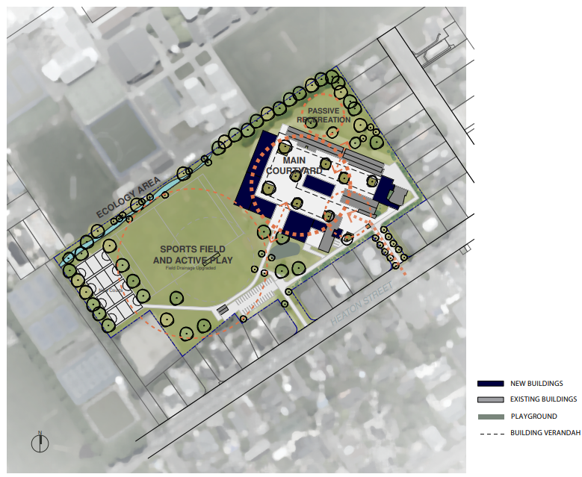
Plan of Overall Masterplan
Timeframes
The Board is currently waiting on MoE to confirm the School’s Rebuild Programme, but we understand that Stage 1 construction works are likely to commence in Summer 2021/22.
Challenges
Whilst the Board are very excited about the Masterplan vision, we are concerned about the limited extent of the proposed Stage 1 construction works (pictured below) that are proposed by MoE, and their expectation that good learning and teaching can continue to occur in the majority of the existing buildings for potentially many years to come.
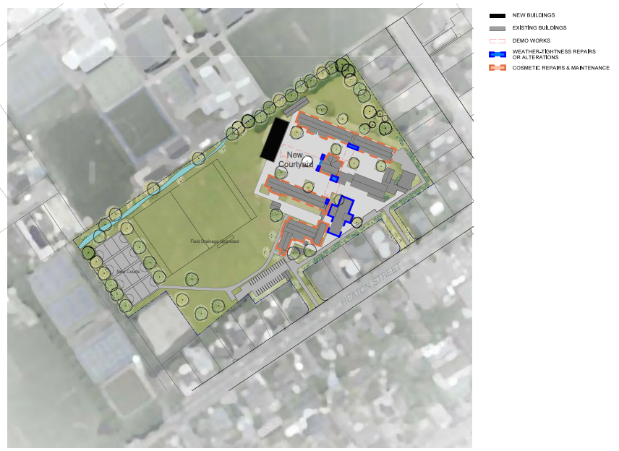
Plan of Stage 1 Construction Works
We have written to the Minister of Education to raise our concerns and to seek the opportunity to present our concerns and potential solutions in person. We have recently received a response to an Official Information Request that we made to MoE, and are currently considering our next steps.
We do not want to delay the school rebuild and are continuing to cooperate with MoE through the current planning and design phase. However, we are also determined to get the opportunity to present the School’s case to the Minister and to seek a timely full Rebuild of the School.
Should you have any questions or can offer support, then please feel free to contact the Board. Our email address is: BOT@heaton.school.nz
We will provide you with another School Rebuild update in Term 4.

