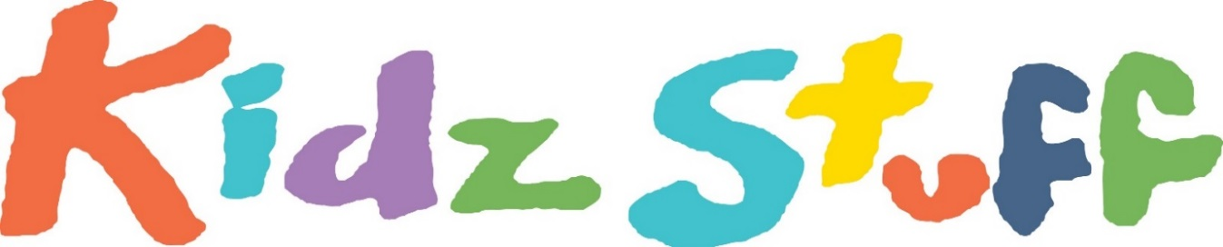

Theatre for Children Inc
The Producers of ‘Jessica Bo peep’ present:
“Robyn Hood and her Merry Gals!”
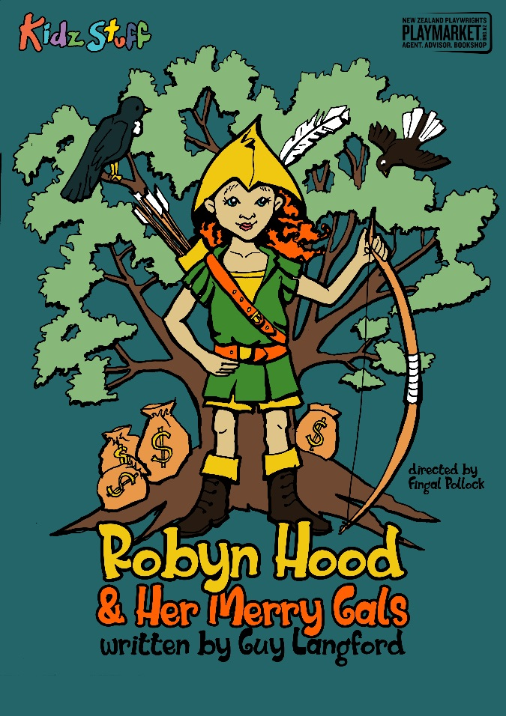
Written by Guy Langford
Directed By Fingal Pollock
When: 1st – 12th October 2018.
Monday - Friday 10am & 11:30am
10am shows only on Saturdays!

Grab your bow and arrows and come and join us in the forest these school holidays!
Robyn is the best archer in the land and always gets her target. She is on a mission to right the wrong and help those in need.
Robyn Hood is a new take on an old tale, with the added bonus of girls can do anything!
So aim your arrows and shoot down to the Tararua Tramping Club to follow Robyn and Her Merry Gals with KidzStuff this October.

Tickets $10.50 pp, Children under 2 Free
$7 Special Opening Preview, Saturday 29th September 2018!
Bookings: www.eventspronto.co.nz/KidzStuff

Contact: Amalia Calder
027 271 7351 / kidzstuffnz@gmail.com
Media Release: For Immediate Release

