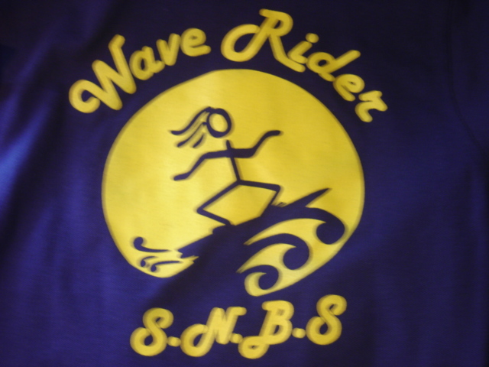
South New Brighton School
Stationery List 2019 – Year 7/8

ITEMS | Looks Like | Number Required
1E5 Exercise Book  (with margins) | 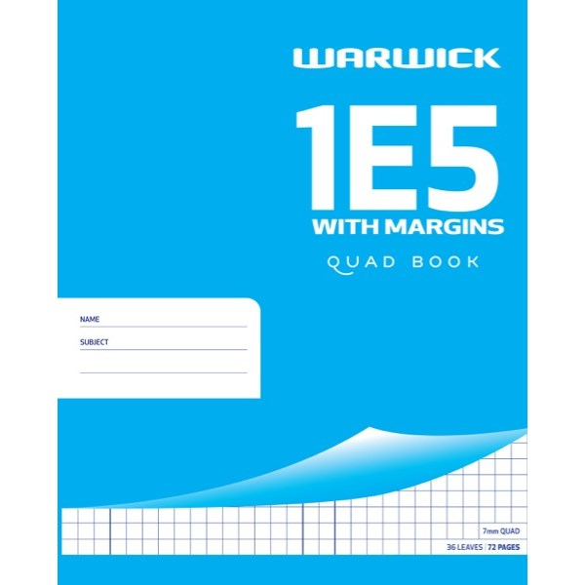 | 2
1B5 Exercise Book | 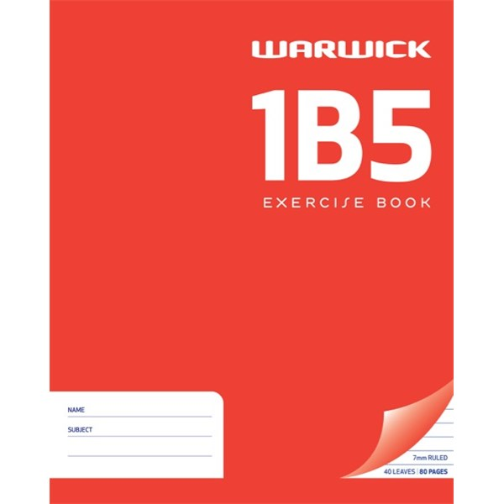 | 5
A4 Lecture Pad Ruled 100 Leaves |  | 1
20 page Display Book – any colour | 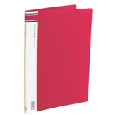 | 1
Please when you are buying the items below, make sure they are of good quality, then they will not need to be replaced as often!
AMOS Glue Sticks  Large AMOS – hard white glue, not liquid | 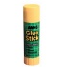 | 2
Ruler  Non Bendable 30cm | 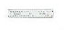 | 2
HB Pencils  HB Pencils | 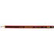 | 5
Rubber  Sensible one | 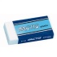 | 2
Plastic Kin Compass | 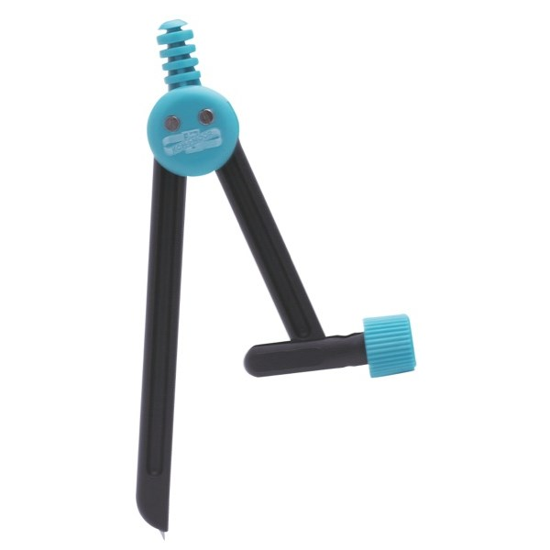 | 1
Taurus Protractor 180 degrees 10cm | 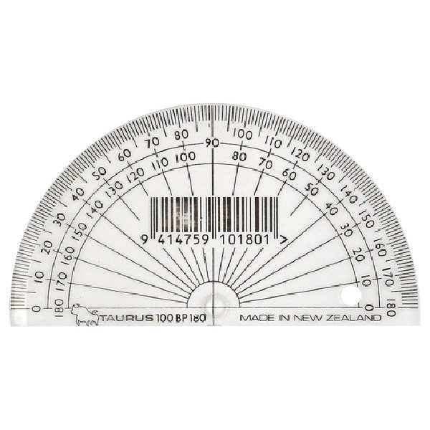 | 1
Casio Fx-82AU Plus II Scientific Calculator  This item is OPTIONAL but essential if you sit level 5 or 6 Astle | 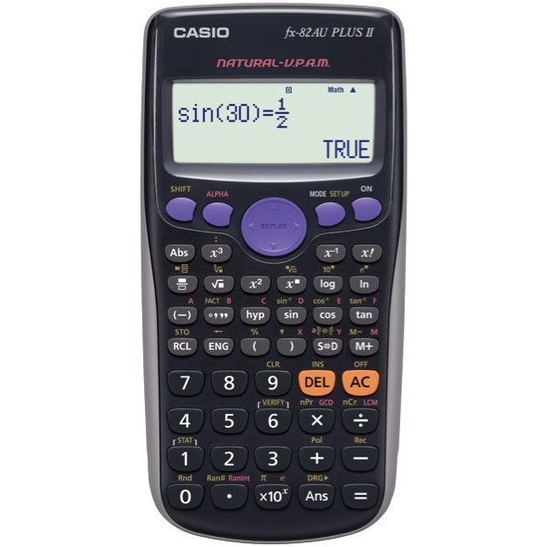 | 1
Blue Whiteboard Marker – Bullet Tip | 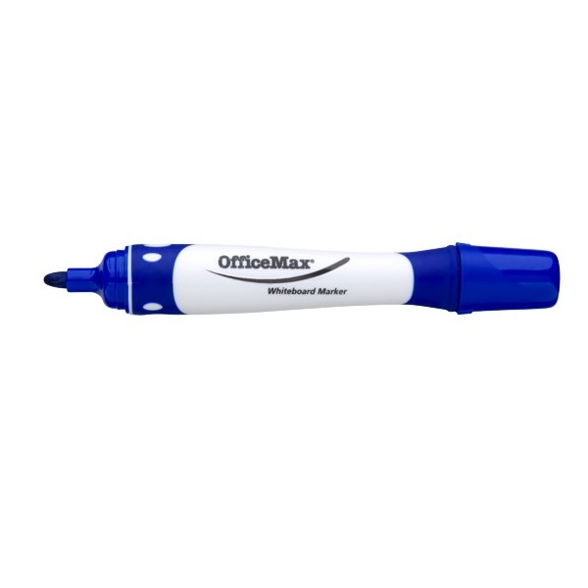 | 4
Earphones | 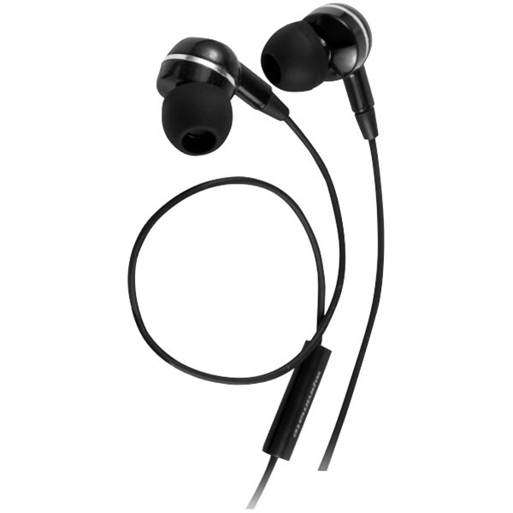 | 1
Paper Mate Inkjoy 100 Blue Ballpoint Pen – meduin tip | 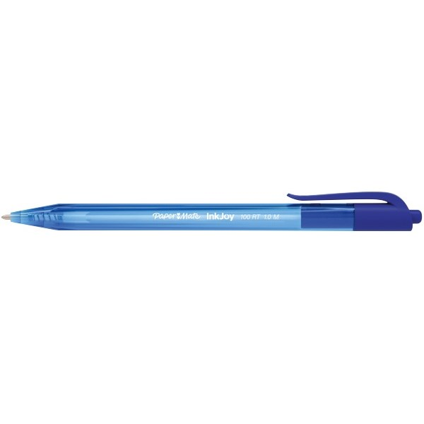 | 4
Paper Mate Inkjoy 100 Red Ballpoint Pen – meduin tip | 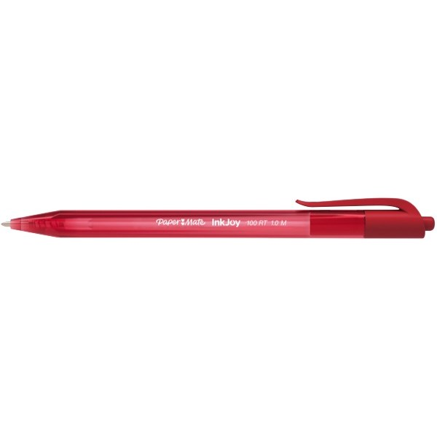 | 2
Black vivid Fine Bullet tip | 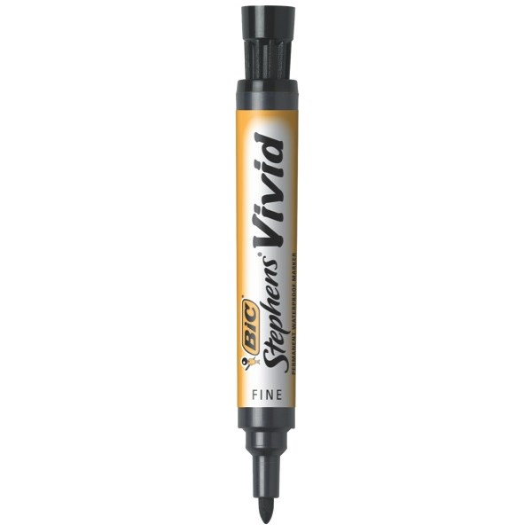 | 1
Orange highlighter – chisel tip | 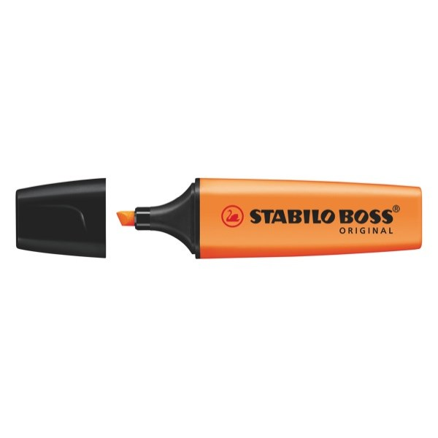 | 1
Green Highlighter – chisel tip | 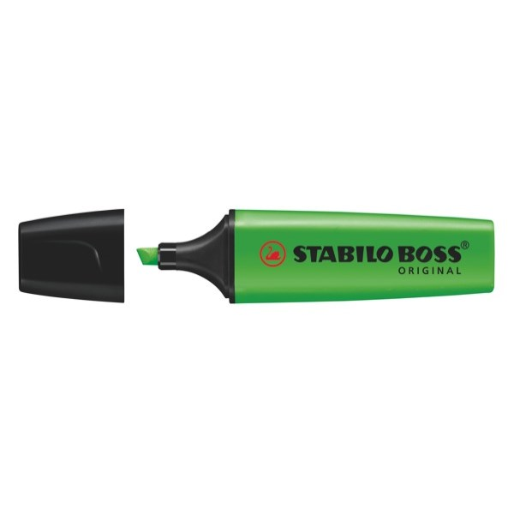 | 1
Colouring felts or pencils | 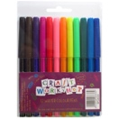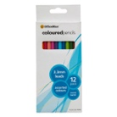 | 1
All the children’s stationery needs to be sent to school clearly named. Some items may need to be replaced through the year or more bought as needed.
Please remember:
- Individually name all items
- Please also label school clothing, hats, lunch boxes and drink bottles
- All children must have a named drink bottle

Thank you for helping your child to be prepared and ready to start school on Day 1.

