  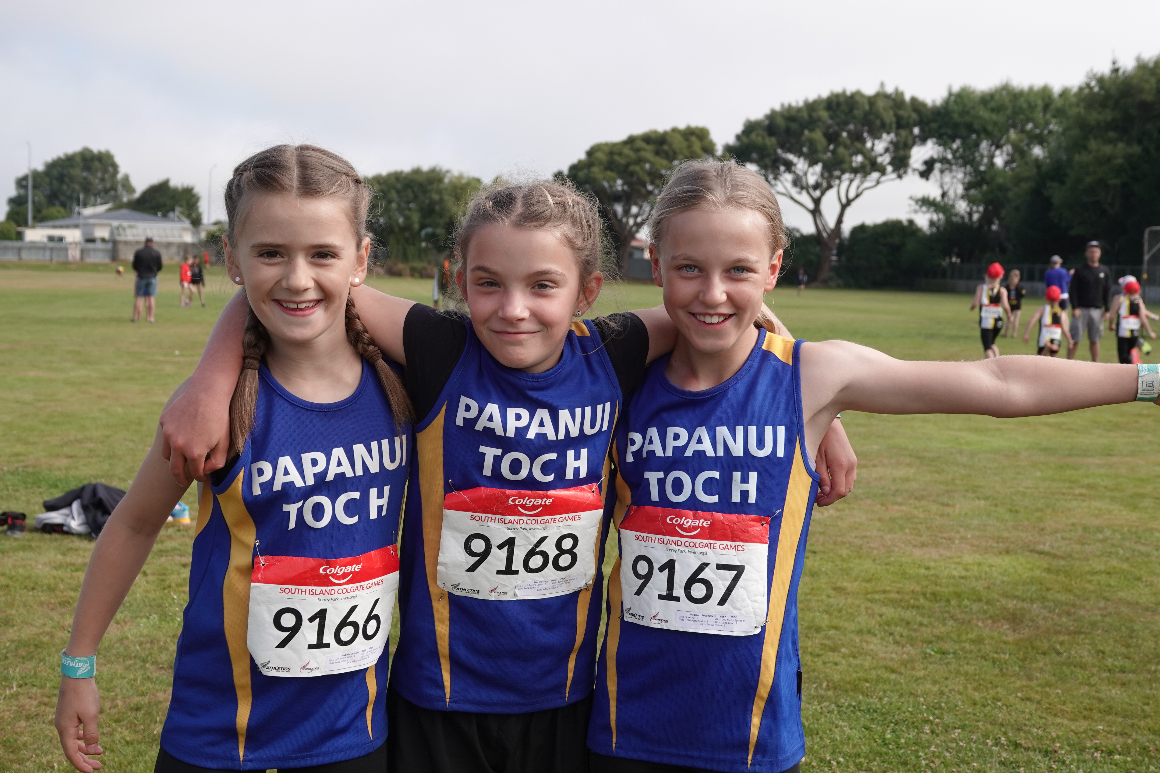
    - Papanui Toc H Athletics
  Open Day
  Come along to our Open Day on Sunday 9th October at 2pm at Papanui High School or at our first Club Night on Tuesday 11th October at 5:30pm to register and get more information.
  Athletics is a sport that teaches great basic physical skills for other sports, provides opportunities to develop social skills and the chance to make long lasting friendships.
  We are a family friendly club with a range of coaching resources to cater for every level and ability. Club nights are held every Tuesday and offer a combination of coaching and competition. Children can also compete against athletes from other clubs on Saturdays at the purpose-built track at Nga Puna Wai.
  
  
  
  9th October 2 pm – 4 pm 11th October 5.30pm – 7pm
  2
  come And throw a shot put like tom walsh
  try to high jump like hamish kerr
  fancy being a sprint queen like zoe hobbs
  At Papanui High School 30 langdons Rd
  papanuitochathletics.org.nz
  jcc@ptoch.org.nz
  
  facebook.com/PapanuiTocH

