**Love this?**



**Then try fencing!**

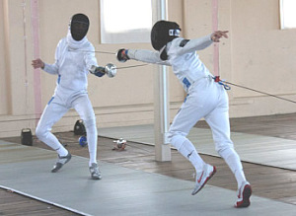

A five-week fencing course for adults and children 8 and over starts on Monday the 30th of July 5.30pm – 6.30pm. The course costs $80.00 and all equipment is provided. It is a great introduction to this exciting sport.

For more information email us at claymoreswordsclub@gmail.com