Shopping online

We’ve set up our Kindo online school shop to make it easy for our families to pay for school costs anywhere, anytime. It’s open 24/7, and available at www.mykindo.co.nz
Now you’ve set-up your family account, have funds available, and it’s time to make a payment.

Select the service you require.

Select the item you require by clicking on the initial icon of the child.
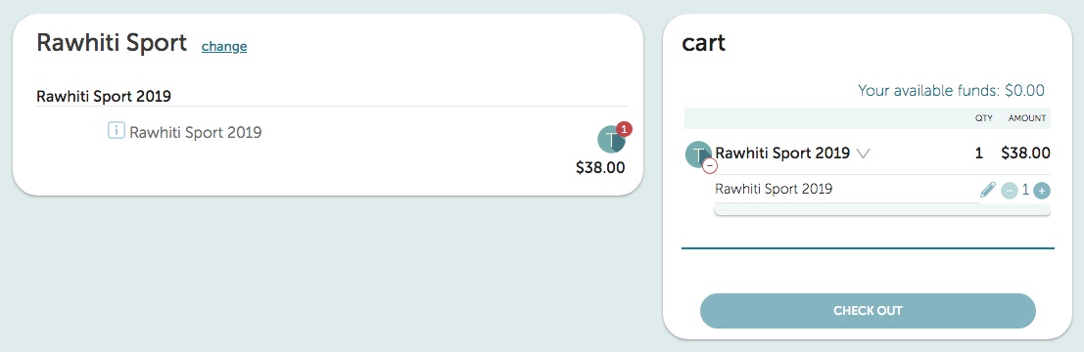
The item will bold and display the quantity that has been added to your cart.
When you have finished selecting the items for your child’s order click 

If there are sufficient funds in your account, you will be able to simply click ‘Place order’ to complete your purchase.
If there are insufficient funds you will be required to Top-up your account before placing the order.

Your order and payment will automatically go through to the school, and you will receive an electronic receipt confirming your payment or top-up.


Need assistance? Call the Kindo helpdesk on free phone 0508 4 KINDO
(0508 454 636). We are open 8am to 4pm Monday to Friday.

SAVE TIME - PAY ONLINE

