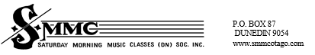
The Saturday Morning Music Classes have spaces starting Term Two this year for the following beginner classes:
Beginner Let’s Make Music (for 5/6 year olds) and Recorder and Guitar (for 7 year olds).
Classes held at George St School, Bathgate Park School on Saturday Mornings; Mornington School after 3:30pm Tuesdays (LMM only); Elmgrove School after 3:40pm Wednesdays; Tainui School (LMM & Guitar) after 3:40pm Thursdays.
Enrolment forms available by email to aart@smmcotago.com
Enquiries to stephanie@smmcotago.com

2nd May 2022

To the principals in the Dunedin area:
Please make the following information available to your parent community through your usual school communications.
Thank you,
Stephanie Hobbs
(SMMC Co-ordinator)

