HALSWELL SCHOOL JUMP JAM FUNDRAISER
Baking Paper $25.00 a roll
Pay in either cash, cheque (made out to Halswell School PTA) or Direct debits can be made to:
Halswell School PTA 03 15840020228 00 - reference JUMP JAM and code with initials and surname

SUPA BAKE
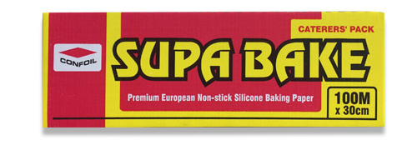
100m (L) X 30cm (W)
Ideal for
- lining frying and baking dishes before cooking
- separating etc before freezing
- Cooking frozen meals and pastries in the oven and microwave

Name | Quantity | Amount | Paid
Eg: Olivia Sim | 3 | $75 | Paid - cash

