CHISNALLWOOD INTERMEDITAE SCHOOL
internationalteam@chisnallwood.school.nz
Introduction
Chisnallwood Intermediate School is a two year school which
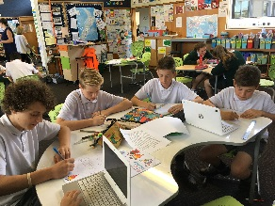
specialises in middle school education for students aged 10- 14years. We are able to offer full or part time courses of study in a New Zealand classroom.
Academic Programme
The school delivers the core curriculum areas of English, Mathematics, Social Sciences, The Arts and Science.
We then offer specialist programmes in
- Technology (Foods, Workshop, Visual Art and Electronics/Robotics)
- ICT Computer programming and coding.
- Physical Education and Sports Programmes
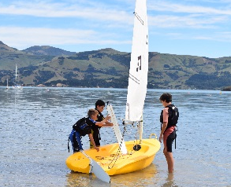
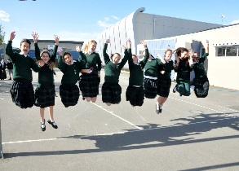
- Itinerant music and Performance music
- Education Outside the Classroom – which includes our own Camp facilities at Akaroa, Ski Trips, and Swimming lessons.
- Dance Groups and Rua Te Kakano and Pasifika Cultural Groups.

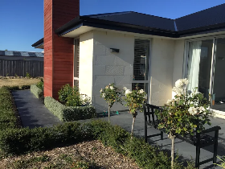
ESOL (English for Speakers of other Languages) is accessed by students who require support and to all students who attend for short term programmes.

Accommodation
The school is able to arrange homestay accommodation with New Zealand families. These families are New Zealand police vetted and approved in accordance with the Code of Practice. These homestays involve students in all aspects of family life and enable students to develop language skills in a family setting.
Regular visits are completed by staff to ensure the safety and an acceptable standard of accommodation provided for students is met.
Fly direct into Christchurch International airport to be met by Chisnallwood Staff.
Special Features
Internationally recognised Music programme with Orchestra, Jazz, Ukelele, Marimba, Rock and many other performance groups.
Sports development programme to extend students who demonstrate talent in sport.

Check out our school: https://www.youtube.com/watch?v=tIhy9-IMWEY
Chisnallwood is a school of opportunity and base the delivery of the curriculum around its values of
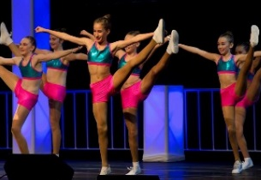
RESPECT │RESILIENCE │RESPONSIBILITY │RELATIONSHIPS
