Hayley Warren Ply 2016

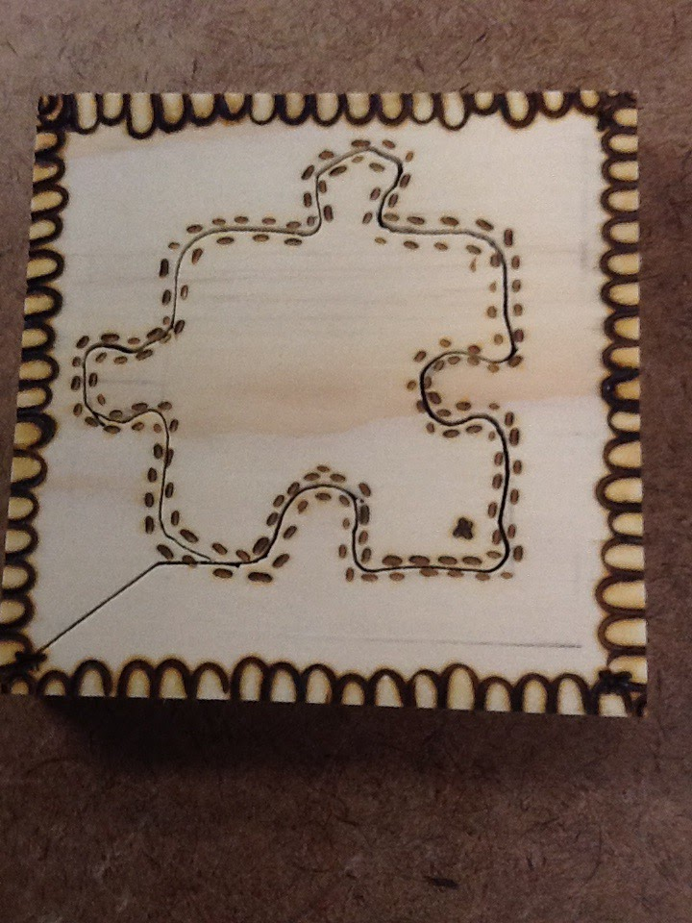

For hard materials this week I decided that I would try to trial a puzzle design for my photo frame not knowing if it would work or not. Mr Arnold didn't know either. he said “you could be my trial run if it works it works if it doesn't it doesn't” which made me want to make it work even more! At first I was skeptical because there was a big chance that it was all going to fall into pieces (not in the way I wanted it to)but it was to late to turn back now I started by doing a single piece to get the feel of it and get used going around the pieces and it was a success!!

And I was confident that it was time to draw out the base of my big main puzzle.

(It looked like this)

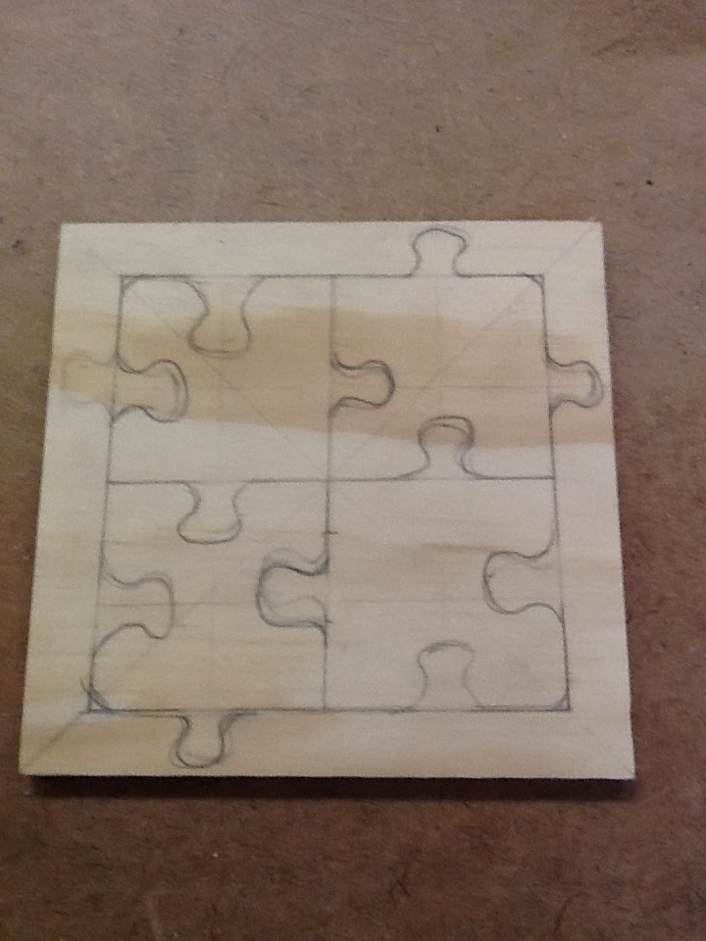

Then I got onto the saw and started cutting which took me about 10-15 minutes to go around the pieces themselves and it worked!

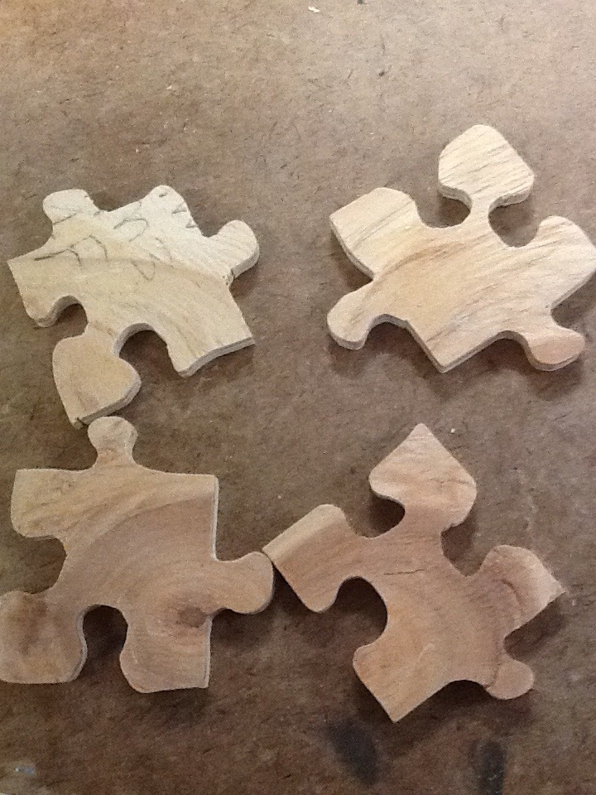

All I had to do now was put on my backing and leave it to dry while I was waiting I hot pokered my puzzle pieces

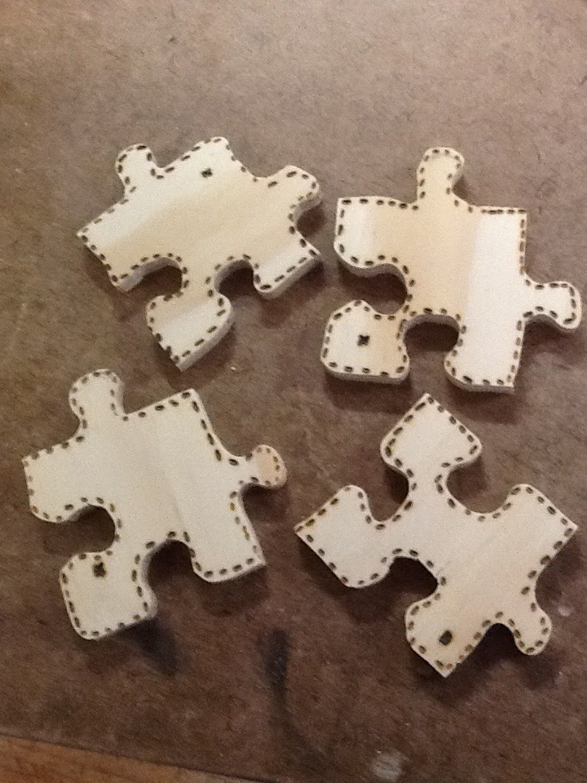

the next day I hot pokered my border and it was complete

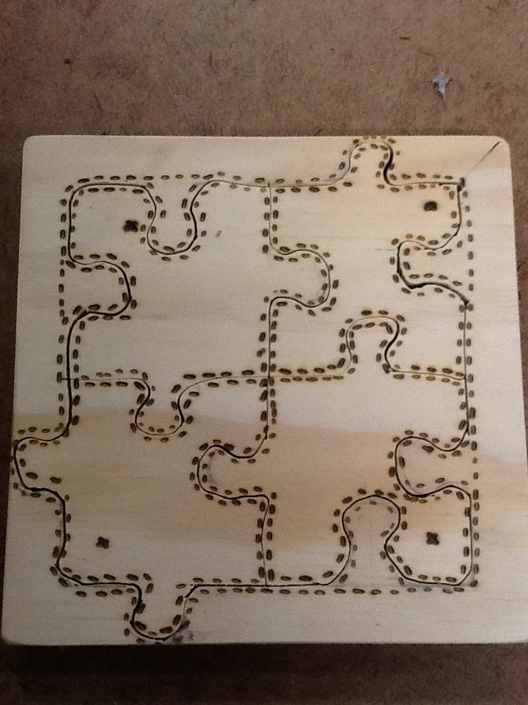

And I even had time to spare to create a plastic design

(a puzzle piece ofcourse)

