
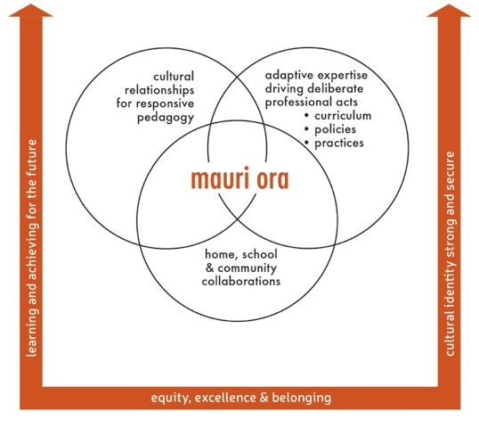

Profiling the critical contexts for change
- What are we doing already?

- Based on evidence,
how effective is
this?

- What will be
our next steps?

